

SCHOOL *of* BUSINESS AND TECHNOLOGY

Department of Engineering and Aviation Sciences

**THE DESIGN FOR A DEBRIS CLEARING VESSEL**

**Hafeez Shittu**

**Mohsin Mehmood**

Advisor: Dr. Lei Zhang

Feb. 27th, 2019

Project Title

THE DESIGN FOR A DEBRIS CLEARING VESSEL

By

Hafeez Shittu, Mohsin Mehmood

Submitted to the Department of Engineering and Aviation Sciences in partial fulfillment of the requirements for the degree of Bachelor of Science in Engineering at the

UNIVERSITY OF MARYLAND EASTERN SHORE

Date Feb 27st 2019

The author hereby grants the University of Maryland Eastern Shore permission to reproduce and distribute publicly, paper and or electronic coPies of this document in whole or in parts.

Authors Hafeez Shittu, Mohsin Mehmood, …

Signature Hafeez Shittu; Mohsin Mehmood

Date Feb 27th 2019

Department of Engineering and Aviation Sciences

Certified by

List of Contents

List of Contents 4

List of Figures 2

List of Tables 4

Abstract 5

1. Introduction 6

1.1 Backgound/Motivation 6

▪ Unwanted Migration: 6

▪ Chemical Contamination: 6

▪ Marine Mammals: 6

1.1 Objective 6

1.2 Design Requirements 7

1.3 Design Constraints 7

Design Method (Approach) 7

2. Project Description 8

2.1 System Description 8

2.2 System Diagram 8

2.3 System Functions 9

3. Implementation Plan 10

3.1 Tasks 10

3.1.1. Task 1. Research Basic Boat Designs 10

3.1.2. Task 2. Preliminary Boat Design 10

3.1.3. Task 3. Weight Calculations 10

3.1.4. Task 4. Hydrostatic Study 10

3.1.5. Task 5. Fluid Dynamics 10

3.1.6. Task 6. CAD Simulations 11

3.1.7. Task 7. Build a Prototype 11

3.1.8. Task 8. Image Recognition System 11

3.1.9. Task 9. Navigation System 11

3.2 Team Organization 11

3.2.1. Responsibility of Team Member 1. 11

Responsibility of Team Member 2. 12

3.3 Timeline/Milestones/Delivery Plan 12

4. Implementation 14

4.1 Implementation of Task 1. 14

4.1.1. Implementation of Subtask 1- Reasearch 14

4.1.1. Implementation of Subtask 2- Idenify Suitable Boat Designs 15

4.2 Implementation of Task 2- Preliminary boat design 16

4.2.1. Implementation of Subtask 1- Hand drawing 16

4.2.1. Implementation of Subtask 2- Compare and Contrast 18

4.3 Implementation of Task 3- Weight Calculation 23

4.3.1. Implemtation of Subtask 1- Calculate Volume 25

4.3.2. Implementation of Subtask 2- Calculate Mass 25

4.4 Implementation of Task 4- Hydrostatic Study 30

4.4.1. Implementation of Subtask 1- Calculate Bouyant Force 30

4.4.2. Implementatiion of Subtask 3- Calculate Displacement 30

4.4.3. Implementation of Subtask 4- Calculate the center of mass 33

4.4.4. Implementation of Subtask 2- Calculate the Center of Bouyancy 34

4.4.5. Implementation of Subtask 5- Calculate Metacentric Height 35

4.4.6. Implementation of Subtask 6- Stability of the boat 36

4.5 Implementation of Task 5 - Fluid dynamics 37

4.5.1. Implementation of Subtask 1- Calculate drag 37

4.5.2. Implementation of Subtask 1- Calculate lift 38

4.6 Implementation of Task 6- CAD Simulation 38

4.6.1. Implementation of Subtask 1- Flow Analysis 38

4.6.2. Implementation of Subtask 2- FEA Stress analysis 38

4.7 Implementation of Task 7- Building the Prototype 75

1. Results: 82

4.8 Implementation of Task 8: 82

4.8.1. Implementation of Subtask 1-Setting up the Image Recognition API 82

4.8.2. Implementattion of Subtask2-Research on Convolution Neural Network 85

4.8.3. Implementation of Subtask 3-Training the model 90

4.8.4. Implementation of Subtask 4-Result 97

4.8.5. Implementation Runtime for Image Recognition Unit 99

4.9 Implementation of Task 9- Navigation System 100

4.9.1. Implementation of Subtask 1- Research on Pixhawk configuration 100

4.9.2. Implementation of Subtask 2- Layout of the Navigation System 104

4.9.3. Implementation of Subtask 3- Runtime of the Navigation System 105

5. Conclusion (Discussion and Future Plans) 106

Acknowledgment 107

REFERENCES 109

List of Figures

Figure 1 Banana Boat 14

Figure 2 Hydrofoil Boat 15

Figure 3 Catamaran boat 15

Figure 4 Pink foam Pontoon boat 16

Figure 5 First design 17

Figure 6 Earlier Design 2 17

Figure 7 Pontoon 18

Figure 8 3D earlier design 2 18

Figure 9 Earlier design 3 19

Figure 10 Collection box, mesh, Pontoon 19

Figure 11 Earlier Design 3 20

Figure 12 Paddle wheel design 20

Figure 13 Solidworks Final design 21

Figure 14 PVC 22

Figure 15 Pink Foam 23

Figure 16 Volume of a rectangle 24

Figure 17 Buoyancy Principle 25

Figure 18 Height of un-displaced pontoon. 31

Figure 19 Center of mass cone 33

Figure 20 Half cylinder COM 34

Figure 21 Center of Buoyancy 34

Figure 22 COM, COB 35

Figure 23 COB 36

Figure 24 Metacenter 36

Figure 25 Stability of ship 37

Figure 26 Resistance in boat 38

Figure 27 Displaced part of vessel 39

Figure 28 Setting up wizard 39

Figure 29 Project setup menu 40

Figure 30 Drag Force 41

Figure 31 Flow analysis iteration chart 41

Figure 32 Absolute max 42

Figure 33 water flow around vessel 42

Figure 34 Flow trajectories 43

Figure 35 Flow trajectory 2 43

Figure 36 Fixed constraints 45

Figure 37 materials 46

Figure 38 Forces 47

Figure 39 Mesh settings 47

Figure 40 Pressure 48

Figure 43 Selected faces 53

Figure 45 Pressure 2 55

Figure 62 Pi graphic interface during update 83

Figure 63 overview 86

Figure 64 Pictorial representation of CNN 86

Figure 65 neural network modification methods 87

Figure 66 edge detection 88

Figure 67 Example of an Inception Neural Network Image Processing 88

Figure 68 finding the error&Figure 69 optimized process 90

Figure 70 installing tf 12.0 & Figure 71 failed installation 92

Figure 72 successful installation 92

Figure 73 jyPiter script tensorflow active 94

Figure 74 dataset of Pictures used to train the system 95

Figure 75 image labelling 95

Figure 76 file generated 96

Figure 77 label map 96

Figure 78 training interface 97

Figure 79 image recognition start up interface 98

Figure 80 Successful Trial 1 98

Figure 81 Successful Trial 2 99

Figure 82 2s battery&Figure 83 image recognition set up 99

Figure 84 power connection layout for Raspberry Pi 100

Figure 85 Pixhawk 100

Figure 86 mission planner interface 101

Figure 87 connection to mission planner through port 101

Figure 88 Select the right firmware 102

Figure 89 motor and servo control set up 103

Figure 90 navigation layout 104

Figure 91 power connection for microcontrollers 105

Figure 92 power connection for motors 106

List of Tables

Table 2. Table 1 Total Volume table 29

Table 3. Table 2 Total Mass table 30

Table 3 New Material property 32

Table 4. Table 4 X, Y, Z coordinates 35

Table 6. Table 5 Physical properties 50

Table 7. Table 6 General objective 50

Table 8. Table 7 Mesh settings 50

Table 9. Table 8 Materials 52

Abstract

The principle objective of this project is to design an autonomous marine vessel, and utilize machine learning and target recognition allowing the vessel to collect floating plastic bottles in ponds, lakes, and streams. The motivation behind this project is to find a cheaper and more efficient solution for clearing certain water bodies (lakes, ponds, streams). The project design encompasses three main design structures, which are the navigation, the mechanical design, and the electrical design. The intent behind the navigational design is to design a vessel which possesses and utilizes both autonomy and smart capabilities. This design purpose gave birth to the use of an autopilot microprocessor called a “Pixhawk” for the autonomy. By setting wave points on software called “Mission Planner,” the Pixhawk can be configured to move from one point to another depending on the area of collection. The Pixhawk moves along the path set by the wave point by controlling the servomechanisms attached to the rudder and the Electronic Speed Controller (ESC). Although this method of control delivered a level of automatic operation and decreased human intervention in that the vessel was able to move unmanned on a fixed path, the vessel was unable to locate bottles through only the Pixhawk. Accordingly, intelligent design was introduced through the implementation of target recognition.

The main focus of the project became implementing intelligent design through target recognition. The process involves two primary aspects, which are training a convolution neural network (CNN) to identify a bottle by employing a transfer learning method, and setting up a target recognition on an application programming interface (API). The Raspberry Pi 2 was identified as the most ideal API because it is affordable and capable enough to run the recognition system. However, due to its lower capability, a relatively less accurate but fast CNN with the fewest parameters, called Mobilenet SSD, is used for recognition. With the aid of TensorFlow, the neural network was optimized to recognize a bottle.

The goal for the mechanical design of the vessel is to ensure that the vessel body floats and will maintain stability under applied force. The mechanical design stages of any floating body consists of “Imagining and Analyzing,” “Concept Design,” “Principle Design and GA Drawings,” and “CAD Design and Analysis.” The majority of time spent in each task was on research. Mechanical design requires weight calculations, hydrostatics study, flow analysis, and FEM analysis using a CAD software (Solid Works). Accurate calculations and analyses served to further improve any design.

The goal for the electrical design of the vessel is to create an environmentally friendly skimming tool which eliminates the use of fossil fuel as a source of energy. The electrical system is powered by two 2s LiPo batteries. The first battery powers the microcontrollers, which are the Raspberry Pi2 and the Pixhawk, and the second battery powers the motors. Using two batteries assists in troubleshooting in case a problem arises, and also ensures even weight distribution for the sake of stability of the vessel.

1. Introduction

This project is based on the design and building of a bottle-collection vessel which operates in lakes and pond. Image recognition and autonomy are utilized to allow the vessel to operate efficiently and unmanned.

## Backgound/Motivation

Plastic never goes away, and it is increasingly finding its way into [oceans](http://www.biologicaldiversity.org/programs/oceans/index.html) and onto beaches. In the Los Angeles area alone, ten metric tons of plastic fragments — such as grocery bags, straws, and soda bottles — are carried into the Pacific Ocean every day. Today, billions of pounds of plastic can be found in swirling convergences making up about 40 percent of the world's ocean surfaces. Plastic waste in lakes, ponds, and smaller water bodies accumulate differently than plastic waste in oceans. Plastics can end up in a different place from where the plastic originated due to the pattern of lake currents. It is likely that some cities pollute with more plastic than what ends up on their own shores. Though plastics that enter a lake may disappear from view, much of the waste can be seen and has many effects on the lives around it. Some of the reasons supporting the control of plastic waste in lakes and ponds include the following:

* Unwanted Migration:

Migration has been in occurrence for as long as the existence of living things on the planet. Although migration is essential for survival, it has proven to be a major source of biological pollution in man and animals. Migration can have a profound effect on the immunity of animals. When animals migrate together to the same place, they are exposed to the body fluids and waste of one another, and superior species are exposed to the genetically inferior species; contact with the waste of an inferior species can lead to an explosion in illness or even death. Biological contamination due to migration can lead to extinction.

* Chemical Contamination:

When fertilizers and pesticides are used for agricultural purposes, they exhibit the benefits of chemical advancements by improving yield, but unfortunately, these chemicals are a major source of pollution. When rain falls, the fertilizers and pesticides are swept by flood into the water bodies and this has a detrimental effect on the lives of aquatic animals and plants. When pesticides meant to kill off pests flow into the water body, they become harmful to the fish in the lakes or ponds which can lead to death in aquatic life. Fertilizers that flow into the water bodies can increase the fertility of the water and cause a large growth of algae. In turn, this creates a canopy on the water surface which deprives the plants and animals of sunlight and oxygen.

* Marine Mammals:

Marine mammals ingest and get tangled in plastic. Large amounts of plastic debris have been found in the habitat of endangered Hawaiian monk seals, including in areas that serve as pup nurseries. Entanglement deaths are severely undermining recovery efforts of this seal, which is already on the brink of extinction. Entanglement in plastic debris has also led to injury and mortality in the endangered Steller sea lion, with packing bands the most common entangling material. In 2008, two sperm whales were found stranded along the California coast with large amounts of fishing net scraps, rope, and other plastic debris in their stomachs.

**Research**

There are countless different ways to design a boat based on the functions of the vessel. Accordingly, the first step for this subtask was to research and understand the capabilities of different types of boats, and which design and its capabilities are most suitable for this particular project and its design requirements.

“A boat is a small vessel which has been specifically designed for navigating in near-shore areas or inland waterways.” Though there appears to be just a thin line separating a ship from a boat, in actuality t[here are quite a few differences which set both of them apart.](https://www.marineinsight.com/types-of-ships/7-differences-between-a-ship-and-a-boat/) Boats can be classified into three main categories, as follows:

1. Unpowered or man-powered (like rafts, gondolas, kayaks, etc.);
2. Sailboats (sail-propelled); and
3. Motorboats (engine-powered).

Because this vessel is required to move slowly through the water in order to achieve its intended purpose, this greatly reduced the list of possible boats to research. The boat designs considered are the following:

Banana Boats

As the name suggests, this boat is banana-shaped. It is an inflatable boat and it easily floats on water. It does not have an in-built motor system. A banana boat has a capacity to seat between approximately three to ten people.

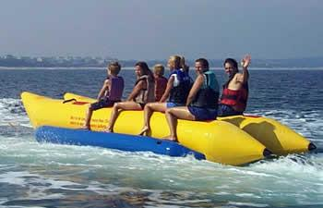

Figure 1 Banana Boat

The reason for this design consideration was its ability to carry heavy payloads. With the addition of the right electrical motors, this passenger boat design could be modified into a debris collecting vessel.

Hydrofoil boats:

The hydrofoil system of boats incorporates the use of wings or lifts (pontoons) to raise the boat from the surface of the water and move forward.

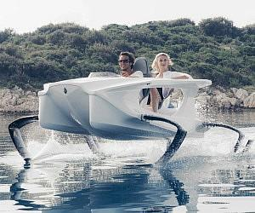

Figure 2 Hydrofoil Boat

The reason for this design consideration was solely because of the empty cavity in the front, which could be turned into the collection bin for the vessel.

## Objective

The objective of this project is to design a Catamaran (Dual Hull) marine vessel capable of detecting 500 ml plastic bottles within a one meter radius, and collect the water bottles using machine learning.

## Design Requirements

The design requirements specified for this objective are as follows:

1. The main frame of the vehicle should be able to support up to 60 lbs. of total load, which includes the payload of up to 20 lbs., 25 lbs. of vehicle itself, and an additional 15 lbs. for the motors and components.

2. The motors should drive the vehicle with the velocity of 5 miles per hour.

3. The design must be cost efficient.

4. The vehicle should recognize floating plastic bottles using machine learning.

5. The vehicle should recognize the target (Volume 500ml, height 23.50cm, diameter 6.58, max weight .40g) and function intelligently.

6. Based on the size of the collection chamber, the vehicle should be able to collect up to 35 empty water bottles.

## Design Constraints

In this system design, the design constraints are as follows:

1. The main frame of the boat should be within 4ft * 3ft * 2ft (L*W*H).

2. Due to lack of funding, the overall budget for the design should be under $100.

3. There are limited resources available.

4. The vehicle must be easy to assemble.

## Design Method (Approach)

For this marine vessel, the design methods include both mechanical and electrical design. The mechanical design methods are as follows:

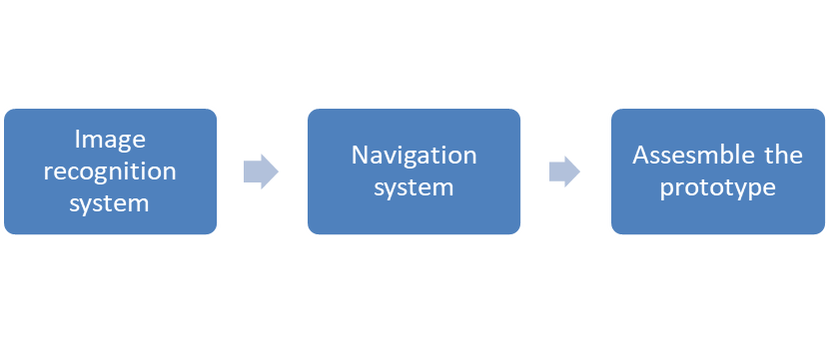

1. Project Description

## System Description

This project integrates both electrical and mechanical implementation. The simplified idea of this vessel is very similar to a boat. For propulsion, the vessel requires two DC motors that are selected based on a number of factors. The factors include consideration of energy consumption, water resistivity, RPM, torque, and the ability to withstand resistance from weight of debris. Those motors are controlled by an Electronic Speed Controller (ESC). The ESC regulates the amount of power supplied into the motors. It is the link between the motors, power supply, and receiver or any microcontroller from which the signal is coming, and this system utilizes two micro-controllers.

In this system, two concepts are implemented to execute the intelligence and the autonomy. The Pixhawk, which is the primary controller of the system, is the microcontroller by setting wave points or paths for the vessel to follow by using software called the Mission Planner.

The Raspberry Pi2, the second microcontroller, is the microcontroller responsible for implementing the intelligence aspect of the system. Intelligence design is the second concept implement. The Raspberry Pi2 implements intelligent design by analyzing images or video captured through the use of a camera.

## System Diagram

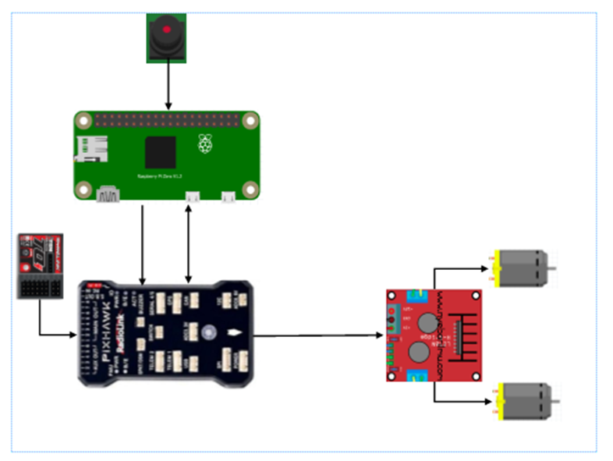

Illustration of the Basic Navigation System.

## System Functions

The diagram above shows an ideal system which will implement both autonomy and intelligence. The diagrams consists of two DC motors controlled or regulated by a motor controller, which will receive signals from the Pixhawk. The motion of the vessel is primarily controlled by the Pixhawk. A Pixhawk is a high-performance autopilot-on-module suitable for fixed wing, multi rotors, helicopters, cars, boats, and any other robotic platform that can move. It is targeted toward high-end research, amateur use, and industry needs, and combines the functionality of the PX4FMU + PX4IO.When the Raspberry Pi detects debris through target recognition, the objective of this methodology is for the Raspberry Pi to communicate with the Pixhawk in real-time to collect the debris. For the implementation of this methodology to be successful, the two microcontrollers must be compatible by using the MAV link or by sending 1 and 0 signals to the Pixhawk for maneuvering.

1. Implementation Plan

## Tasks

The design methods used in this process are converted into main tasks and sub-tasks. The tasks are divided into mechanical design tasks and electrical design tasks. The tasks are as follows:

### Task 1. Research Basic Boat Designs

#### Subtask 1. Research

Research various boat designs and how they work.

#### Subtask 2. Identify Suitable Boat Design

Identify a design based on research Subtask 1.

### Task 2. Preliminary Boat Design

#### Subtask 1. Hand Drawing

Draw basic design which was identified using Task 1 and come up with different designs from which to choose.

#### Subtask 2. Compare and Contrast

Compare and contrast all the designs. Learn about their pros and cons and, based on those, choose the most effective design.

### Task 3. Weight Calculations

#### Subtask 1. Calculate Volume

Calculate the volume of each part to ultimately determine the mass of each part and then the entire system.

#### Subtask 2. Calculate Mass

Calculate the mass using the volume from Subtask 1, and the density of each part.

### Task 4. Hydrostatic Study

#### Subtask 1. Calculate the Bouyancy Force

Use the volume and the mass to calculate the buoyancy force of the floating vessel.

#### Subtask 2. Calculate the Center of Buoyancy

Use the area submerged to find the center of the buoyancy force.

#### Subtask 3. Calculate Displacement

Calculate the volume of the water displaced.

#### Subtask 4. Calculate the Center of Mass

Identify and calculate the center of mass of the whole system.

#### Subtask 5. Calculate the Meta Centric Height

Find the meta centric height based on the COM and COB.

#### Subtask 6. Calculate Stability

Identify the stability of the vessel using the angles 0-15 degrees to ensure the boat will not tip over and the system will be stable.

### Task 5. Fluid Dynamics

#### Subtask 1. Calculate Drag

Calculate the drag of the vessel in fluid.

#### Subtask 2. Calculate Lift

Calculate the lift of the vessel in fluid.

### Task 6. CAD Simulations

#### Subtask 1. Flow Analysis

Simulate the boat in fluid using computer aided design software. In this case, SolidWorks was utilized.

#### Subtask 2. FEA Stress Analysis

Simulate the boat stress analysis to identify if the system will fail.

### Task 7. Build a Prototype

#### Subtask 1. Ordering Components

#### Subtask 2. Build the Boat

### Task 8. Image Recognition System

#### Subtask 1. Set up the Image Recognition API

Configure the Raspberry Pi microprocessor, and install all dependencies required to perform target recognition.

#### Subtask 2. Research on CNN

Comprehend how a convolution works, and build, manipulate, and train the network. The task also requires selecting the best model for this process.

#### Subtask 3. Training the Model

Train the neural network with the dataset.

#### Subtask 4. Result

Upload trained model into the Raspberry Pi and test to obtain results.

### Task 9. Navigation System

#### Subtask 1. Research on Pixhawk Configuration

Research how a Pixhawk works and how it can be configured to adapt to sailing.

#### Subtask 2. Layout of the Navigation system

Deliver a Pictorial representation of the system to aid adequate comprehension, and explain the communication pattern between the Raspberry Pi and Pixhawk.

#### Subtask 3. Run-time of the Entire System

Illustrate the power connection and for how long the vessel can be operational.

## Team Organization

This project is split into the mechanical design and the electrical design. Team Member 1 is responsible for the mechanical design. Team member 2 is responsible for the electrical design.

### Responsibility of Team Member 1.

❖ Task 1

❖ Task 2

❖ Task 3

❖ Task 4

❖ Task 5

❖ Task 6

❖ Task 7

### Responsibility of Team Member 2.

❖ Task 1

❖ Task 2

❖ Task 7

❖ Task 8

❖ Task 9

## Timeline/Milestones/Delivery Plan

1. Project Timeline and Delivery Plan

|  |  |  |  |
| --- | --- | --- | --- |
| **Time** | **Task** | **Comments** | **Responsible Personnel** |
| Week 1-4 | Choosing toPics | Week 1 through 4 were spent looking for the toPic. | Mohsin Mehmood, Hafeez Shittu |
| Week 5 | Finished task 1.1  Started subtask 8.3 | Research  Setting up the API | Mohsin Mehmood  Hafeez Shittu |
| Week 6 | Finished Subtask 1.2  Finished subtask 8.1 | Identify suitable boat design  Setting up the API | Mohsin Mehmood  Hafeez Shittu |
| Week 7 | Finished Subtask 2.1  Started subtask 8.1 | Hand drawings  Training the model | Mohsin Mehmood  Hafeez Shittu |
| Week 8 | Started Subtask 2.2  Finished subtask 8.5 | Compare and contrast  Runtime for the Raspberry Pi3 | Mohsin Mehmood  Hafeez Shittu |
| Week 9-11 | Finished Subtasks 3.1,3.2,3.3  Finished subtasks 8.4, 8.3. | Calculate volume, mass, displacement  Training the model /Results | Mohsin Mehmood  Hafeez Shittu |
| Week  12-15 | Finished Subtasks 4.1-4.6  Started subtask 9.1 | Calculate displacement, center of mass, MC height, stability  Research on Pixhawk configuration | Mohsin Mehmood  Hafeez Shittu |
| Week 16 | Finished Subtask 5.1,5.2  Finished Subtask 9.1 | Calculate drag and lift  Research on Pixhawk configuration | Mohsin Mehmood  Hafeez Shittu |
| Week 17 | Finish Subtask 6.1  Finish Subtask 9.2 | Flow analysis  Layout of the navigation system | Mohsin  Hafeez |
| Week 18- | Finish subtask 6.2  Finish Subtask 9.3 | Fem analysis  Runtime of the whole system | Mohsin  Hafeez |
| Week 19-32 |  |  |  |

1. Implementation

## Implementation of Task 1.

### Implementation of Subtask 2- Idenify Suitable Boat Designs

Catamaran Boats:

According to the Google Definition: “A catamaran (/ˌkætəməˈræn/) (informally, a ‘cat’) is a [multi-hulled](https://en.wikipedia.org/wiki/Multihull) [watercraft](https://en.wikipedia.org/wiki/Watercraft) featuring two parallel [hulls](https://en.wikipedia.org/wiki/Hull_(watercraft)) of equal size. It is a geometry-stabilized craft, deriving its stability from its wide [beam](https://en.wikipedia.org/wiki/Beam_(nautical)).”

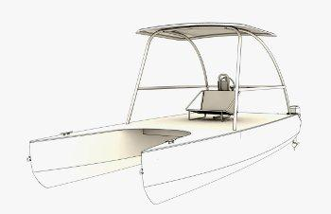

Figure 3 Catamaran Boat

The catamaran maintains its stability primarily due to equal sized hulls on each side. A catamaran boat with three hulls is also plausible in real life, but for this design purpose, the two hull catamaran design best suited the vessel’s design and purpose.

Pontoon and Its Advantages:

As noted previously, the design specifications require the collection and holding of at least 25 pounds. Accordingly, after review of all possible boat design options, it was determined that the pontoon boat design best met the vessel design requirements due to its many advantages. Some of the advantages are as follows:

Ease of Use/Maintenance

Pontoons can be made from any light materials. Aluminum is the ideal material used for industrial pontoons. The intended material for the debris collecting vessel is Pink insulation foam, which is then reinforced using fiberglass sheets and Epoxy resin. Working with Pink foam is easy and the Pink foam is very easy to maintain.

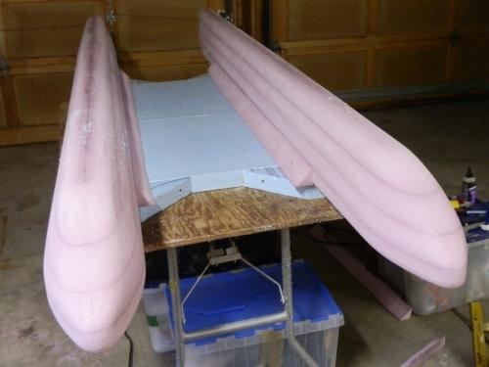

Figure 4 Pink Foam Pontoon Boat

Longevity:

Longevity is one of the most important factors in deciding to use pontoons. Pontoons built using Pink foam can last longer and are very easy to maintain. These boats can be left in the water for long periods of time and can still function without any problems.

Building Costs and Storage:

The building costs for a pontoon boat using Pink foam is very low, and is estimated to be approximately $80 dollars for this particular vessel. This amount includes the costs for the Pink foam, epoxy resins, and the fiberglass sheets.

Using pontoon boats will provide an empty area already existing in the overall pontoon design, and this empty area will function as the collection bin for the water bottles collected.

## Implementation of Task 2- Preliminary boat design

### Implementation of Subtask 1- Hand drawing

Designing the Vessel:

Task 1, Subtask 1 involves a rough, three-dimensional diagram of the parts of the system, as well as the entire three-dimensional design of the vessel itself. Working on the rough design first requires identification of all of the dimensions, sizes, and materials, which satisfy the design requirements. Developing the three-dimensional design of the vessel requires the ability to constantly review and improve upon the earlier designs. The following are some of the initial designs which were improved throughout the process:

First Design:

The first design for the boat was a rough, hand-drawn sketch based on the initial design idea. Although this first design was rudimentary and was able to be improved-upon, most of the later designs as well and the final design follow the same pattern of design. The first design was as follows:

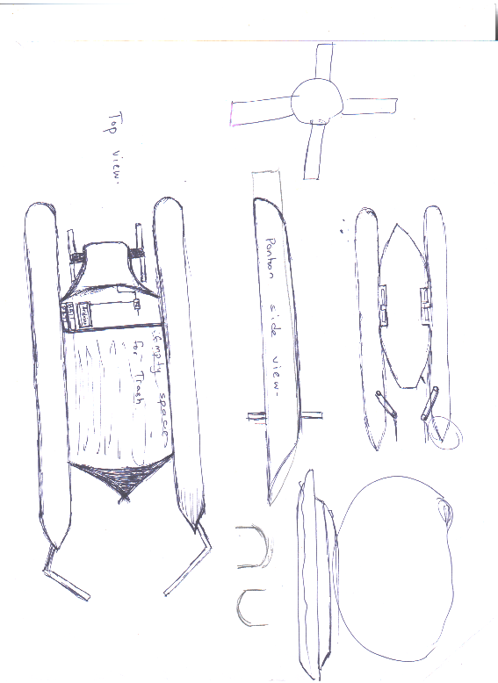

Figure 5 First design

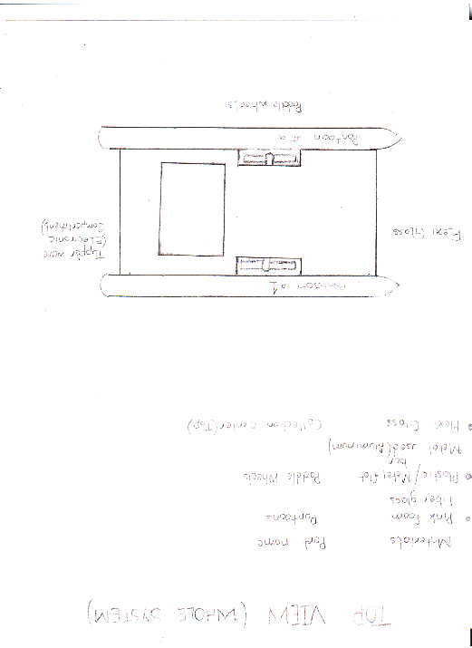

Figure 6 Earlier Design 2

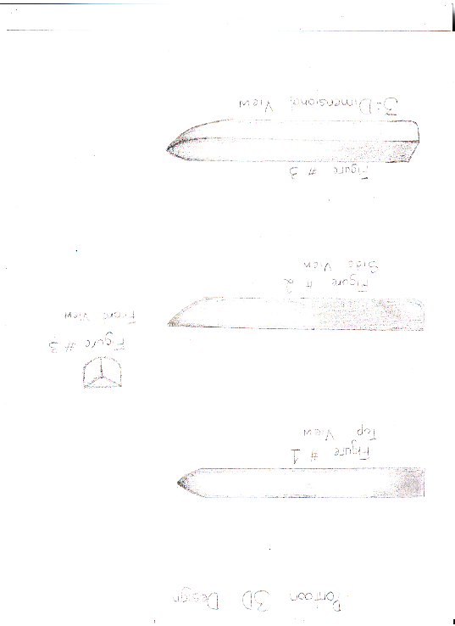

Figure 7 Pontoon

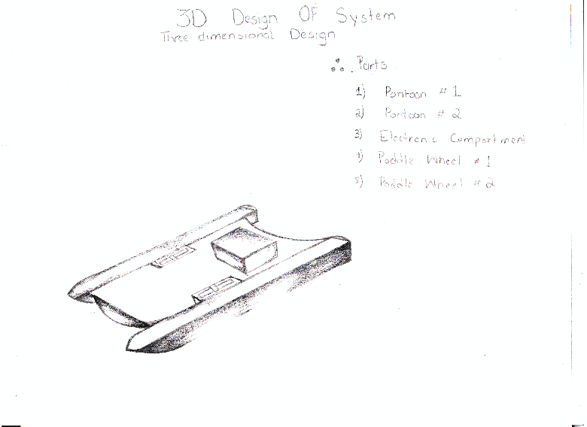

Figure 8 3D earlier design 2

### Implementation of Subtask 2- Compare and Contrast

Cons for Earlier Design 2:

The first design appeared to meet all but two design requirements. The two design requirements not met were:

1: Required storage space:

Due to lack of storage space, this design could not hold more than 16.6 pound of weight.

2: Shallow ends collection:

The second reason for this design failure was its inability to collect debris from the shallow ends of bodies of water, which is one of the most important design requirements.

Earlier Design 3:

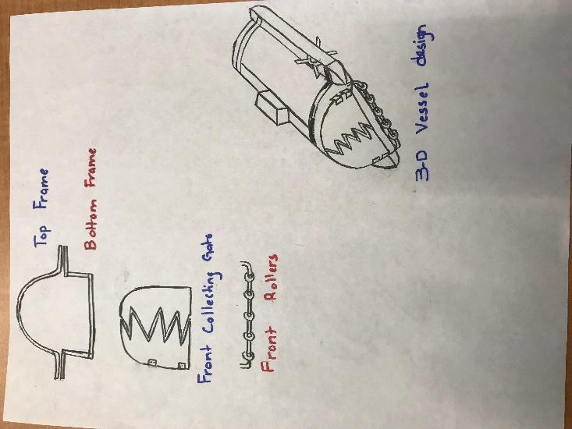

Figure 9 Earlier design 3

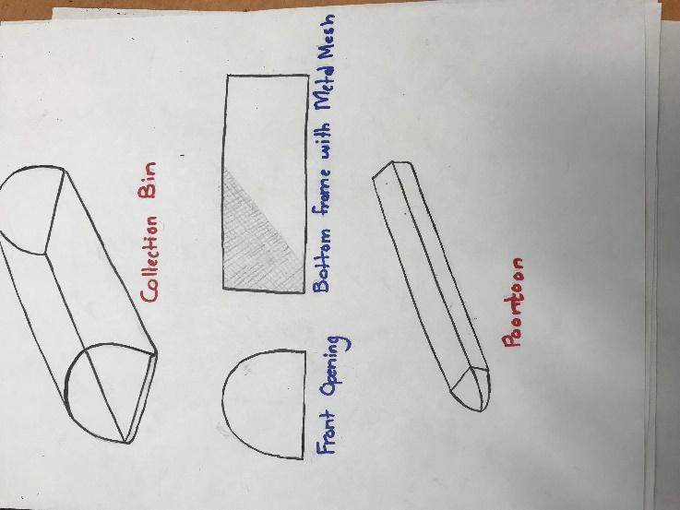

Figure 10 Collection Box, Mesh, Pontoon

Cons for Earlier Design 3:

This was a valid basic design and met all of the design requirements. However, this design was determined to be too similar to boat designs already in production. Accordingly, additional changes were made to the design in order to make the project more unique and innovative, and less similar to boats already in existence.

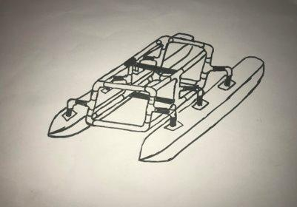

Figure 11 Earlier Design 3

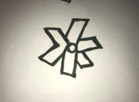

Figure 12 Paddle Wheel Design

Cons for Earlier Design 3

Concerns with the efficiency of this design existed due to weight and collection limitation.

Pros for “Earlier Design 3”

The pros for the final design are as follows:

1: The frame is very light.

2: The pontoons are also very light.

4: The parts can be re-assembled for storage.

5: Malleable parts.

Final Design:

The final design, as seen in Figure 15, was finally developed based upon consideration of all of the completed research as well as continuous trial and error in designing the vessel. This final design meets all of the design requirements. In addition, the design style is sleek and innovative, and while recognizable as a boat, it features a contemporary design that is unique to the project idea.

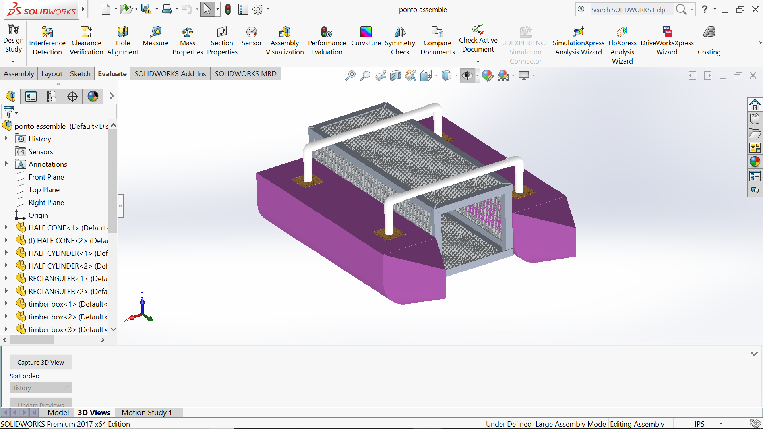

Figure 13 Solidworks Final design

Final Design:

A significant portion of time was spent researching the best possible materials to be used for this build. The following are the characteristics sought after in deciding on the appropriate materials:

1: Light-Weight:

The material should be lightweight, which will assist in making the vessel easy to use and operate. Being lightweight will ensure that less force is required to move the vessel around.

2: Strength:

Strength is a big contributing factor when considering materials as well, because the vessel should be able to hold 25 pounds or more of debris without the system sinking. Because many lightweight materials are not strong, this required the testing of materials through trial and error.

3: Cost efficient:

The overall purpose of this vessel is to clean bodies of water in a cost-efficient and economic manner. Accordingly, the materials used must to be cost efficient in order to meet the intended effects of lowing costs and saving money.

4: Ease of access:

Consideration was also given to the accessibility in acquiring necessary materials for college students. All materials must be easily found in local hardware stores.

Materials:

Based on all the factors above, the following materials were identified for the final design:

1: PVC Pipes

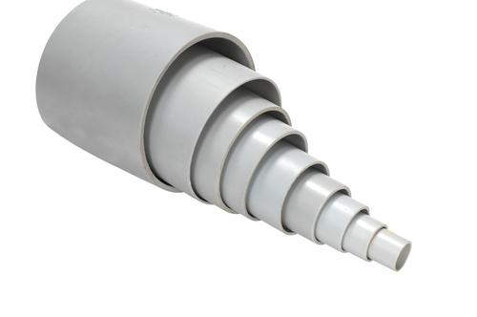

Figure 14 PVC

Pros:

The pros for using PVC Pipes are following:

* Superior corrosion resistance
* Cheap
* Good heat resistance
* Strength
* High pressure resistance
* Inert to most mineral acids, bases and salts.
* Ease of access
* Choice of size

2: Pink foam

The pontoons of the vessel will be built using Pink foam or polyurethane panels:

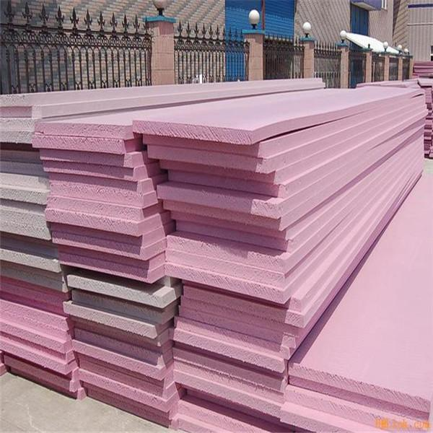

Figure 15 Pink Foam

Pros for Pink Foam:

Some of the pros of using Pink foam are the following:

1: Thermal conductivity

2: Moisture sensitivity

3: Compressive strength

4: Ease of installation

5: Durability - resistance to degradation from compression, moisture, decomposition, etc.

6: Ease of replacement at end of life

7: Cost effectiveness

## Implementation of Task 3- Weight Calculation

The formulas used were identified:

Formulas Used:

Different shapes have different volume formulas. The following shapes were utilized to determine volume for each part of the boat:

1: Rectangular prism

This formula was used to determine the volume for rectangular parts of pontoon:

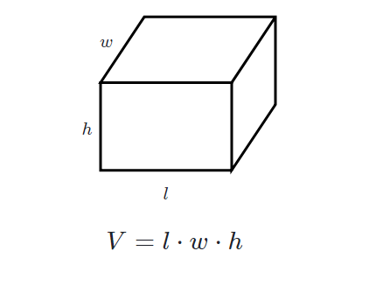

Figure 16 Volume of a Rectangle

2: Triangular Prism

This formula was used to determine the volume for the front part of pontoon.

3: Cylinder

This formula was used to determine the volume for the half-cylinder shape of the pontoon.

4: Cone

This formula was used to determine the front conic volume for pontoon.

Density Formula:

Formulas used:​

* Density = Mass / Volume​

Or​

* d = M / V​
* Volume of Cylinder: Pi * r^2 * h

Key-Terms​

* P = represents density
* m = represents mass
* v = represents volume

This formula is used to identify individual mass.

Buoyant force is the upward force exerted on objects submerged in fluids. When examining why fluids exert an upward buoyant force on submerged objects, it has been determined to be caused by differences in pressure between the bottom of the submerged object and the top of the object. Because the amount of pressure exerted increases as an object submerges deeper into a fluid, the force from the pressure exerted downward on the top of the body will be less than the force from the pressure exerted upward on the bottom of the body. That is why the buoyant force is necessary for a boat design:

$$(Fb=rho gh)$$

$$Buoyant force = ρgV​$$

Where:​

ρ is the density of the fluid​

g is the gravitational acceleration​

V is the volume of the fluid displaced

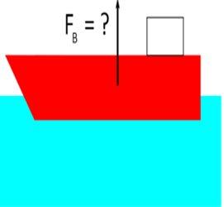

Figure 17 Buoyancy Principle

* Density of water = $62.42796529 lb/ft^3 >> 999.992061 kg/m^3$

​
* g = 9.81 m/s^2​

### Implemtation of Subtask 1- Calculate Volume

### Implementation of Subtask 2- Calculate Mass

Finding volume and mass for each part:

Half Cylinder:

Radius of half cylinder = 0.10160m

Density of foam = 21 kg/m^3

Height of the Half cylinder = 0.7154m

Volume of Half cylinder = ($pi*r^{2}*h)/2$

(3.14 * (0.1016^2) * 0.7154) / 2

= 0.011 m^3

To calculate for two cylinders = $Volume of 1 cylinder * 2$

= $(0.011m^3 * 2)$

= 0.022 m^3

Mass of one cylinder = Volume * Density

Density of Pink insulation foam = 21 kg/m^3

$$= 0.01153*21$$

= 0.24213 kg

To calculate mass for two cylinders = $Mass of 1 cylinder *2$

$$=0.24213*2$$

= .48426 kg

Front cone half Volume and Mass:

This includes the two half conic sections and the triangular sections on the pontoon.

Total volume = Volume of half cone + Volume of triangular Pieces

>> Half cone Volume

Radius = 0.101m

Height + 0.203m

Volume of a half cone = $(\frac{1}{6}*(3.14)*{(0.101}^{2})*(0.203))$

= $1.083 *{10}^{-3} m^{3}$

>> Triangular Pieces

Volume of Triangle $= (Area of triangle * Height)$

$$=((B*H*L)/2$$

= (0.203 * 0.203 * 0.101) / 2

= $2.08*{10}^{-3} m^{3}$

Volume for two of each Piece because there are two pontoons

= $\left(\left(1.083*{10}^{-3}\right)+\left(2.08*{10}^{-3}\right)\right)*2$

= $0.00632 m^{3}$

Mass calculation for the above Pieces = Volume * density

$$=\left(3.16*{10}^{-3}\right)*21$$

= 0.06636 kg

Mass for two of each part in consideration = $0.06636*2$

= 0.13272 kg

Wooden Cubes

>> Volume of outer cube

Volume = L * B * H

= 0.076 * 0.076 * 0.076

= $4.38*{10}^{-4} m^{3}$

>> Volume of Inner circle

Volume = $π*r^{2}*h$

$$=3.14*{0.0125}^{2}*0.025$$

= $9.81*{10}^{-5}$

Total volume = $\left(4.38*{10}^{-4}\right)-\left(9.81*{10}^{-5}\right)$

= $\left(3.39*{10}^{-4}\right)*2$

= $0.00678 m^{3}$

Mass = v*d

= $3.39*{10}^{-4}*680$

= 0.23052 kg

For 4 wooden cubes=

= 0.23052*4

= 0.92208 kg

Rectangular Blocks * 2

>>Volume

L*b*h = 0.711*0.203*0.101

=0.0145 m^3

Total volume= {volume of rectangular blocks – (volume of 2 3*3*3 blocks)} *2

= $0.145-\left(4.38*{10}^{-4}\right)*2$

=0.0272m^3

Weight = (0.0136*21)*2

=0.2856kg * 2

=0.5712kg

PVC Pipes 18.5 inches*2/ 4 inches*4

Volume/mass for 18.5 inches:

$$V=pi \left(R^{2}-r^{2}\right)*h$$

$$=3.14*\left({0.0125}^{2}-{0.011}^{2}\right)*0.4699$$

$$=5.20*{10}^{-}5 m^{3}$$

So, to calculate the volume for 2 18.5 inch PVC Pipes $=\left(5.20 * {10}^{-5}\right)*2$

= $0.000104 m^{3}$

>> Mass Calculation (18.5 inch PVC)

Using Density equation = $5.20*{10}^{-5}*1300$

= 0.0676 kg

For two PVC Pipes (18.5 inch)

= 0.0676 * 2

= 0.1352kg

>> Volume for PVC (4 inches)

Volume = $π\left(R^{2}-r^{2}\right)*h$

$$=3.14\left({0.0125}^{2}-{0.011}^{2}\right)*0.101$$

$$=1.117*{10}^{-3}{ m}^{3}$$

For 4 Pieces = $(1.117*{10}^{-3} m^{3}*4$

$$=0.004468 m^{3}$$

>> Mass Calculation (4 inch)

Mass = $1.117*{10}^{-3}*1300$

$$=0.0145 kg$$

For 4 Pieces = (0.0145 * 4)

= 0.058 kg

Elbow PVC Volume and mass calculation

>> Volume Calculation

Volume = $2*3.14*3.14\left(r^{2}-r_{1}^{2}\right)*R$

r = outer ring radius

$$r_{1}= inner ring radius$$

R = radius of curvature

$$=2*3.14*3.14\left({\left(14.5*{10}^{-3}\right)}^{2}\right)-{\left(12.5*{10}^{-3}\right)}^{2})*14.5*10^-3$$

$$=1.54*{10}^{-5}m^{3}$$

For 4 Pieces of PVC elbows = (1.54 *10^-5 m^3)*4

$$=0.0000616 m^{3}$$

>> Mass Calculations (PVC Elbow)

Mass

= $\left(1.54*{10}^{-5}\right)*\left(1300\right)$

=0.02002 kg

For 4 PVC elbows =

= 0.02002 * 4

= 0.08008 kg

Volume and Mass Calculations (Aluminum Angle bar 28 inches)

>>Volume Calculations

Volume = $\left(l_{1}*b_{1}*h_{1}\right)+\left(l_{2}*b_{2}*h_{2}\right)$

= $\left(0.03*3.18*{10}^{-32}*0.7\right)+\left(0.02*3.18*{10}^{-3}*0.7\right)$

$$=1.113*{10}^{-4} m^{3}$$

For 4*28 inches aluminum angle bar = $\left(1.113*{10}^{-4}\right)*4$

$$=0.0004452 m^{3}$$

>> Mass Calculations

Mass = Volume * Density

$$=\left(1.113*{10}^{-4}\right)\left(2700\right)$$

= 0.030051 kg

For 4 * 28 inches Aluminum angle bars

= 0.030051 kg * 4

= 0.120204 kg

Volume and Mass Calculations for Aluminum angle bar (12 inches)

>> Volume Calculations

$$Volume= \left(l_{1}*b_{1}*h_{1}\right)+\left(l_{2}*b_{2}*h_{2}\right)$$

$$=\left(0.03*3.18*{10}^{-3}\right)+\left(22.23*{10}^{-3}*0.3*3.18*{10}^{-3}\right)$$

$$=4.98*{10}^{-5}m^{3}$$

For four 28 inches aluminum angle bars =

$=4.98*{10}^{-5}m^{3}$*4

= $0.0001992 m^{3}$

>> Mass Calculations

Mass = ($4.98*{10}^{-5})*(2700)$

= 0.134 kg

For four 28 inches aluminum angle bars

$$=0.134*4$$

= 0.538 kg

Mass and Volume calculations For Box aluminum bars

>> Volume Calculations

Volume = Volume of outer cube – Volume of inner cube

$$=\left(l_{1}*b_{1}*h_{1}\right)-\left(l_{2}*b_{2}*h_{2}\right)$$

$$=\left(\left(25.4*{10}^{-3}*2504*{10}^{-3}*247.6*{10}^{-3}\right)-\left(19.05*{10}^{-3}*19.05*{10}^{-3}*247.6*{10}^{-3}\right)\right)$$

$$=0.069*{10}^{-3} m^{3}$$

For 4 Pieces

$$=0.069*{10}^{-3}*4$$

= $0.000276 m^{3}$

>> Mass Calculations

Mass

= $0.069*{10}^{-3}*2700$

= 0.188 kg

For four Pieces = 0.188 kg *4

= 0.752 kg

Volume and Mass calculations for Aluminum Mesh

>> Volume calculations

Total volume = Volume of whole body – Volume of displaced holes

$$={\left(25.4*{10}^{3}\right)}^{2}*\left(2.54*{10}^{-3}\right)-\left(1.524*{10}^{3}\right)*100$$

= $1.04*{10}^{-6}m^{3}$

>>Mass Calculations

Mass = $1.04*{10}^{-6}*1016$

= 2.85 kg

Mass Calculations for the screws

Standard weight for the screws used = 0.00585 kg

For 20 screws

= 0.00585 * 20

= 0.0117 kg

Total volume Table

|  |  |
| --- | --- |
| Parts | Volume |
| Half Cylinder | $$-0.48426 m^{3}$$ |
| Front Cone | $$0.00632 m^{3}$$ |
| Wooden Cubes | $$0.000678 m^{3}$$ |
| Rectangular blocks | $$0.0272 m^{3}$$ |
| PVC 18.5 inch | $$0.000104 m^{3}$$ |
| PVC 4 inch | $$0.004468 m^{3}$$ |
| PVC Elbow | $$0.0000616 m^{3}$$ |
| Aluminum Angle Bar 28 inch | $$0.0004452 m^{3}$$ |
| Aluminum Angle Bar 12 inch | $$0.0001992 m^{3}$$ |
| Aluminum Box Bar 12 inch | $$0.000276 m^{3}$$ |
| Aluminum Mesh | $$1.04*{10}^{-6} m^{3}$$ |
| Total Volume | $$0.5241304 m^{3}$$ |

1. Total Volume table

Total mass Table

|  |  |
| --- | --- |
| Parts | Mass |
| Half Cylinder | 0.48426 kg |
| Front Cone | 0.13272 kg |
| Wooden Cubes | 0.92208 kg |
| Rectangular blocks | 0.5712 kg |
| PVC 18.5 inch | 0.1352 kg |
| PVC 4 inch | 0.058 kg |
| PVC Elbow | 0.08008 kg |
| Aluminum Angle Bar 28 inch | 0.120204 kg |
| Aluminum Angle Bar 12 inch | 0.538 kg |
| Aluminum Box Bar 12 inch | 0.752 kg |
| Aluminum Mesh | 2.85 kg |
| Screws | 0.117 kg |
| Total Mass | 6.760744 kg |

1. Total Mass table

## Implementation of Task 4- Hydrostatic Study

### Implementation of Subtask 1- Calculate Bouyant Force

### Implementatiion of Subtask 3- Calculate Displacement

Mass breakdown of the ship:

Total weight of the building materials = 6.760744 kg =>14.8736368 pounds

The mass of electronics = 10.17 pounds

Maximum Mass of the payload = 25 pounds

Total weight of the boat including dead weight and payload weight = 50 pounds => 22.72727 kg

Total Water Displacement

$$Total mass =22.72727kg$$

$$v =\frac{22.72727}{1000}$$

$$v =2.272727×{10}^{-2}m^{3}$$

Volume of Boat Base Parts







$$Volume of the semi-cylindrical parts$$

$$Volume of the cone shaped parts$$

$$Total bottom part$$

Total water displacement should be 0.0227 cubic meters.

But, 0.0227<V1+V2. Hence, both cylindrical and conical parts are not fully submerged in water due to the 22.727 kg weight.

$$Volume of excessively displaced water=0.025394-0.0227=0.002667 cubic meters$$

>> If height of excessively displaced water is h,









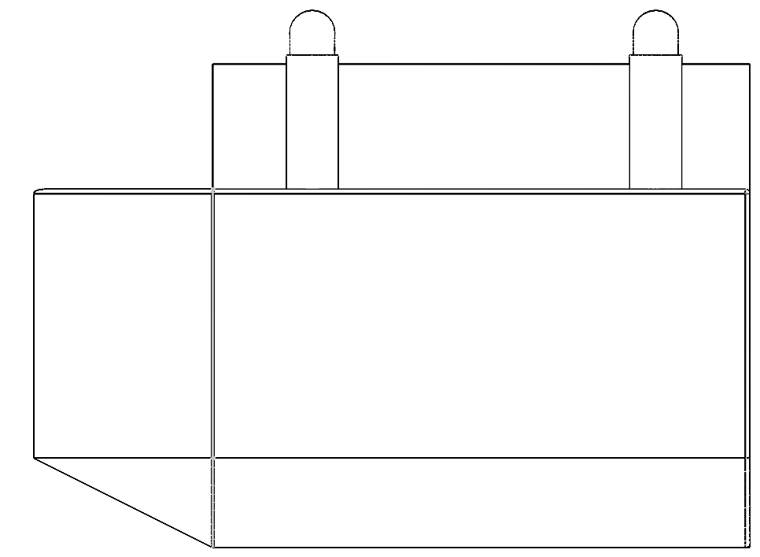

**0.109 meters**

Figure 18 Height of Un-Displaced Pontoon.

Mass and Floating Properties:

There are several varying materials used in boat components. However, due to lack of viable options in SolidWorks and Inventor, some materials had to change in order to be compatible with the design. The new materials which were chosen are provided below:

|  |  |  |
| --- | --- | --- |
| Part | Material | Density (lbs-inch-3) |
| Base | Styrofoam | 0.001301 |
| Connecting tubes | PVC | 0.050578 |
| Container | Aluminum Plates + Mesh | 0.097544 |
| Top Mesh | Aluminum Plates + Mesh | 0.097543 |

1. New Material property

### Implementation of Subtask 4- Calculate the center of mass

Since the density of the Styrofoam is extremely low whereas the volume of the PVC parts are negligible, one can assume that the center of mass of the boat is the one of the container.

The distance between the center of mass of semicircle and the center of mass of the respective circle is the following:

.

One can calculate the x and z coordinates of the center of mass of the cone part as follows:

 

Where,



Hence,

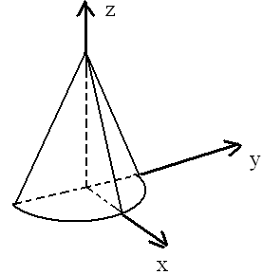

Figure 19 Center of Mass Cone

In the case of the semi-cylinder, the coordinates of the center of mass are the following:

m, , meters.

Since h<<0.1016 m, one can assume that the center of the mass of the part of the semi-cylinder that is not submerged has the coordinates m, m, and. Hence, for the coordinates of the center of mass of the submerged part of the cone, one can write the following:

,, and  where  and . Hence, m and m.

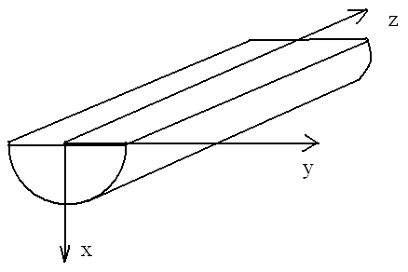

Figure 20 Half Cylinder COM

### Implementation of Subtask 2- Calculate the Center of Bouyancy

Assuming that the coordinate origin is chosen on the top edge of the bottom part as shown below, one can calculate the coordinates of the center of the buoyancy as follows:

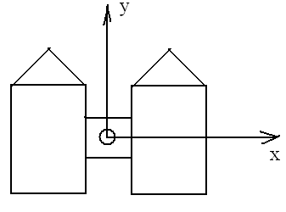

Figure 21 Center of Buoyancy

|  |  |  |  |  |  |
| --- | --- | --- | --- | --- | --- |
| Part | , cubic meters | , meters | , meters |  | , meters |
| Left semi-cone | 0.000931 | -0.1396 | 0.4295 |  | -0.0389 |
| Right semi-cone | 0.000931 | 0.1396 | 0.4295 |  | -0.0389 |
| Left semi-cylinder | 0.01043 | -0.1396 | 0 |  | -0.0475 |
| Right semi-cylinder | 0.01043 | 0.1396 | 0 |  | -0.0475 |
| Center of the buoyancy |  | 0 | 0.035203 |  | -0.0468 |
|  |  |  |  |  |  |

1. X, Y, Z coordinates

### Implementation of Subtask 5- Calculate Metacentric Height

The location of the center of mass (COM) and the center of buoyancy (COB) are shown below:

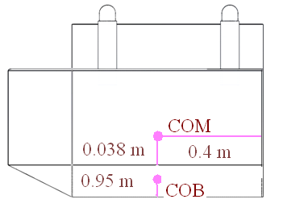

Figure 22 COM, COB

The metacentric radius is the distance between COB and the metacenter. It equals  where  is the second moment of area of the water plane section with respect to the y axis (see the illustration below). As for, it is the total water displacement and equals 0.0227 cubic meters. One can calculate the value of I as follows



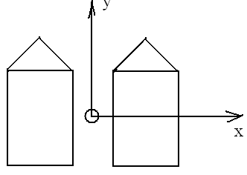

Figure 23 COB

Hence, the metacentric radius equals = 0.336 meters. Since the metacentric height is the distance between the metacenter and COM, it is equal to 0.251 m.

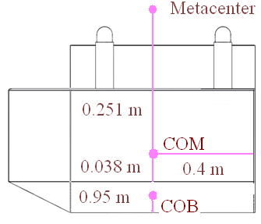

Figure 24 Metacenter

-

The moment due to the movement of the load equals  where  is the displacement of the load and M is the load mass. Since the load mass equals the one of the boat, the moment due to the shift of the center of mass equals . Hence, the displacement of the load s that corresponds to the tilt angle  has such the value . Thus, if  ranges from 0 to 15°, then the load displacement ranges from 0 m to 0.131 m.

### Implementation of Subtask 6- Stability of the boat

On Figure 1,, M, G, B, and  are respectively the angle of a heel, the metacenter, the center of gravity, the center of buoyance when , and the center of buoyance when the angle of a heel equals . The stability curve is the plot of the dependence  (see Figure 1). For small values of, one can assert that. For this scenario,.

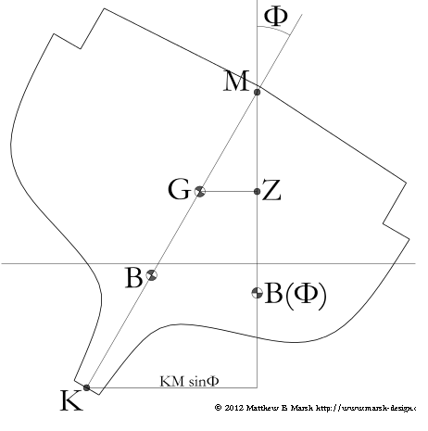

Figure 25 Stability of ship

## Implementation of Task 5 - Fluid dynamics

Once the hydrostatic evaluation of the design is completed, the next step is to move on to finding out the Drag and Lift forces that will be applied to the design while moving at the velocity of 5mph.

This will compute the fluid dynamics of the design.

### Implementation of Subtask 1- Calculate drag

Because the velocity is very slight, the flow is the creeping flow type. Therefore, one can assert that the shape of the boat is streamlined. Hence, the pressure drag vanishes. As for the viscous drag, one usually ignores it when calculating the speed of the boat. Hence, the drag force equals zero.

On Figure 2, the hydrodynamic side force is the lift. From Figure 2, it follows that under the condition of the zero drag, the directions of the apprent wind and the true one coinside and are opposite to the boat course. Hence, from the symmetry considerations, it follows that the lift equals 0 too.

### Implementation of Subtask 1- Calculate lift

Because evaluating drag and lift force is an important part of designing a marine vessel, Solidworks was utilized to evaluate drag and lift forces.

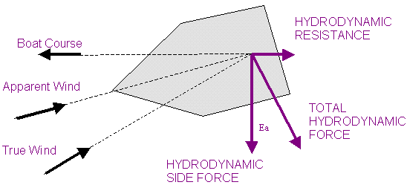

Figure 26 Resistance in Boat

## Implementation of Task 6- CAD Simulation

### Implementation of Subtask 1- Flow Analysis

According to SolidWorks, “SOLIDWORKS Flow Simulation. Engineering Fluid Dynamics (EFD) is a new breed of Computational Fluid Dynamics (CFD) software that enables mechanical engineers to simulate fluid flow and heat transfer applications with powerful, intuitive, and accessible 3D tools.”

### Implementation of Subtask 2- FEA Stress analysis

Stress analysis helps compute a virtual design’s structural analysis. It is used to find the product’s real world physical behavior. Initially, the plan was to utilize only one computer aided design software in order to demonstrate both FEA and flow simulation. The software immediately accessible was SolidWorks, and the outdated 2012 version at first was the only software available for use. Ultimately, however, it was determined necessary to upgrade the software to the 2017 version of SolidWorks. Designing the vessel in SolidWorks was simple but time consuming. A primary issue was that many of the systems used to run the software could not handle the memory usage. After approximately one month of attempts through trial and error, the flow simulation was able to be successfully run.

Setting up Flow Simulation:

All flow simulation steps used for this project are as follows:

1: Cut Section and Set-Up Wizard:

The first step is to cut the vessel assembly directly on the computed waterline. This assists in not only lowering the run time, but it also helps ensure that focus is maintained on only the submerged parts of the vessel.

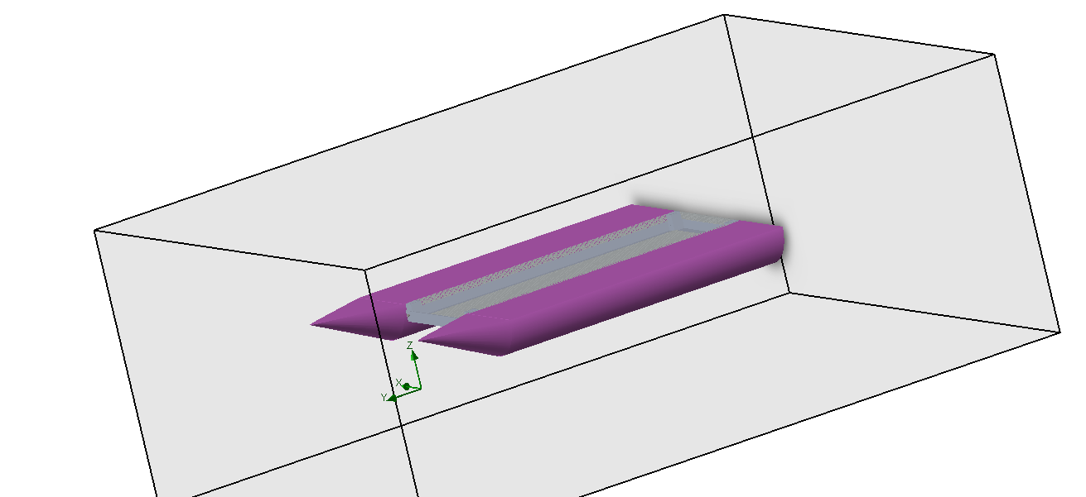

Figure 27 Displaced Part of Vessel

After the body is cut at the water line, the next step is to set-up the wizard for flow simulation. While setting up the wizard, any kind of liquids and/or gases that are present in the library can be applied. The velocity of the vessel at which it will be moving under water is also applied during the Set-Up Wizard.

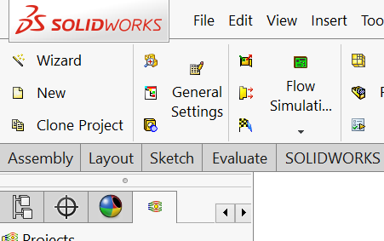

Figure 28 Setting up Wizard

**Project Setup:**

Once the SolidWorks flow simulation wizard is completed, the next step is to focus on the project settings. Project settings include computational domain set-up, fluid subdomain set-up, boundary conditions set-up, goals set-up, and, lastly, mesh setup:

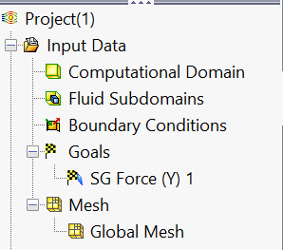

Figure 29 Project Setup Menu

After the setup of the computational domain is completed, which includes all the cut-through body submerged, the next step is to provide this project with its unique boundary conditions, such as buoyancy, force, etc. These values were calculated previously, as detailed above.

Next, the goal is to find all forces on the conic face of the vessel; this is the drag force, which is being applied to the front of the vessel while it moves at 5 miles per hour.

With all of the conditions set, the simulation was run and the results are as follows:

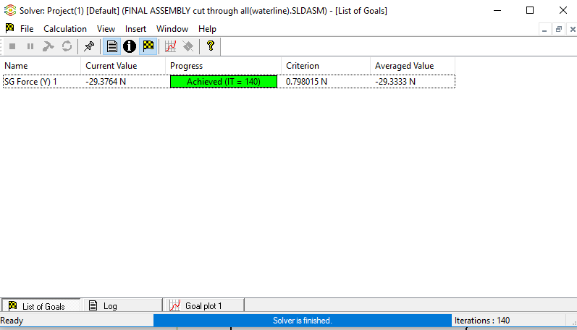

Figure 30 Drag Force

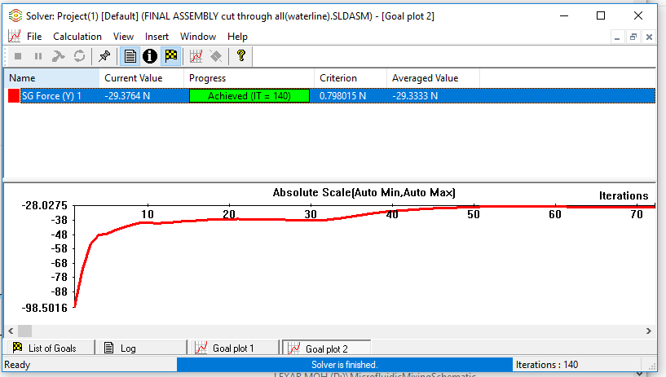

Figure 31 Flow Analysis Iteration Chart

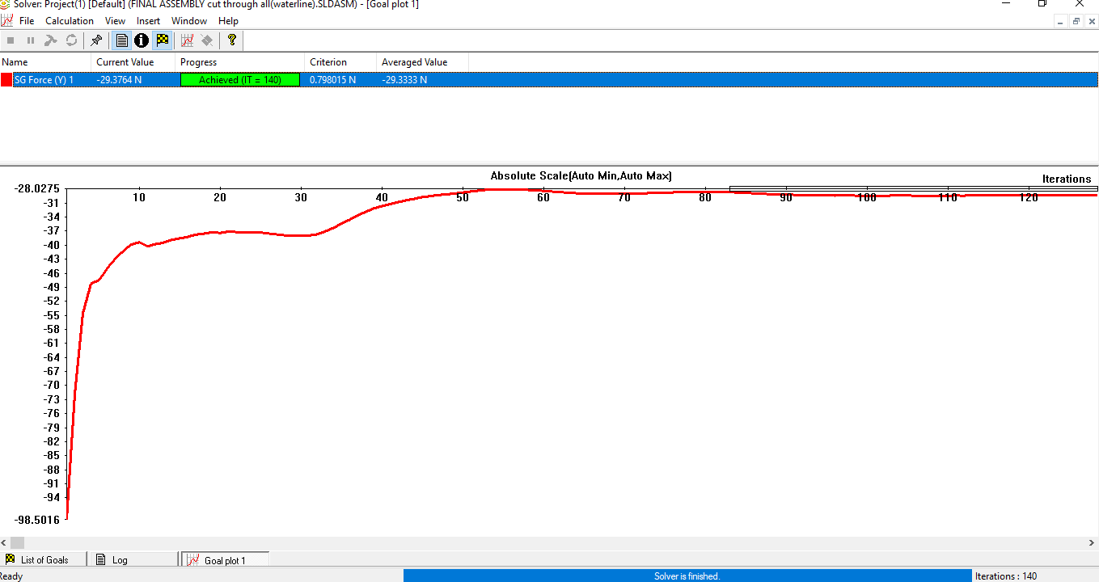

Figure 32 Absolute Max

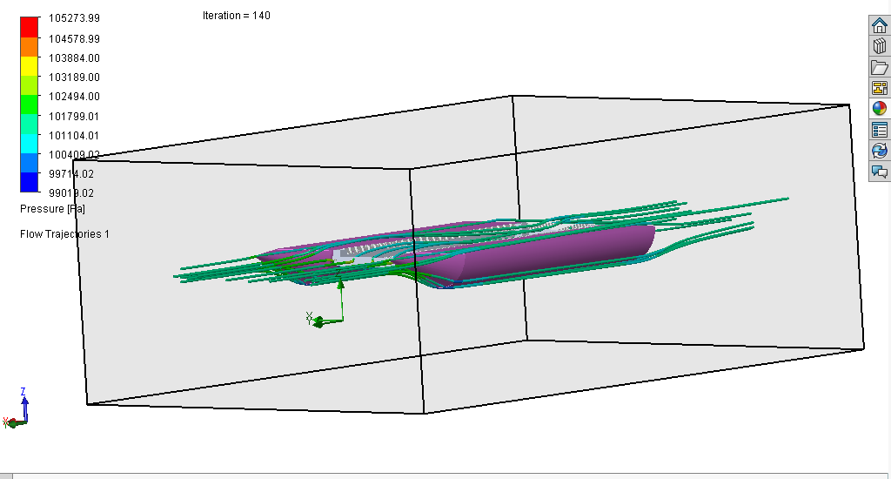

Figure 33 Water Flow around Vessel

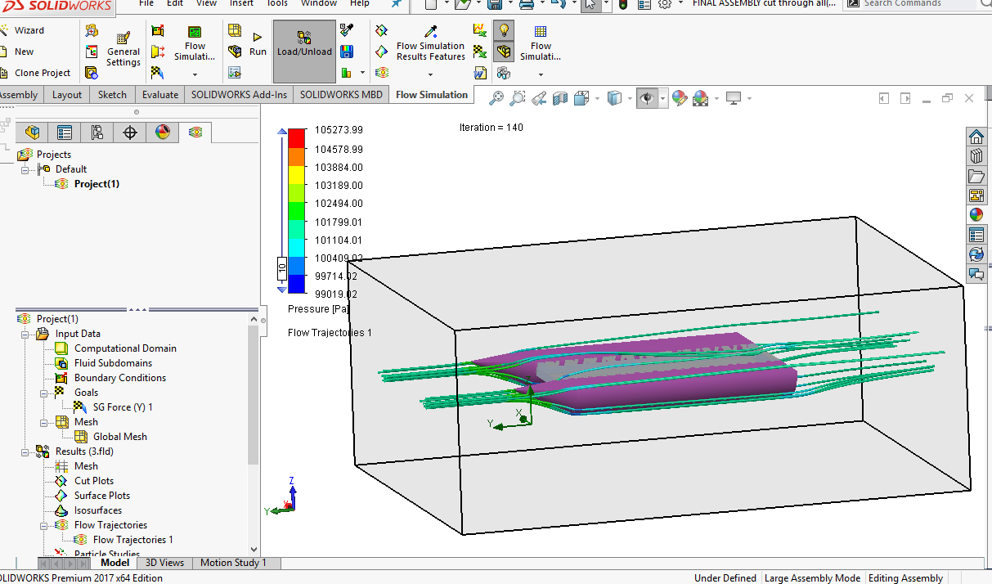

Figure 34 Flow trajectories

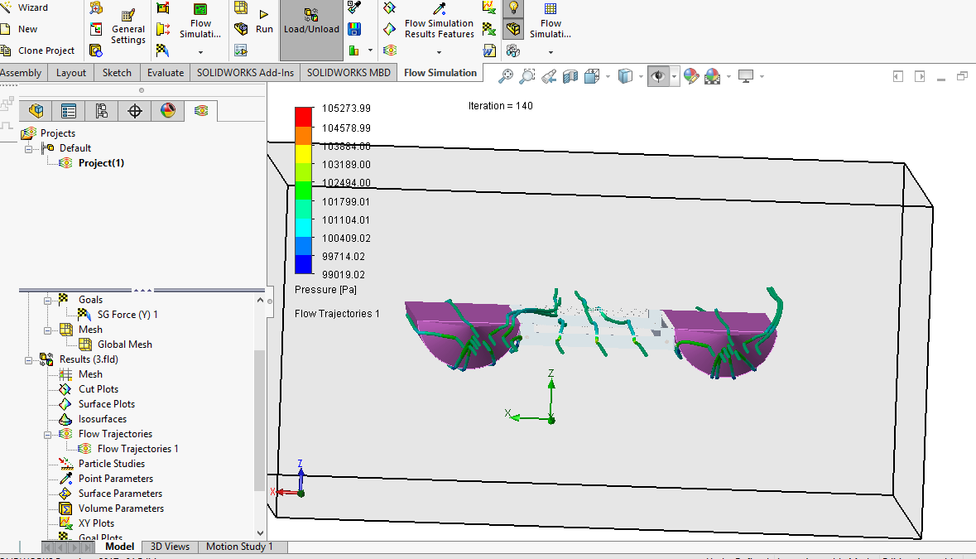

Figure 35 Flow trajectory 2

**Results:**

Through this flow simulation, the flow of water was able to be seen through the vessel itself. In addition, the drag force was able to be determined, which is about 29.37 N. This value will further assist in running the stress analysis. Drag force will also be used to in order to identify the motor and power required to overcome this force.

**FEA analysis:**

Similar to flow simulation, FEA analysis originally was intended to be completed using SolidWorks. However, after many failed attempts due to software crashes, the decision was made to use Inventor instead of SolidWorks. Inventor meshes the product itself.

The primary issue identified with the vessel itself is the aluminum mesh that surrounds the collection chamber. Because the system is advanced, two different simulations were determined necessary to run: one without the collection chamber and one with the chamber. In addition, the wooden blocks that are supposed to hold the PVC together cannot be identified in Inventor, so silicon with same weight was substituted for purposes of the simulation.

The forces that are applied in this case are the following:

1: Drag Force

2: Weight of electronics and cargo

3: Buoyant force

The results showed only one failure point and that failure point was due to the temperature change in the silicon that was used. The silicon melted and the PVC Pipe pulled itself out of the coupling. In the actual vessel, oak blocks are being utilized instead of silicone, eliminating this issue. As noted above, the silicon was only substituted for purposes of identification in Inventor. Also, an epoxy will be utilized to hold the system together, further eliminating this issue. Epoxy and fixing options are not found in Inventor, hence the issues.

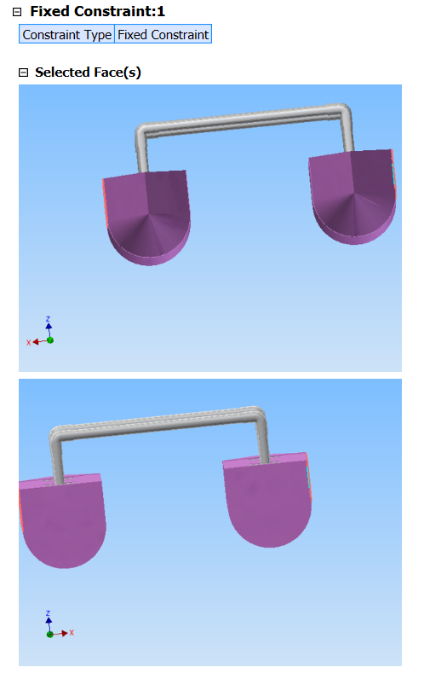

Figure 36 Fixed Constraints

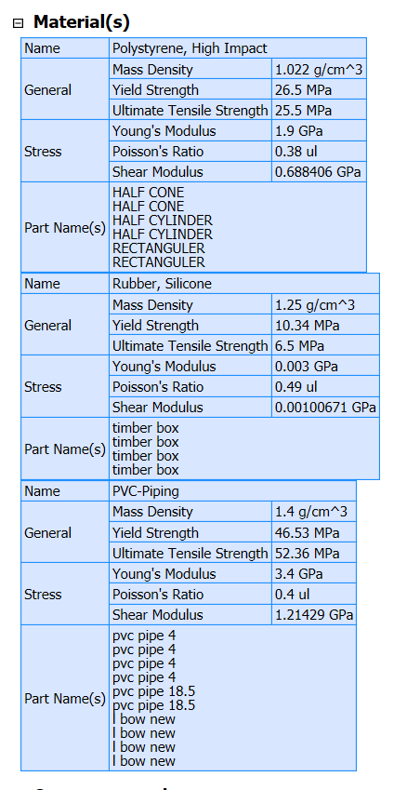

Figure 37 Materials

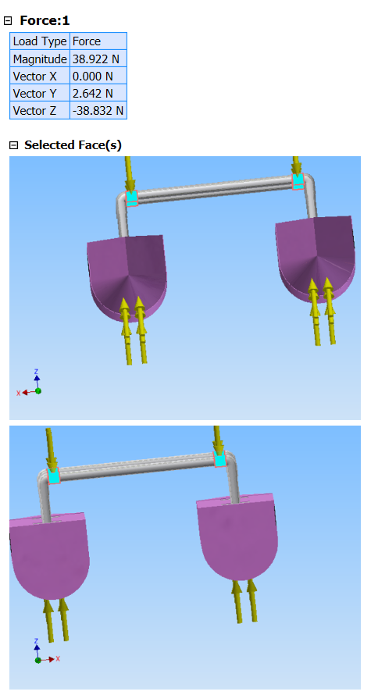

Figure 38 Forces

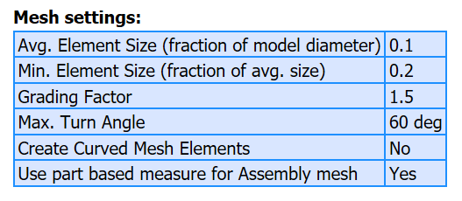

Figure 39 Mesh Settings

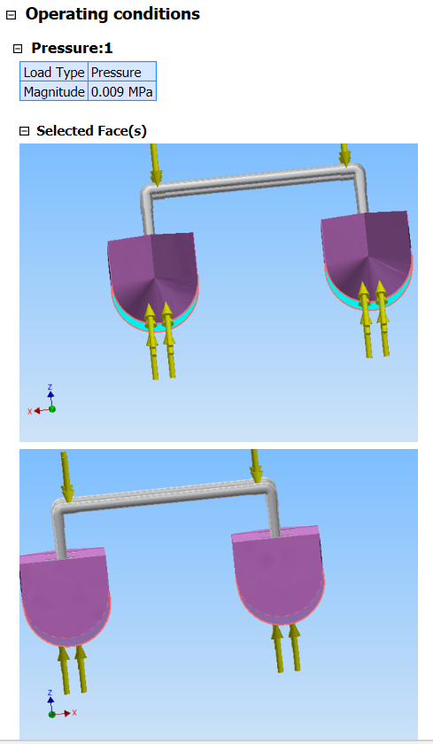

Figure 40 Pressure

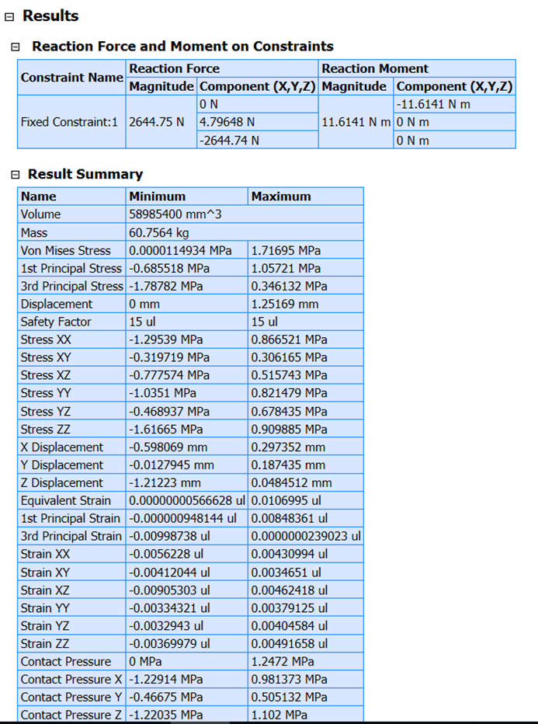

1. Result Summary

Stress analysis (Whole System)

The last step is to run stress analysis on the entire system and apply all the materials and fixtures using This sentence isn’t completed …

1. Physical

|  |  |
| --- | --- |
| Mass | 65.3553 kg |
| Area | 4.78583 m^2 |
| Volume | 0.0635279 m^3 |
| Center of Gravity | x=-0.0866133 m y=-0.353545 m z=0.21317 m |

1. Physical properties

Note: Physical values could be different from the physical values used by FEA as reported below.

1. Static Analysis:1

General objective and settings:

|  |  |
| --- | --- |
| Design Objective | Single Point |
| Study Type | Static Analysis |
| Last Modification Date | 11/27/2018, 6:59 PM |
| Detect and Eliminate Rigid Body Modes | No |
| Separate Stresses Across Contact Surfaces | No |
| Motion Loads Analysis | No |

1. General objective

Mesh settings:

|  |  |
| --- | --- |
| Avg. Element Size (fraction of model diameter) | 0.1 |
| Min. Element Size (fraction of avg. size) | 0.2 |
| Grading Factor | 1.5 |
| Max. Turn Angle | 60 deg |
| Create Curved Mesh Elements | No |
| Use part based measure for Assembly mesh | Yes |

1. Mesh settings

 Material(s)

|  |  |  |
| --- | --- | --- |
| Name | Polystyrene, High Impact | |
| General | Mass Density | 1.022 g/cm^3 |
| Yield Strength | 26.5 MPa |
| Ultimate Tensile Strength | 25.5 MPa |
| Stress | Young's Modulus | 1.9 GPa |
| Poisson's Ratio | 0.38 ul |
| Shear Modulus | 0.688406 GPa |
| Part Name(s) | HALF CONE HALF CONE HALF CYLINDER HALF CYLINDER RECTANGULER RECTANGULER | |

|  |  |  |
| --- | --- | --- |
| Name | PPS Plastic | |
| General | Mass Density | 1.637 g/cm^3 |
| Yield Strength | 68.9 MPa |
| Ultimate Tensile Strength | 82.7 MPa |
| Stress | Young's Modulus | 2.7 GPa |
| Poisson's Ratio | 0.4 ul |
| Shear Modulus | 0.964286 GPa |
| Part Name(s) | timber box timber box timber box timber box electric box | |

|  |  |  |
| --- | --- | --- |
| Name | PVC-PiPing | |
| General | Mass Density | 1.4 g/cm^3 |
| Yield Strength | 46.53 MPa |
| Ultimate Tensile Strength | 52.36 MPa |
| Stress | Young's Modulus | 3.4 GPa |
| Poisson's Ratio | 0.4 ul |
| Shear Modulus | 1.21429 GPa |
| Part Name(s) | pvc Pipe 4 pvc Pipe 4 pvc Pipe 4 pvc Pipe 4 pvc Pipe 18.5 pvc Pipe 18.5 l bow new l bow new l bow new l bow new | |

|  |  |  |
| --- | --- | --- |
| Name | Aluminum 6061 | |
| General | Mass Density | 2.7 g/cm^3 |
| Yield Strength | 275 MPa |
| Ultimate Tensile Strength | 310 MPa |
| Stress | Young's Modulus | 68.9 GPa |
| Poisson's Ratio | 0.33 ul |
| Shear Modulus | 25.9023 GPa |
| Part Name(s) | part middle case all aluminum | |

1. Materials

Operating conditions

Pressure:1

|  |  |
| --- | --- |
| Load Type | Pressure |
| Magnitude | 0.009 MPa |

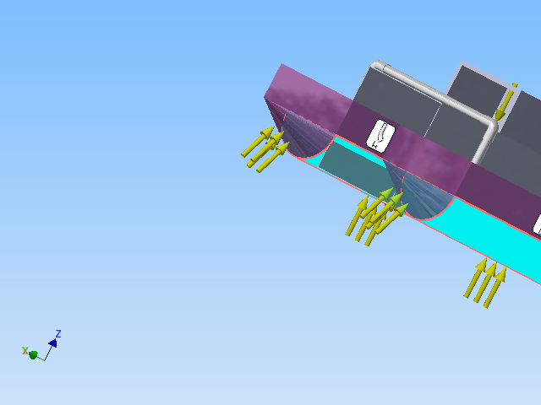

Figure 41 Selected Faces

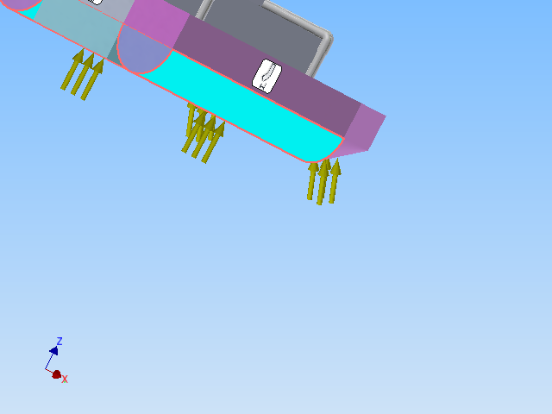 Pressure:2

|  |  |
| --- | --- |
| Load Type | Pressure |
| Magnitude | 0.001 MPa |

 Selected Face(s)

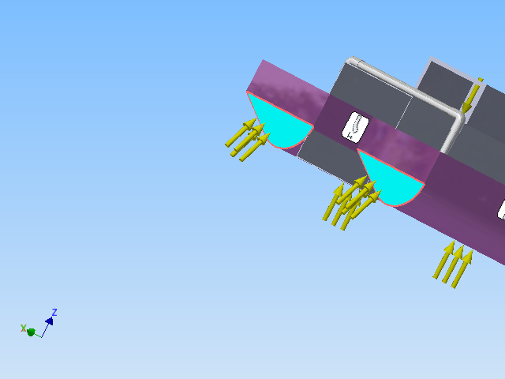

Figure 42 Pressure 2

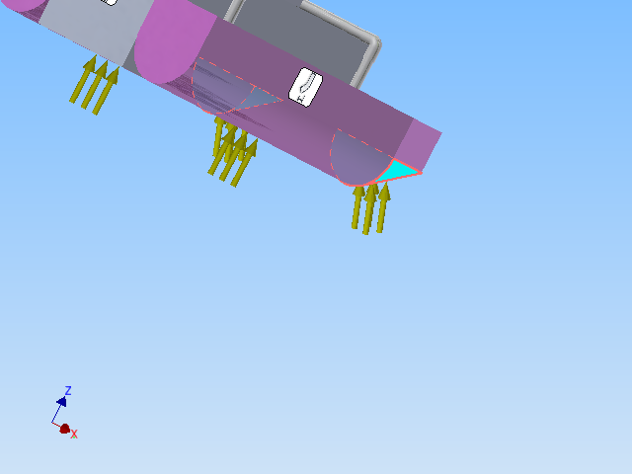

1. Pressuer 2

 Force:1

|  |  |
| --- | --- |
| Load Type | Force |
| Magnitude | 44.480 N |
| Vector X | 0.000 N |
| Vector Y | 0.000 N |
| Vector Z | -44.480 N |

1. Force 1

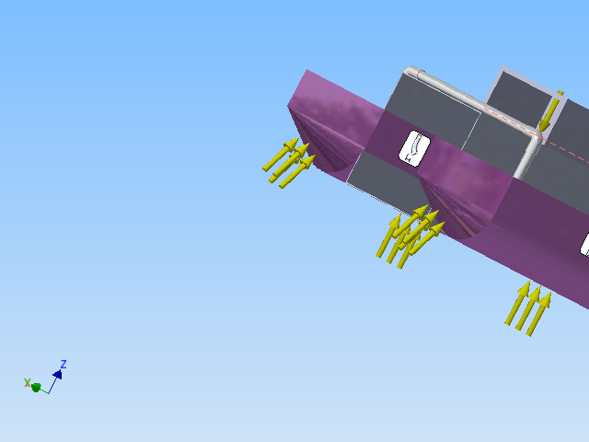

1. Force 1

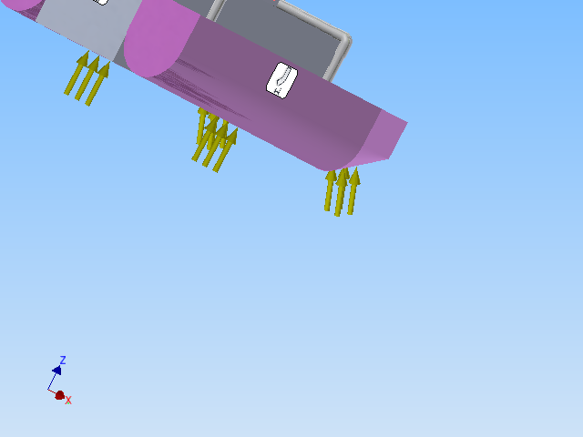

1. Force 1

|  |  |
| --- | --- |
| Load Type | Force |
| Magnitude | 111.207 N |
| Vector X | 0.000 N |
| Vector Y | -0.000 N |
| Vector Z | -111.207 N |

1. Force 2

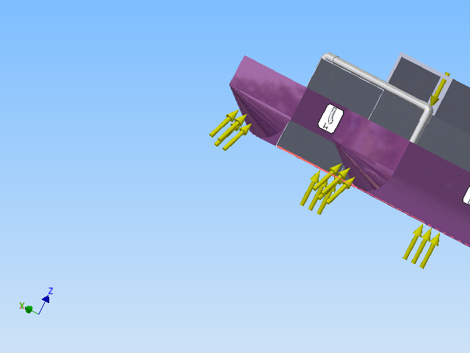

1. Selected faces

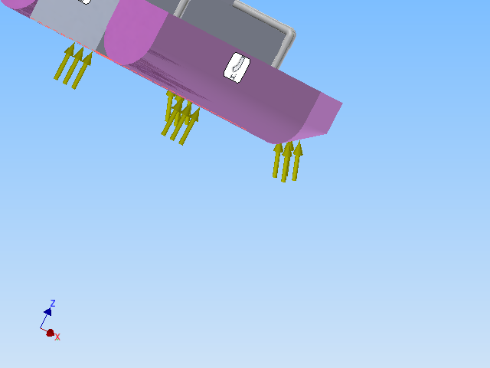

1. Force 2

|  |  |
| --- | --- |
| Constraint Type | Fixed Constraint |

Selected Face(s)

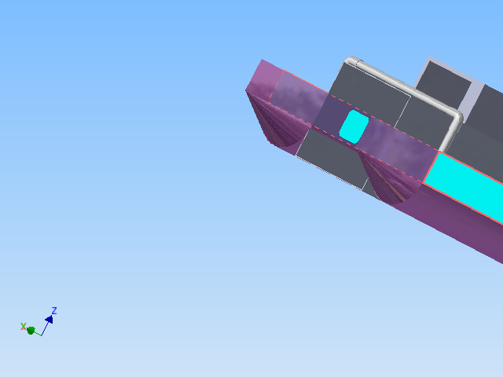

1. Selected faces

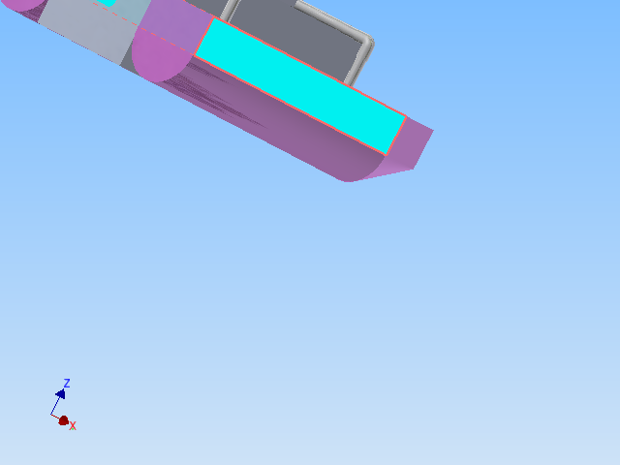

1. Selected faces fixture

Contacts (Bonded)

|  |  |
| --- | --- |
| Name | Part Name(s) |
| Bonded:1 | RECTANGULER:2 timber box:4 |
| Bonded:2 | RECTANGULER:1 timber box:1 |
| Bonded:3 | RECTANGULER:1 timber box:1 |
| Bonded:4 | RECTANGULER:2 timber box:4 |
| Bonded:5 | RECTANGULER:1 timber box:1 |
| Bonded:6 | RECTANGULER:2 timber box:4 |
| Bonded:7 | RECTANGULER:2 timber box:4 |
| Bonded:8 | RECTANGULER:1 timber box:1 |
| Bonded:9 | RECTANGULER:1 timber box:1 |
| Bonded:10 | RECTANGULER:2 timber box:4 |
| Bonded:11 | RECTANGULER:1 timber box:2 |
| Bonded:12 | RECTANGULER:2 timber box:3 |
| Bonded:13 | RECTANGULER:2 timber box:3 |
| Bonded:14 | RECTANGULER:1 timber box:2 |
| Bonded:15 | RECTANGULER:1 timber box:2 |
| Bonded:16 | RECTANGULER:2 timber box:3 |
| Bonded:17 | timber box:1 pvc Pipe 4:3 |
| Bonded:18 | RECTANGULER:1 timber box:2 |
| Bonded:19 | RECTANGULER:2 timber box:3 |
| Bonded:20 | timber box:2 pvc Pipe 4:2 |
| Bonded:21 | timber box:3 pvc Pipe 4:4 |
| Bonded:22 | timber box:4 pvc Pipe 4:1 |
| Bonded:23 | timber box:1 pvc Pipe 4:3 |
| Bonded:24 | RECTANGULER:1 timber box:2 |
| Bonded:25 | RECTANGULER:2 timber box:3 |
| Bonded:26 | timber box:2 pvc Pipe 4:2 |
| Bonded:27 | timber box:3 pvc Pipe 4:4 |
| Bonded:28 | timber box:4 pvc Pipe 4:1 |
| Bonded:29 | pvc Pipe 4:2 l bow new:2 |
| Bonded:30 | pvc Pipe 4:3 l bow new:4 |
| Bonded:31 | pvc Pipe 4:4 l bow new:1 |
| Bonded:32 | pvc Pipe 18.5:2 l bow new:3 |
| Bonded:33 | RECTANGULER:1 part middle case all aluminum:1 |
| Bonded:34 | part middle case all aluminum:1 electric box:1 |
| Bonded:35 | pvc Pipe 4:1 l bow new:3 |
| Bonded:36 | pvc Pipe 18.5:1 l bow new:1 |
| Bonded:37 | HALF CONE:2 RECTANGULER:1 |
| Bonded:38 | HALF CONE:1 RECTANGULER:2 |
| Bonded:39 | HALF CONE:1 HALF CYLINDER:1 |
| Bonded:40 | HALF CONE:2 HALF CYLINDER:2 |
| Bonded:41 | HALF CYLINDER:2 RECTANGULER:1 |
| Bonded:42 | HALF CYLINDER:1 RECTANGULER:2 |
| Bonded:43 | HALF CYLINDER:2 part middle case all aluminum:1 |
| Bonded:44 | HALF CYLINDER:1 part middle case all aluminum:1 |
| Bonded:45 | RECTANGULER:2 part middle case all aluminum:1 |

1. Bonds

Results

Reaction Force and Moment on Constraints

|  |  |  |  |  |
| --- | --- | --- | --- | --- |
| Constraint Name | Reaction Force | | Reaction Moment | |
| Magnitude | Component (X,Y,Z) | Magnitude | Component (X,Y,Z) |
| Fixed Constraint:1 | 2527.93 N | 0 N | 11.6762 N m | -11.6762 N m |
| 14.9663 N | 0 N m |
| -2527.89 N | 0 N m |

1. Reaction Forces

Result Summary

|  |  |  |
| --- | --- | --- |
| Name | Minimum | Maximum |
| Volume | 63527900 mm^3 | |
| Mass | 71.4218 kg | |
| Von Mises Stress | 0.00000066323 MPa | 3.333 MPa |
| 1st Principal Stress | -0.840666 MPa | 2.82522 MPa |
| 3rd Principal Stress | -3.2432 MPa | 1.257 MPa |
| Displacement | 0 mm | 0.160998 mm |
| Safety Factor | 15 ul | 15 ul |
| Stress XX | -2.7084 MPa | 2.63936 MPa |
| Stress XY | -0.54475 MPa | 0.548962 MPa |
| Stress XZ | -1.4552 MPa | 1.3929 MPa |
| Stress YY | -1.09942 MPa | 1.25918 MPa |
| Stress YZ | -0.339979 MPa | 0.773526 MPa |
| Stress ZZ | -3.23762 MPa | 2.82242 MPa |
| X Displacement | -0.00946153 mm | 0.00953897 mm |
| Y Displacement | -0.00114884 mm | 0.0154656 mm |
| Z Displacement | -0.160998 mm | 0.018783 mm |
| Equivalent Strain | 0.00000000019701 ul | 0.0000436901 ul |
| 1st Principal Strain | -0.000000202602 ul | 0.0000369209 ul |
| 3rd Principal Strain | -0.0000454897 ul | 0.000000775057 ul |
| Strain XX | -0.0000354651 ul | 0.0000341433 ul |
| Strain XY | -0.0000172027 ul | 0.0000127968 ul |
| Strain XZ | -0.0000280902 ul | 0.0000268876 ul |
| Strain YY | -0.0000138316 ul | 0.0000134103 ul |
| Strain YZ | -0.00000656272 ul | 0.00001764 ul |
| Strain ZZ | -0.0000453819 ul | 0.0000367485 ul |
| Contact Pressure | 0 MPa | 1.05001 MPa |
| Contact Pressure X | -1.01768 MPa | 0.786651 MPa |
| Contact Pressure Y | -0.254685 MPa | 0.298772 MPa |
| Contact Pressure Z | -0.151817 MPa | 0.289182 MPa |

1. Results

Von Mises Stress

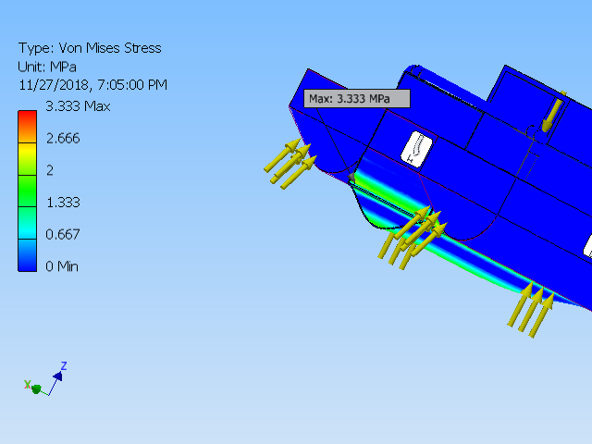

1. Von Mises Stress

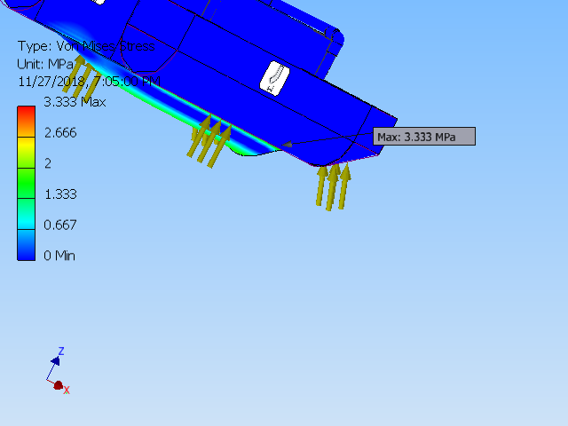

1. Min to Max Von mises stress

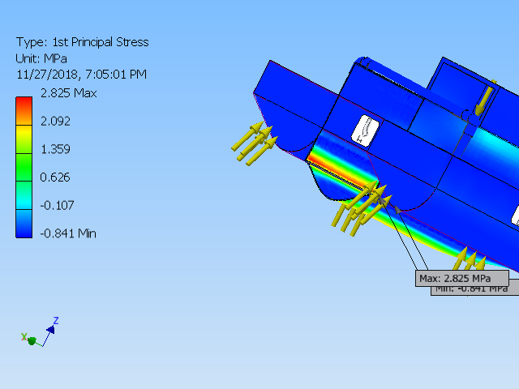

1. principle stress

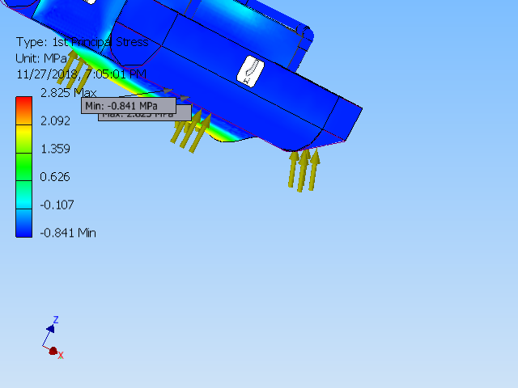

1. Max and Min principle stress

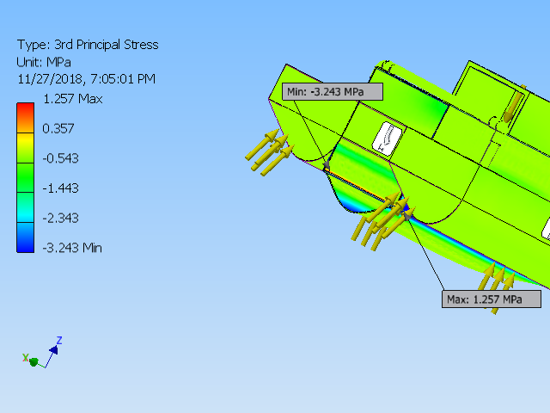

1. 3rd principle stress

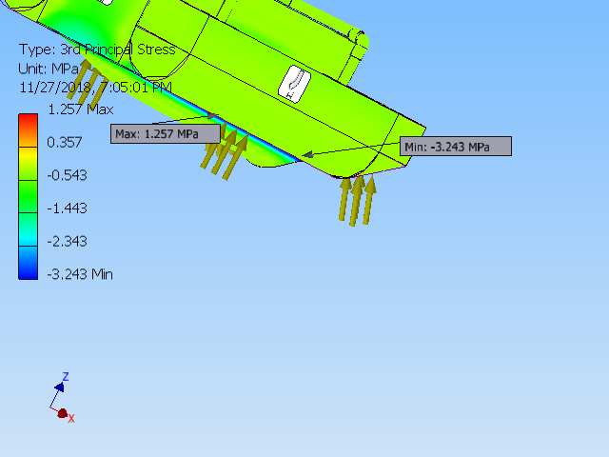

1. Displacement

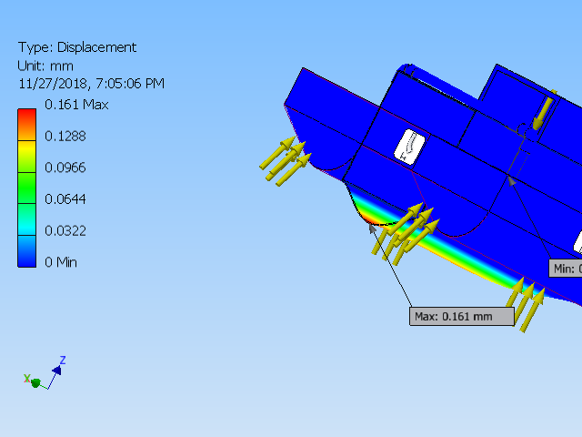

1. Max and Min Displacement

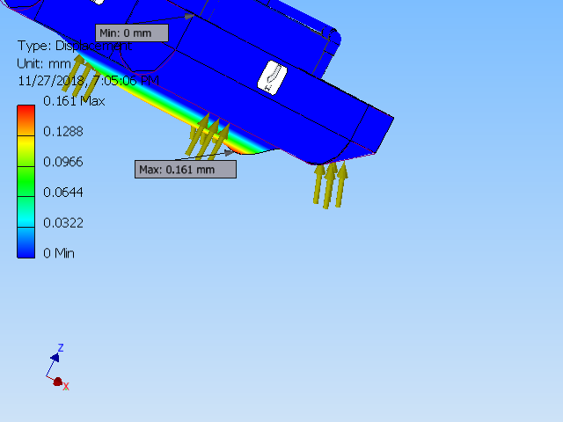

1. Displacement Max point

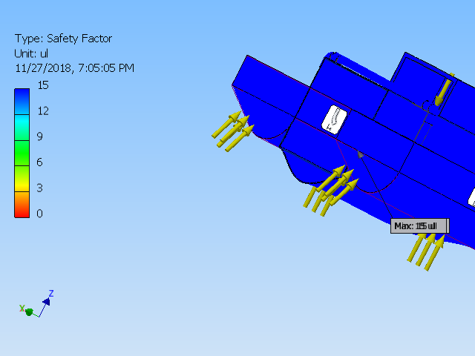

1. Safety Factor

## Implementation of Task 7- Building the Prototype

The last task for mechanical implementation was to build the prototype. The steps are as follows:

* Buying the parts:
* Shaping the pontoons
* Making the middle collection chamber:
* Applying paint to make it water-proof:

**For this step, the parts ordered were the following:**

* Pink foam
* aluminum square bars
* aluminum L bars
* aluminum mesh
* spray paint
* door hinge
* various nuts and bolts
* Pvc Pipes (schedule 40)
* PVC 90 couplings

Assembly:

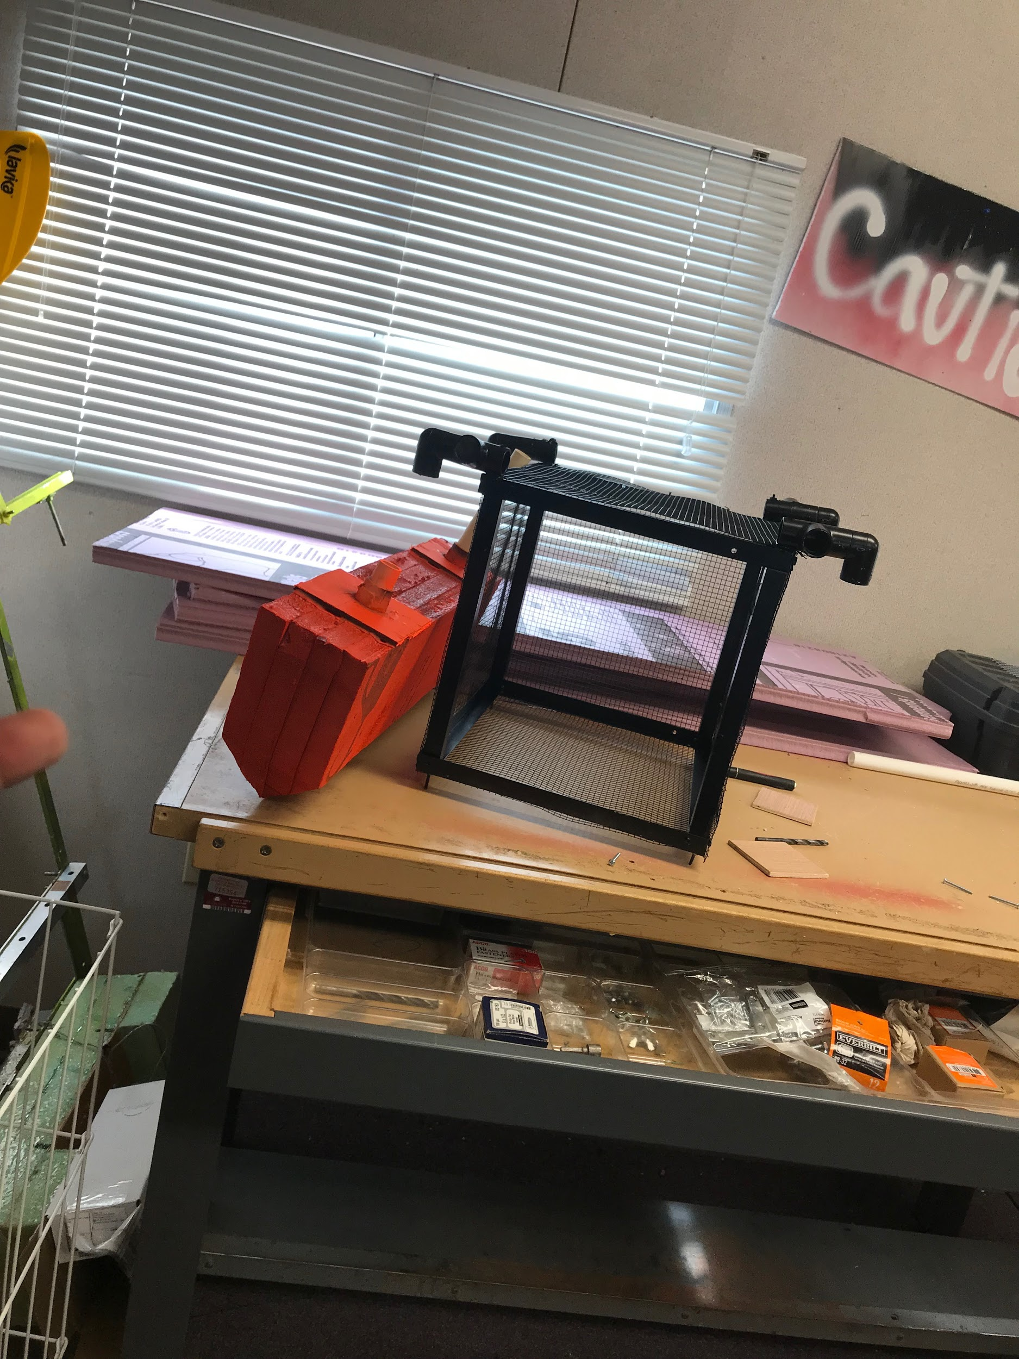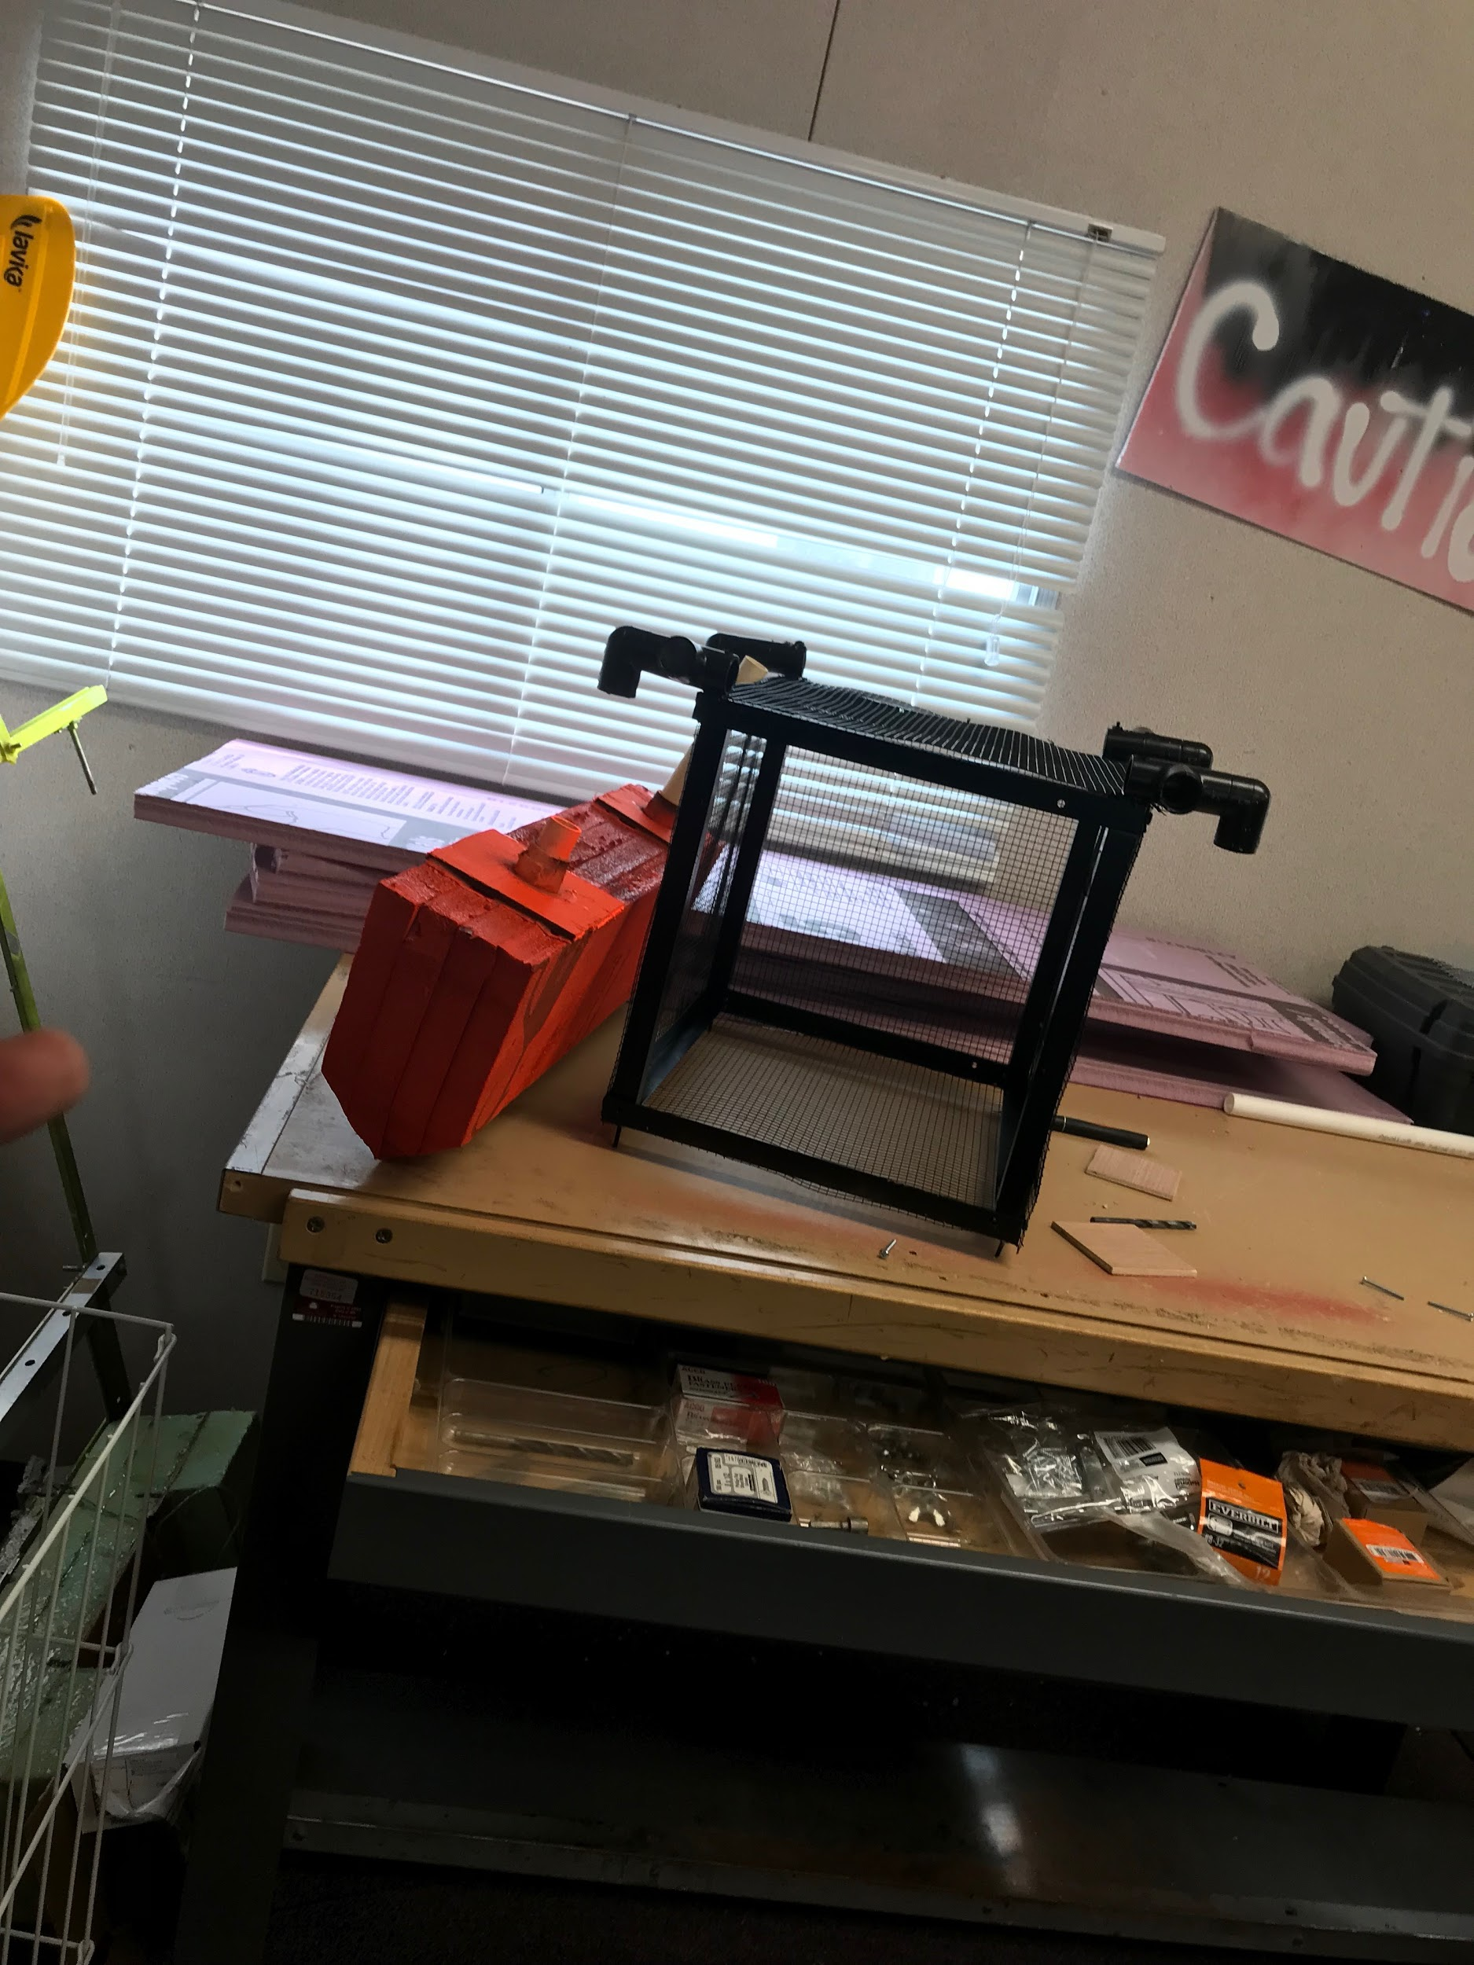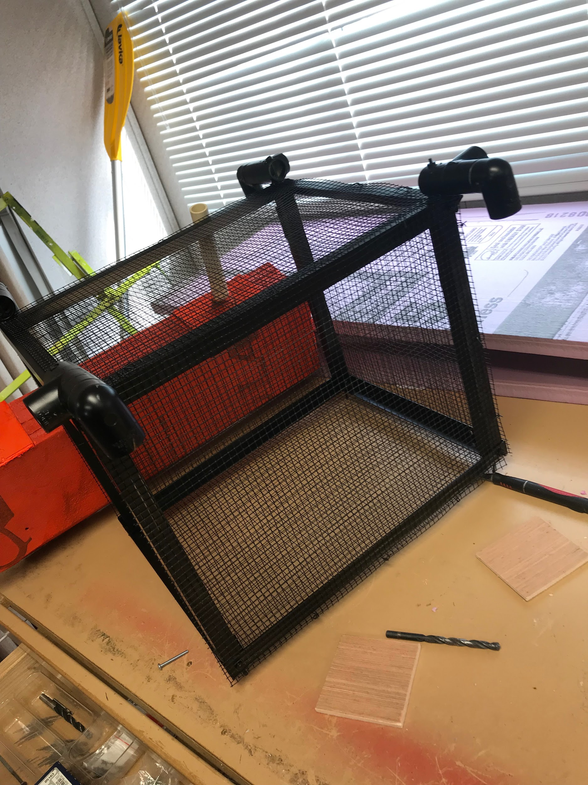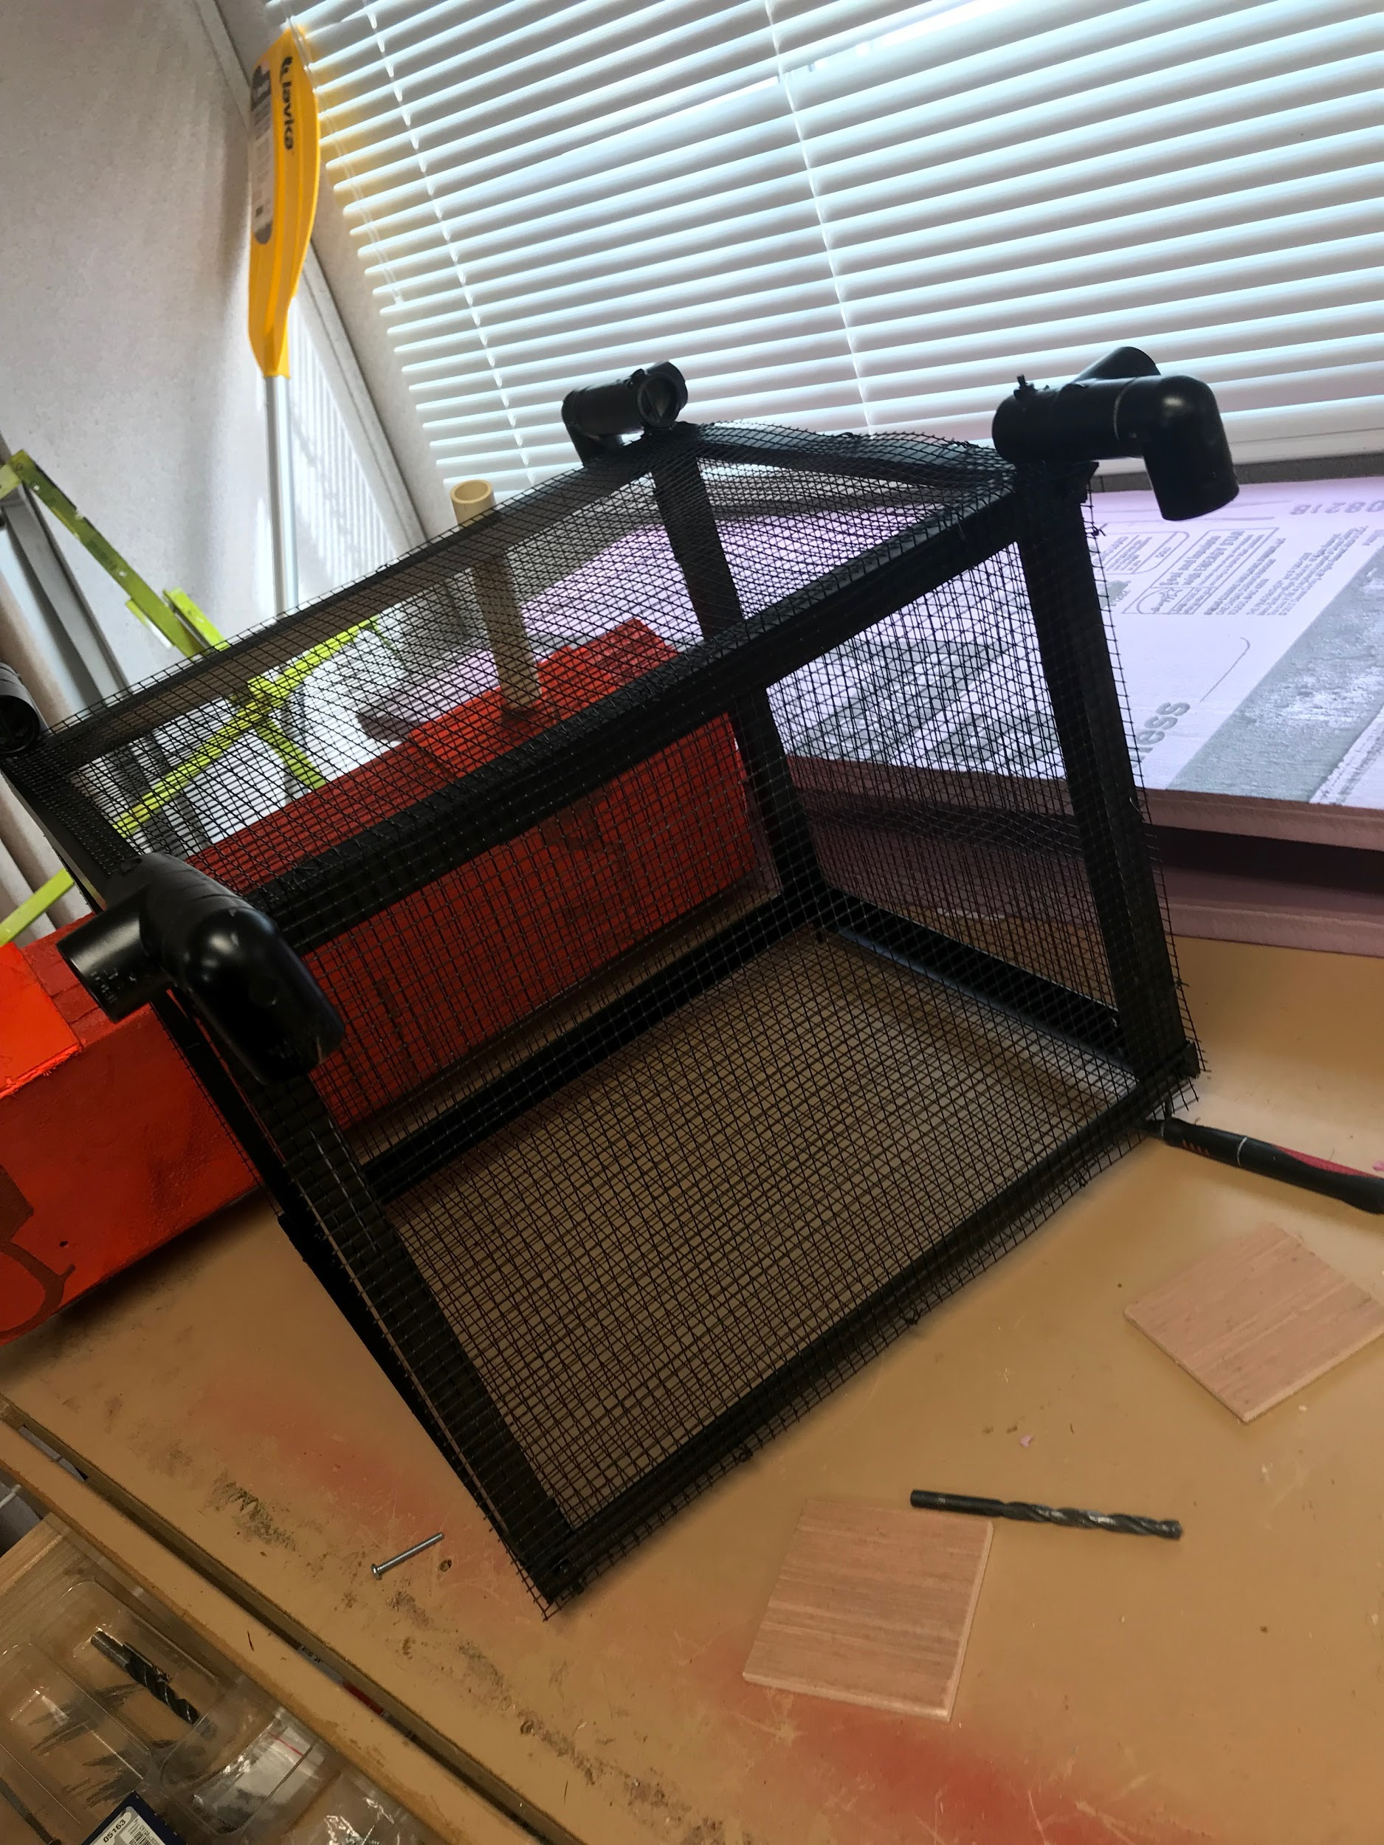

Fig 62. Diagrams of the Vessel

As seen in the images above, the middle collection chamber is painted black and it is enclosed by using aluminum mesh. There is also PVC couplings and Pipes that can be seen which connect the middle frame with the pontoons (colored red). Most of the time was spent in shaPing the pontoons, which is made of Pink foam. To make the vessel more secure, wooden plank Pieces were utilized to further secure the PV Pipes to the pontoons.

Power Calculation:

The power calculation is required in order to determine the motor and propeller for this vessel to achieve the velocity at the acceleration according to design requirements. For this calculation, the process is as follows:

1: Calculate acceleration first

2: Calculate thrust force required.

3: Calculate power based on thrust force.

4: Choose a propeller and calculate the RPM required based on speed and the radius of the prop.

4: Use the RPM and Power to find a motor.

1. Results:

Based on the thrust force required, the vessel was determined to require 80W power in order to successfully overcome drag force. Based on this information, the motor necessity could be determined and power analysis could be completed.

## Implementation of Task 8:

### Implementation of Subtask 1-Setting up the Image Recognition API

HARDWARE

Before utilizing an image recognition system, a platform must first be determined. Image recognition can be implemented on various operating systems and devices but due to the mobility of the boat and flexibility, the Raspberry Pi3 was determined to be the best option to meet the vessel’s needs. The model will be trained on a Windows operating system desktop computer, but the recognition will be implemented on the field with a Raspberry Pi3. Below are the list of deceives required:

* Raspberry Pi3
* Webcam / Pi cam
* Micro SD card {containing the Rasbian OS}
* A personal computer
* Portable Power Supply
* Wireless Wi-Fi dongle
* Mouse
* Keyboard

SOFTWARE

Certain steps and configurations have to be accomplished before the Raspberry Pi3 can be operational. These steps and configurations are listed and then explained comprehensively below:

* Update the Raspberry Pi3
* Install TensorFlow
* Install openCV
* ComPile and install Protobuf
* Set up Tensor flow directory Structure and the PYTHONPATH variable
* Test the system

1. Update the Raspberry Pi3

sudo apt-get update

sudo apt-get dist-upgrade

The first line command updates the Pi while the second line command upgrades the Pi. Note that “dist-upgrade” should be used instead of just “upgrade” in order to avoid errors in future coding operations. The time taken will vary based upon the version of Pi being used.

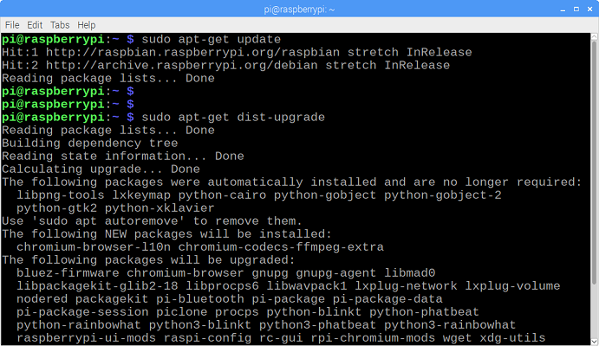

Figure 43 Pi Graphic Interface during Update

1. Install TensorFlow

Tensor flow is the optimizer and it is very important in the recognition process. To install TensorFlow, in the /home/Pi directory, create a folder called “tf”, which will be used to hold all of the installation files for TensorFlow.

mkdir tf

cd tf

wget <https://github.com/lhelontra/tensorflow-on-arm/releases/download/v1.8.0/tensorflow-1.8.0-cp35-none-linux_armv7l.whl>

install TensorFlow by issuing:

sudo Pip3 install /home/Pi/tf/tensorflow-1.8.0-cp35-none-linux_armv7l.whl

TensorFlow also needs the LibAtlas, Pillow, lxml, jupyter, matplotlib, cython packages

sudo apt-get install libatlas-base-dev

sudo Pip3 install Pillow lxml jupyter matplotlib cython

sudo apt-get install python-tk

1. Install OpenCV

In order to ensure that OpenCV works properly on the Raspberry Pi, there are quite a few dependencies that need to be installed through apt-get. If any of the following commands do not work, issue “sudo apt-get update” and then try again. Issue:

sudo apt-get install libjpeg-dev libtiff5-dev libjasper-dev libpng12-dev

sudo apt-get install libavcodec-dev libavformat-dev libswscale-dev libv4l-dev

sudo apt-get install libxvidcore-dev libx264-dev

sudo apt-get install qt4-dev-tools

Once those are all installed, install OpenCV. Issue:

Pip3 install opencv-python

1. ComPile and Install Protobuf

The TensorFlow object detection API uses Protobuf, a package that implements Google’s Protocol Buffer data format. First, obtain the packages necessary to comPile Protobuf from source. Issue:

sudo apt-get install autoconf automake libtool curl

Then download the protobuf release from its GitHub repository by issuing:

wget https://github.com/google/protobuf/releases/download/v3.5.1/protobuf-all-3.5.1.tar.gz

Configure the build by issuing the following command:

./configure

Build the package by issuing:

make

make check

make install

Export the library path:

cd python

export LD_LIBRARY_PATH=../src/.libs

Next, issue:

python3 setup.py build --cpp_implementation

python3 setup.py test --cpp_implementation

sudo python3 setup.py install --cpp_implementation

Then issue the following path commands:

export PROTOCOL_BUFFERS_PYTHON_IMPLEMENTATION=cpp

export PROTOCOL_BUFFERS_PYTHON_IMPLEMENTATION_VERSION=3

Finally, issue:

sudo ldconfig

Verify it is installed correctly by issuing the command below and making sure it puts out the default help text:

protoc

The Raspberry Pi needs to be restarted after this process, or TensorFlow will not work.

sudo reboot now

1. Set up TensorFlow Directory Structure and PYTHONPATH Variable

mkdir tensorflow1

cd tensorflow1

Download the tensorflow repository from GitHub by issuing:

git clone --recurse-submodules https://github.com/tensorflow/models.git

Next, modify the PYTHONPATH environment variable to point at some directories inside the TensorFlow repository downloaded

sudo nano ~/.baser

Move to the end of the file, and on the last line, add:

export PYTHONPATH=$PYTHONPATH:/home/Pi/tensorflow1/models/research:/home/Pi/tensorflow1/models/research/slim

Use Protoc to comPile the Protocol Buffer (.proto) files used by the Object Detection API. The .proto files are located in /research/object_detection/protos

cd /home/Pi/tensorflow1/models/research

protoc object_detection/protos/*.proto --python_out=.

This command converts all the "name".proto files to "name_pb2".py

cd /home/Pi/tensorflow1/models/research/object_detection

1. Test the System

The Raspberry Pi is ready to accept a trained CNN model in order to start recognition.

### Implementattion of Subtask2-Research on Convolution Neural Network

During the course of designing this bottle collection system, several different methods of making this machine intelligent in different ways were considered. For example, consideration was given to methods such as using a thermal camera, or by using a sonar sensor in identifying objects. Unfortunately, however, none of the methods considered were efficient enough to meet the vessel’s intended purpose; only the use of image recognition was determined suitable for the vessel’s needs. By implementing image recognition with the aid of artificial intelligence, the vessel will be able to identify specific objects which will then be collected, and avoid unwanted obstacles at the same time. Although a fairly complicated method of intelligent design, it is practical for the purpose of the vessel.

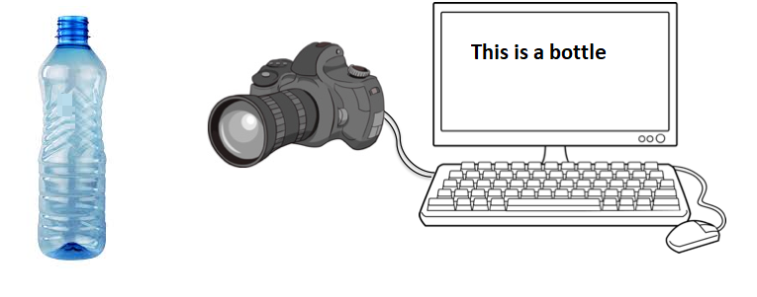

Figure 44 Overview

Implementing image recognition is a tremendous task in develoPing and testing machine learning approaches. Vision is debatably our most powerful sense and comes naturally to most humans. Image recognition can be implemented as either supervised learning or unsupervised learning. In light of this project’s well-define objective, supervised learning was determined appropriate. In supervised learning, the computer is supplied with a dataset of images and with a specified general process of how the computer should be able to evaluate the images. The system then will be able learn by working with a defined mathematical model which links the input image to the output model. With the use of Artificial Intelligence during the training stage, the system learns and corrects its parameters until a high degree of accuracy is established. The entire implementation results in an optimizing problem.

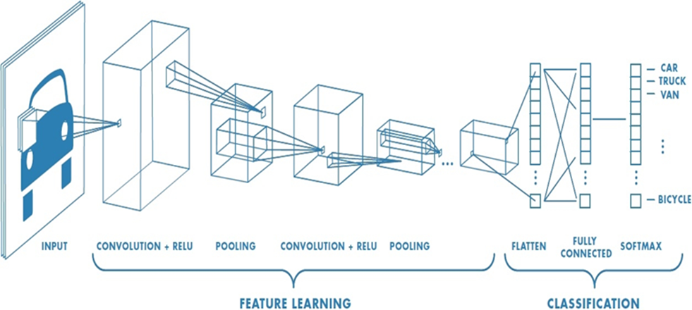

Figure 45 Pictorial Representation of CNN

In every CNN, there are two stages: the feature stage and the classification stage. At the classification stage, the input (Picture or video feeds broken down in frames) is converted to Pixel values. These values are passed through filters and these filters have specific values in matrix form which are convoluted with the Pixel values, and then the output is convoluted again with more filters. The more filters, parameters, and layers, the more precise the CNN tends to be. However, gaining more precision will also have affect the speed negatively. As such, when choosing a CNN, speed and accuracy also must be taken into consideration depending upon the use. Operations such as pooling and striding are employed to manipulate the size of the convolution matrix. The arrays of the parameters are aligned to form a single in the classification section then compared to the softmax.

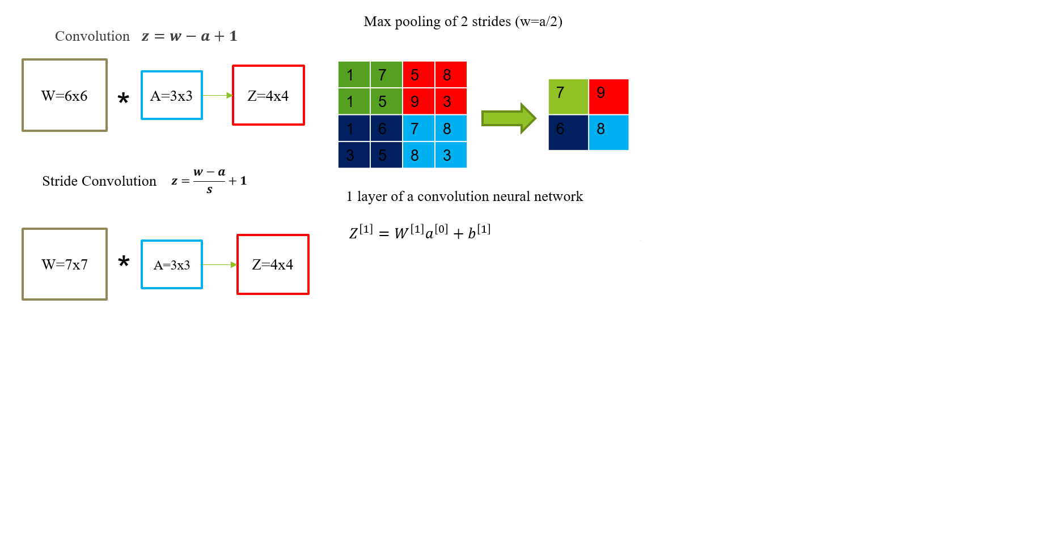

Figure 46 Neural Network Modification Methods

In order to develop or comprehend a CNN, some manipulations processes must be understood. These manipulations are used to move from one layer to another while refining the parameters in the feature learning stage. The diagram above, Figure 67, exhibits three of these manipulations.

Convolution is the method of combining the Pixel values and the filter. For every single convolution process, a patch is generated in the next layer*. $z=w-a+1$*  is the equation used to determine the matrix size of the output parameters.

Strided convolution is similar to plain convolution. It varies depending on the number of stride: the more the stride, the lesser the number of parameters in the matrices. Output matrix size can be derived by

$$z=\frac{w-a}{s}+1$$

Max pooling does not involve the use of a filter; it is a process of shrinking a matrix. Max pooling is implemented above in a stride of two. The max value is selected and that forms a patch in the output matrix.

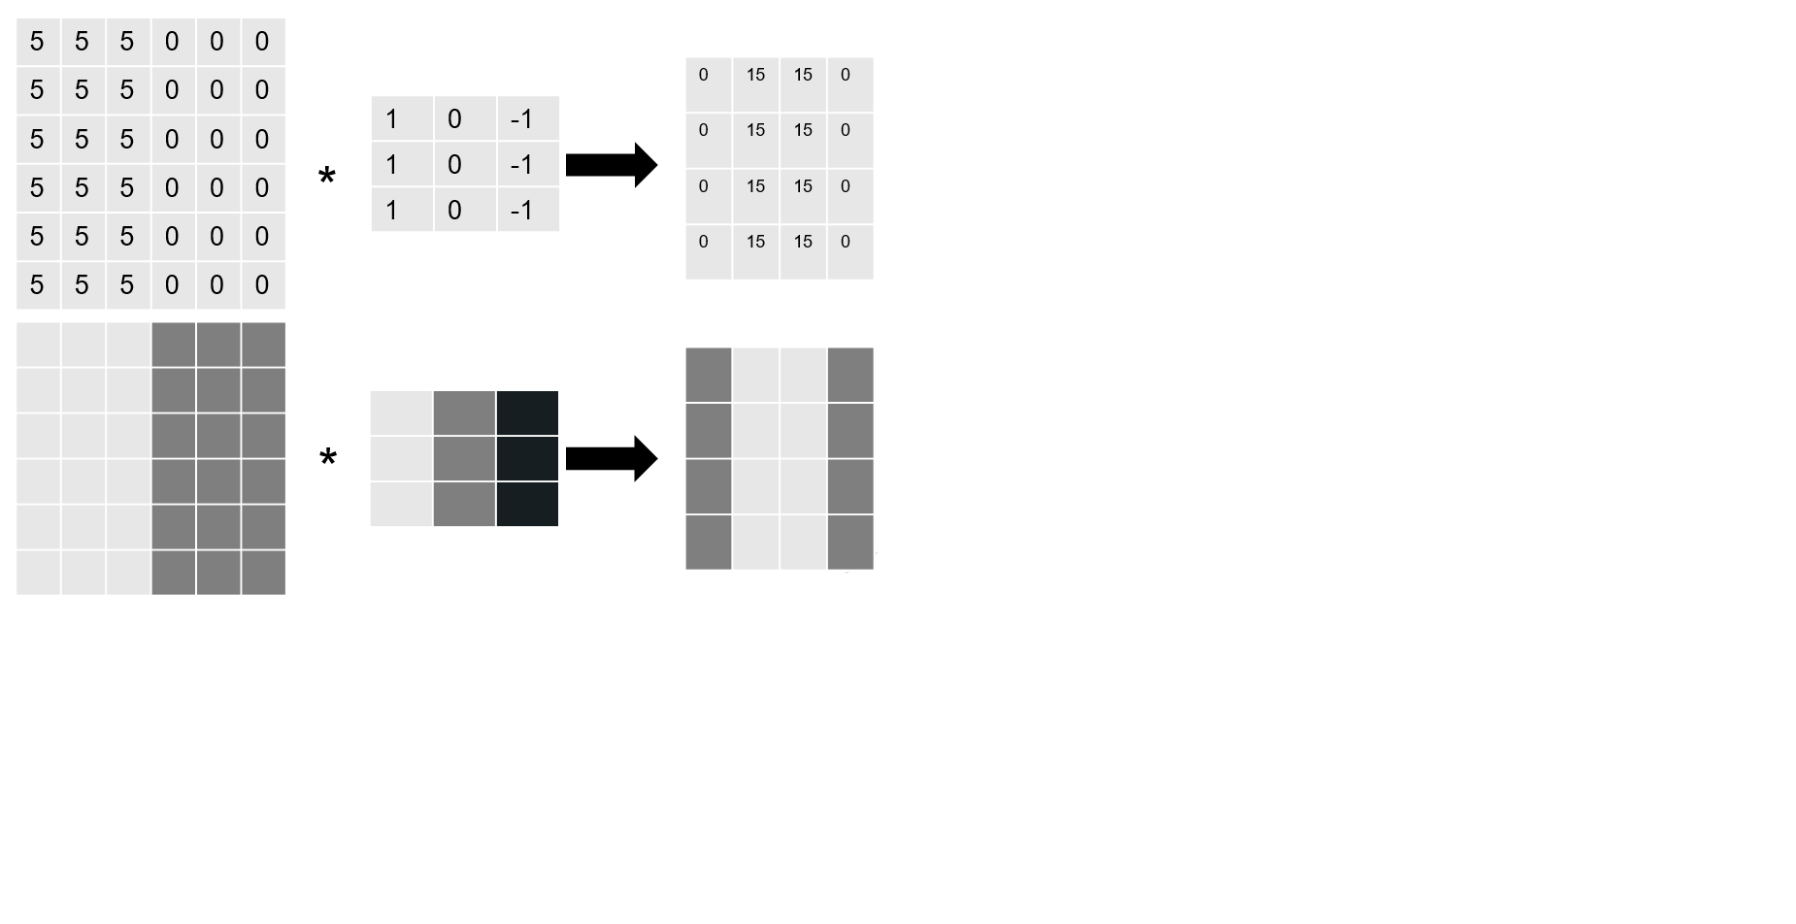

Figure 47 Edge Detection

The above diagram, Figure 68, is a Pictorial representation of how a vertical edge detection filter works. When a random Pixel value is convoluted with the filter above, it gives a specific pattern. If a clearly defined pattern as shown above is acquired where the light and dark regions are aligned, a vertical edge will be detected.

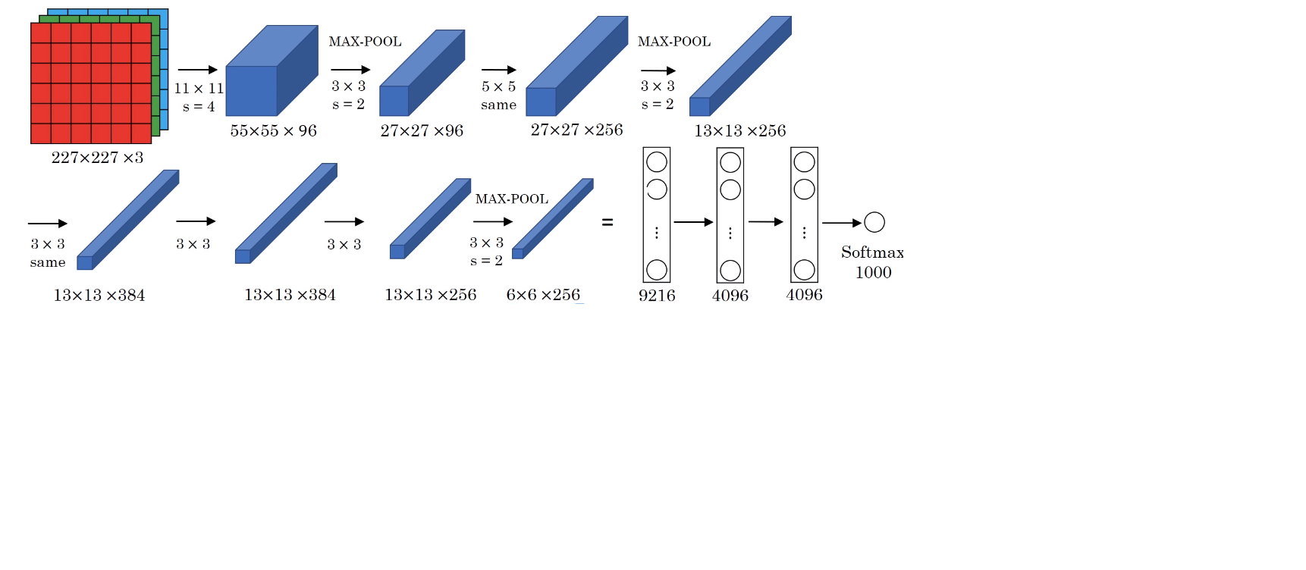

Figure 48 Example of an Inception Neural Network Image Processing

Figure 69 above is the inception neural network which will be used for implementing the training. The CNN above has 8 layers, 1984 nodes and is above 6 million. The networks have already been pre-trained by Google. By applying transfer learning, the CNN will be able to adapt to the training necessary for the vessel by introducing the prepared dataset to the network. Above is a 227x227x3 RGB image convoluted with a 11x11x3 filter with a stride of three to get a second layer 55x55x96. Max pooling was also used between layers.

* The convolution layers have different parameter vales weight(w) and biases(b) from the equation $Z^{\left[1\right]}=W^{\left[1\right]}a^{\left[0\right]}+b^{\left[1\right]}$
* Cost function $j=\frac{1}{m}\sum_{i=1}^{m}{L({\hat{y}}^{\left(i\right)},y^{(i)}) }$
* w, b are randomly initialized. J is the sum of losses
* To train the neuro-network, the gradient decent is used. Tensor flow is employed to optimize all the parameters in the neuro-network with the aim of reducing the cost function J

TensorFlow is an open source software library for machine learning, which was released by Google in 2015 and has quickly become one of the most popular machine learning libraries being used by researchers and practitioners all over the world. It is used to do the numerical heavy lifting for this vessel’s image classification model. During training, the model's predictions are compared to their true values. This information is then used to update the parameters. During testing there is no feedback anymore; the model simply generates labels.

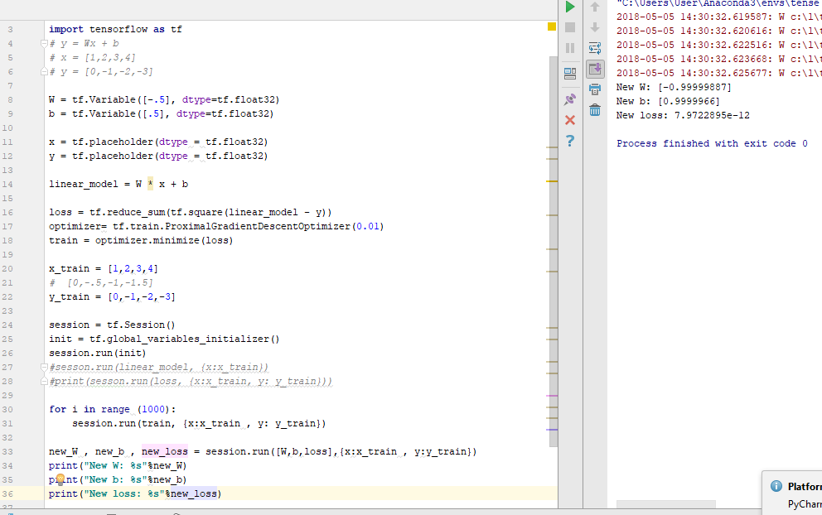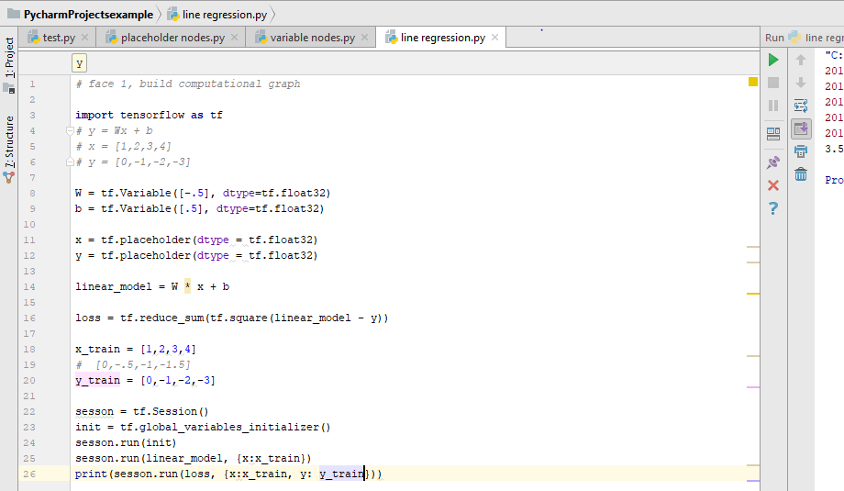

Figure 49 Finding the Error & Figure 50 Pptimized process

𝑦_2=𝑤𝑥+𝑏

Error = $\sum_{0}^{3}{{(y_{2}-y_{1})}^{2}}$

The error in the value obtained which is 3.5 using out assumed values for w and b. The point is to train the code to minimize the error as much as possible.

Training of a line regression, error is reduced to 7.9722𝑒^(−12). New value for w = -1, New value for b = 1.

### Implementation of Subtask 3-Training the model

Below are the steps required to successfully train a working model:

* Installing TensorFlow-GPU
* Setting up anaconda Virtual Environment and the Object Detection directory structure
* Gathering and labeling Pictures
* Generating training data
* Creating a label map and configuring training
* Training
* Exporting the inference graph
* Upload into the Raspberry Pi3 and test.

1. Installing TensorFlow-GPU :

In order to install TensorFlow, installing some dependencies required by the GPU is required. A desktop with GPU GeForce GTX 1050 is being used. Tensorflow requires CUDA 9.0 and cuDNN 7.1. Unfortunately, they are not compatible with a newer version of Tensorflow so a downgrade to version 1.5 is necessary.

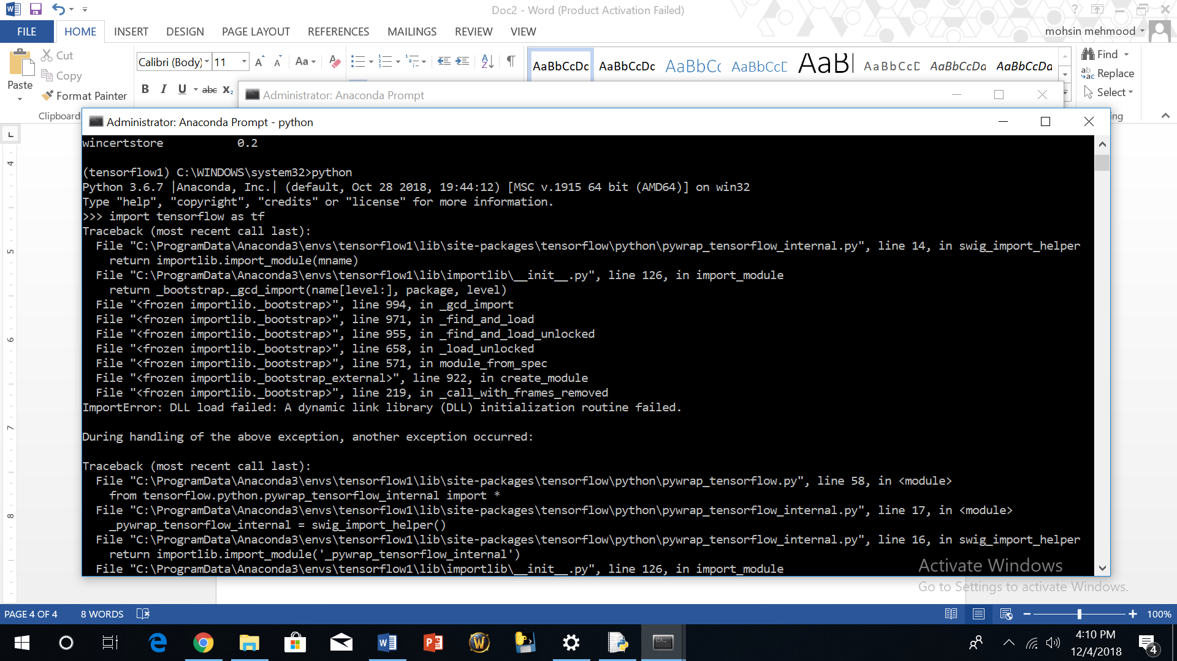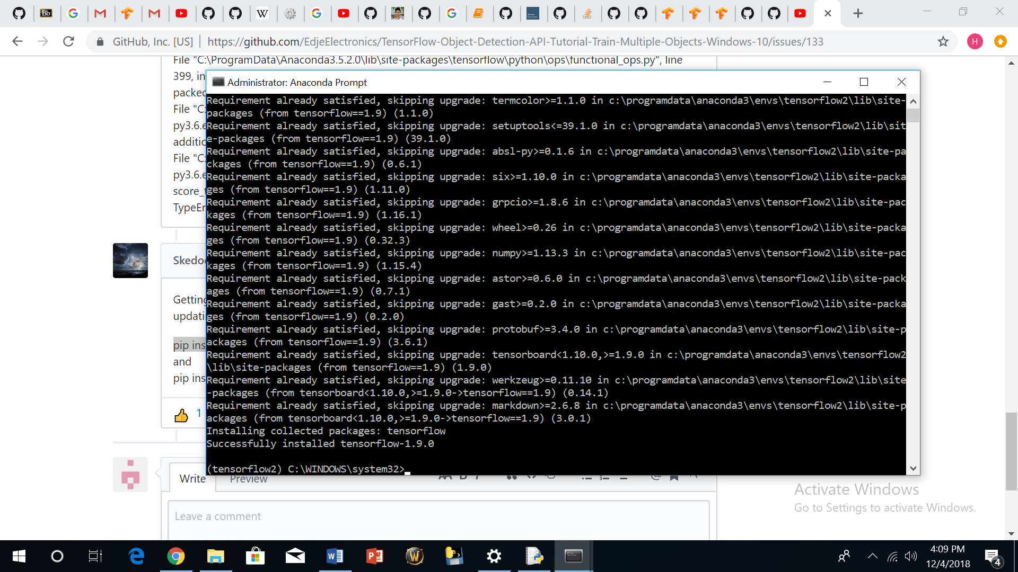

Figure 51 Installing tf 12.0 & Figure 52 Failed Installation

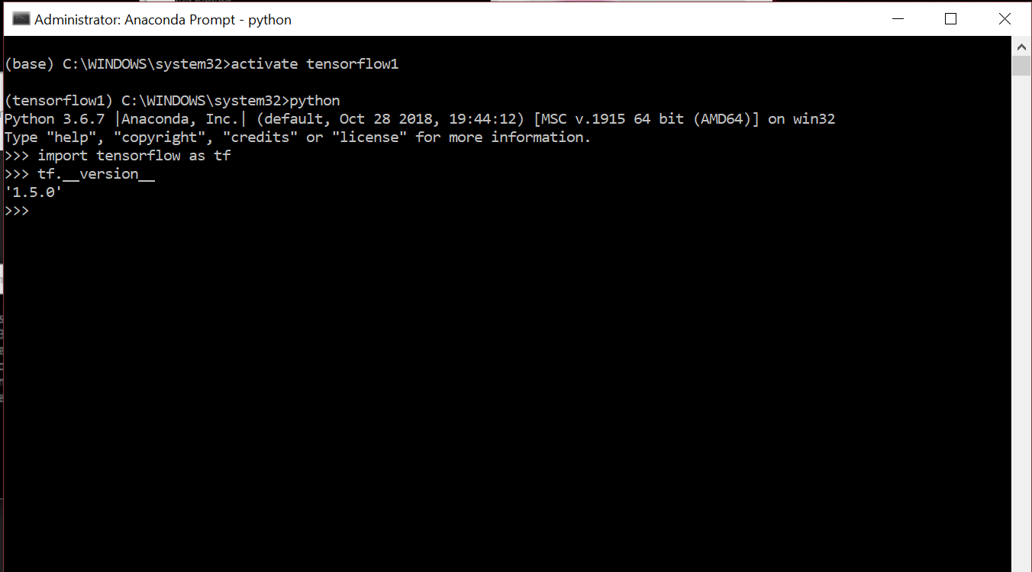

Figure 53 Successful Installation

1. Setting up Anaconda Virtual Environment and the Object Detection Directory Structure

Training will the done with the ssd-Mobilenet model, which has the same structure as the inception neural network but with fewer parameters. Due to the weak processing power of the Raspberry Pi3, a neural network is required that would also be fast enough. Unfortunately, accuracy will be a trade-off.

Then, an environment on anaconda must be created:

C:\> conda create -n tensorflow1 Pip python=3.5

Then activate the environment by:

C :\> activate tensorflow1

Other dependencies are required and they will be installed by issuing:

(tensorflow1) C:\> conda install -c anaconda protobuf

(tensorflow1) C:\> Pip install Pillow

(tensorflow1) C:\> Pip install lxml

(tensorflow1) C:\> Pip install Cython

(tensorflow1) C:\> Pip install jupyter

(tensorflow1) C :\> Pip install matplotlib

(tensorflow1) C:\> Pip install pandas

(tensorflow1) C:\> Pip install opencv-python

The PYTHONPATH environmental variable needs to be configured by issuing:

(tensorflow1)C:\>setPYTHONPATH=C:\tensorflow1\models;C:\tensorflow1\models\research;C:\tensorflow1\models\research\slim

Next, comPile protobuf:

protoc--python_out=..\object_detection\protos\anchor_generator.proto .\object_detection\protos\argmax_matcher.proto.\object_detection\protos\bipartite_matcher.proto.\object_detection\protos\box_coder.proto.\object_detection\protos\box_predictor.proto.\object_detection\protos\eval.proto.\object_detection\protos\faster_rcnn.proto .\object_detection\protos\faster_rcnn_box_coder.proto.\object_detection\protos\grid_anchor_generator.proto.\object_detection\protos\hyperparams.proto.\object_detection\protos\image_resizer.proto.\object_detection\protos\input_reader.proto.\object_detection\protos\losses.proto.\object_detection\protos\matcher.proto.\object_detection\protos\mean_stddev_box_coder.proto.\object_detection\protos\model.proto.\object_detection\protos\optimizer.proto .\object_detection\protos\Pipeline.proto.\object_detection\protos\post_processing.proto .\object_detection\protos\preprocessor.proto.\object_detection\protos\region_similarity_calculator.proto.\object_detection\protos\square_box_coder.proto.\object_detection\protos\ssd.proto.\object_detection\protos\ssd_anchor_generator.proto.\object_detection\protos\string_int_label_map.proto.\object_detection\protos\train.proto.\object_detection\protos\keypoint_box_coder.proto.\object_detection\protos\multiscale_anchor_generator.proto.\object_detection\protos\graph_rewriter.proto

To test if the Tensorflow set up is functional, run a jupyter script. If there is no error and the Pictures below are identified, everything is fine.

(tensorflow1) C:\tensorflow1\models\research\object_detection> jupyter notebook object_detection_tutorial.ipynb

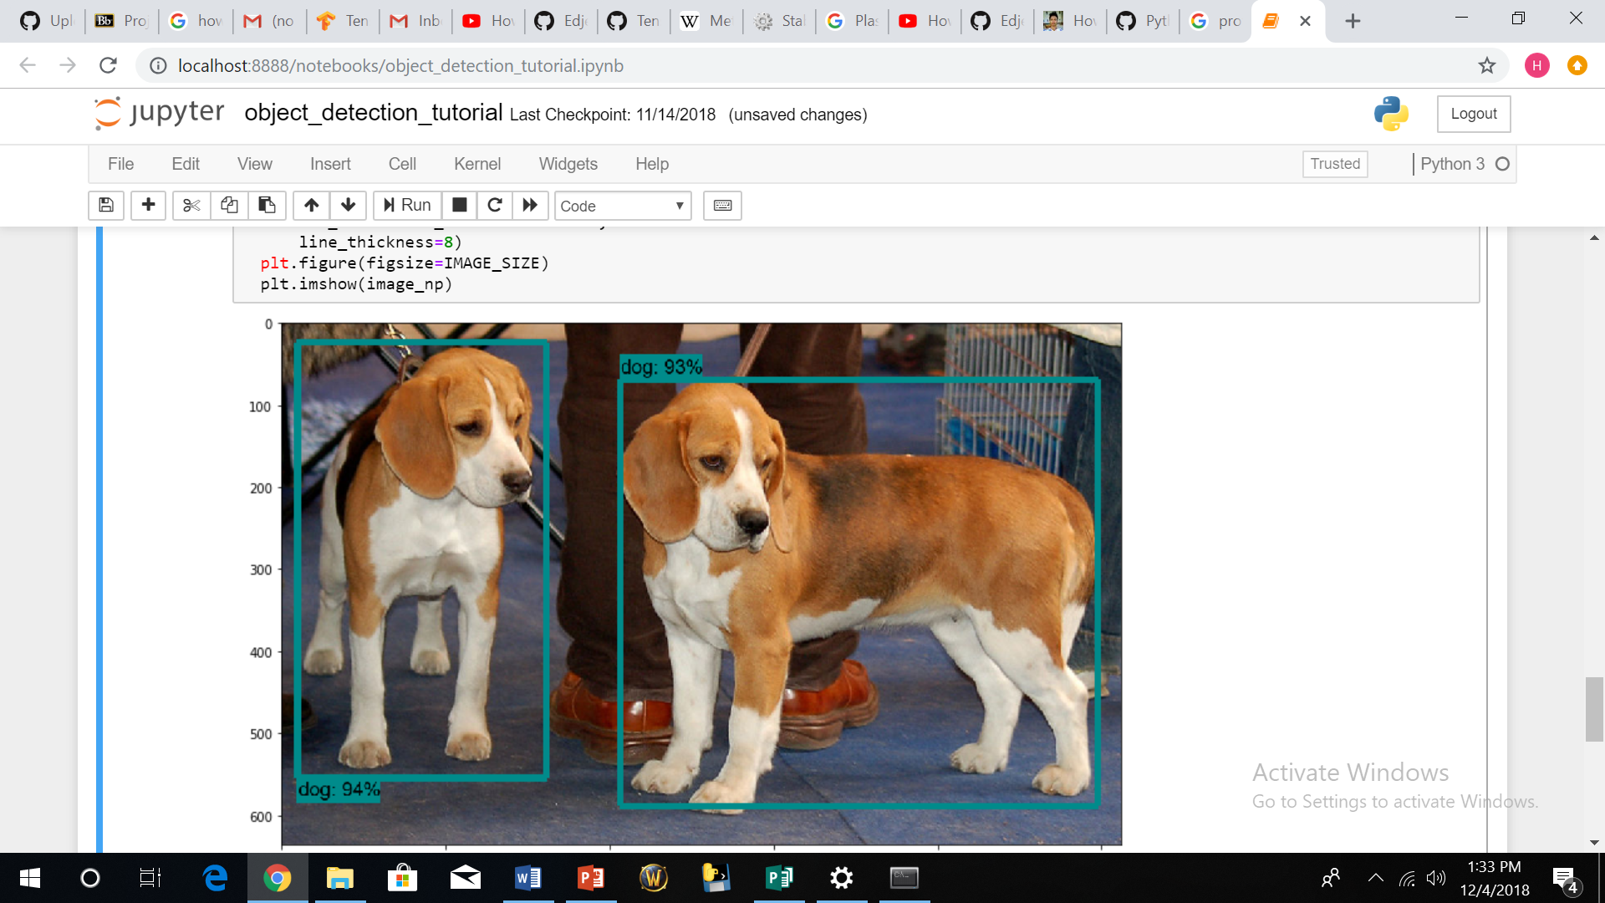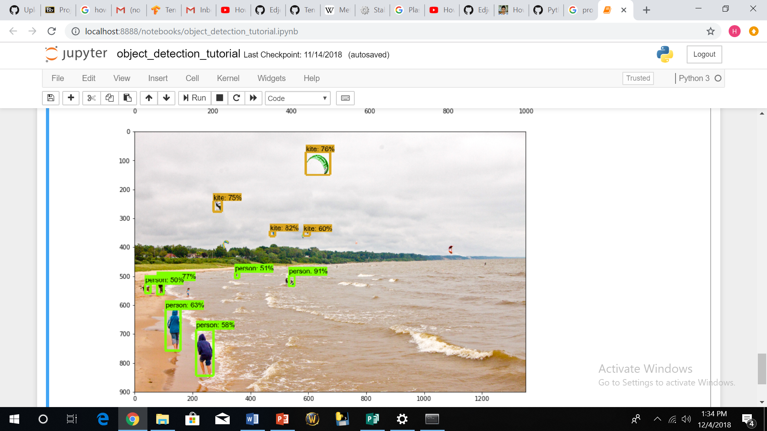

Figure 54 (a,b) jpyter Script TensorFlow Active

When running the script, modifications had to be made. The condition of the code had to be changed from tensorflow < 1.8 to tensorflow < 1.4 in order for it to run successfully. The result is shown above in Figure 75, which demonstrates the setup is ready for training.

1. Gathering and labeling Pictures

For this project, approximately 245 Pictures were taken in different terrain and lighting conditions, and then divided into two groups. Approximately 20 percent of the Pictures were placed in the testing folder, and the remaining Pictures were placed in the training folder. The more diverse the Pictures are, the more efficient the model will be in recognizing the object.

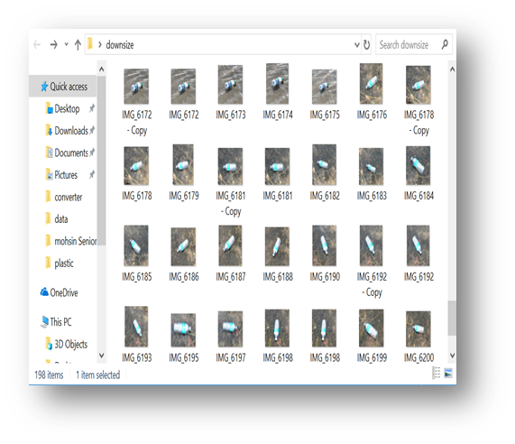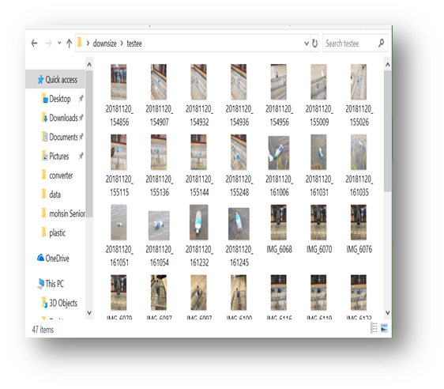

Figure 55 Dataset of Pictures Used to Train the System

The Pictures were labeled using the llabelmg software, and then xml files which contains the coordinate values of all the Pictures were generated.

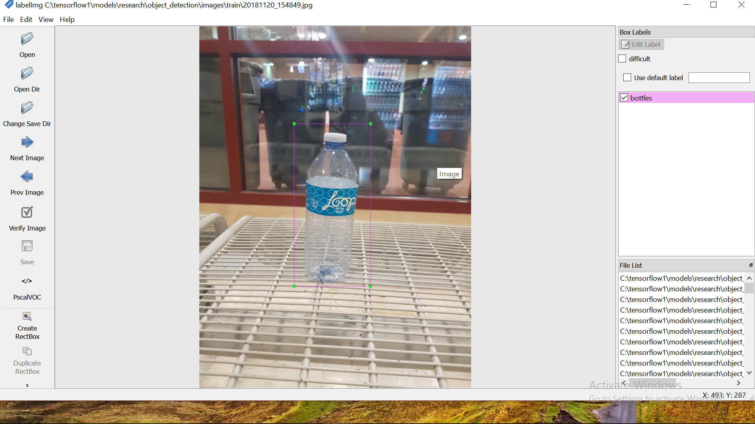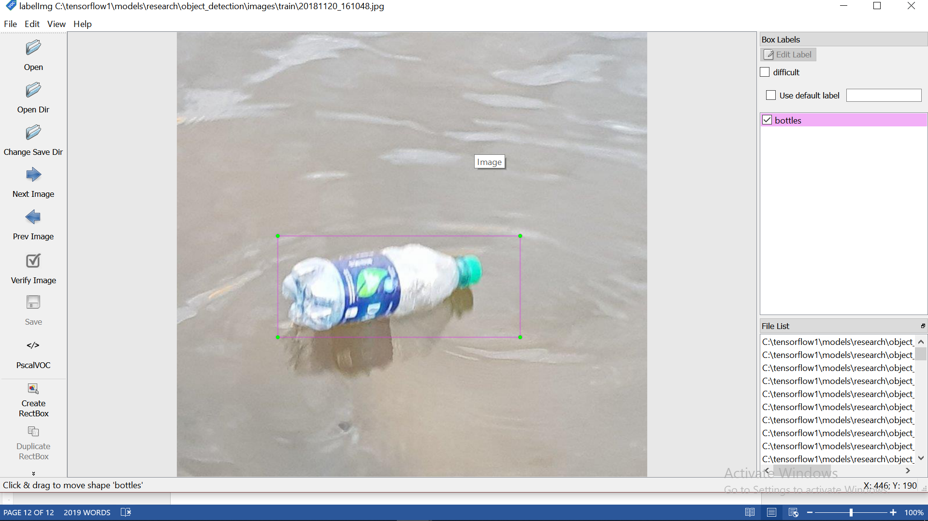

Figure 56 (a,b)Image Labelling

1. Generate Training data

(tensorflow1) C:\tensorflow1\models\research\object_detection> python xml_to_csv.py

After running that, csv file is generated in the object detection folder:

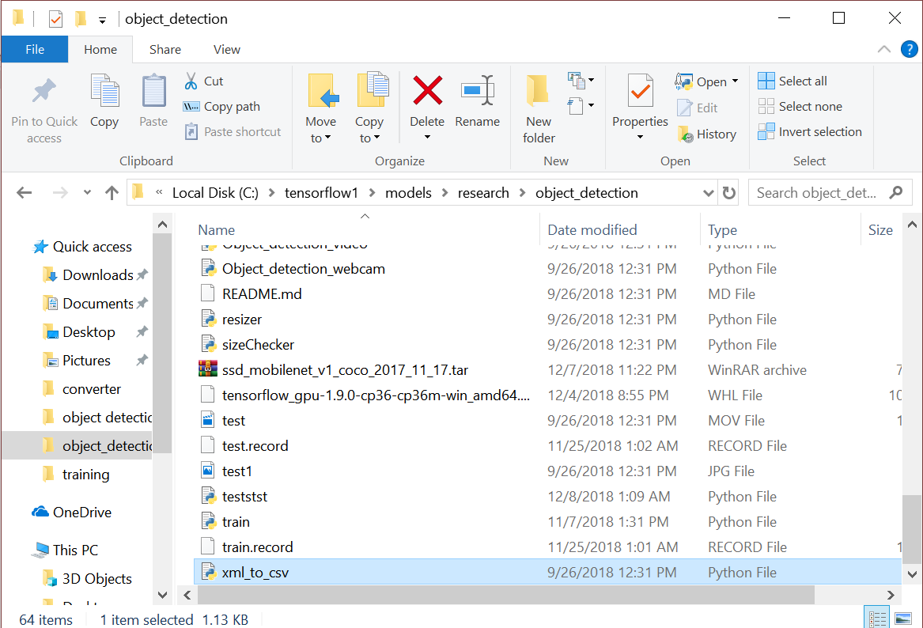

Figure 57 File Generated

1. Create Label Map and Configure Training

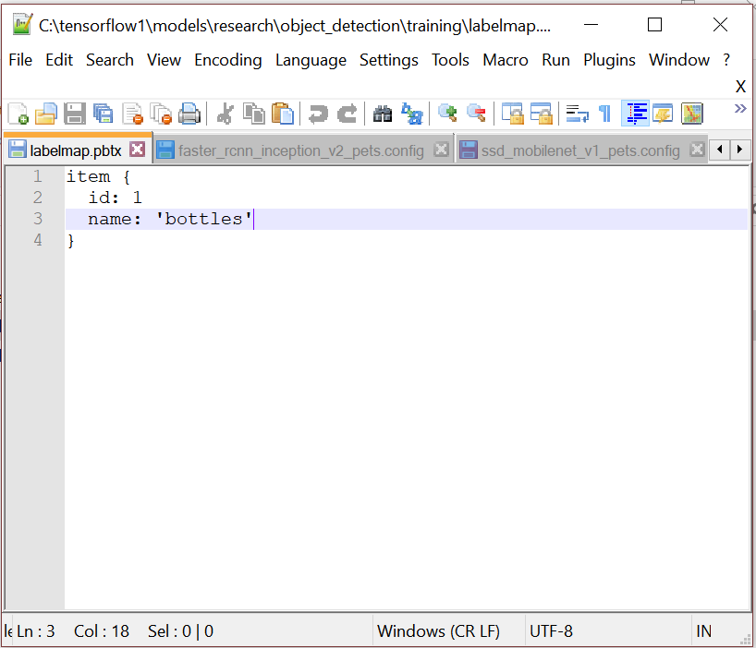

Figure 58 Label Map

The labelmap.pbtx must be saved in the training folder.

1. Run the training

Run the code:

python.pylogtostderrtrain_dir=training/Pipeline_config_path=training/ssd_mobilenet_v1_pets.config

The training commenced as follows:

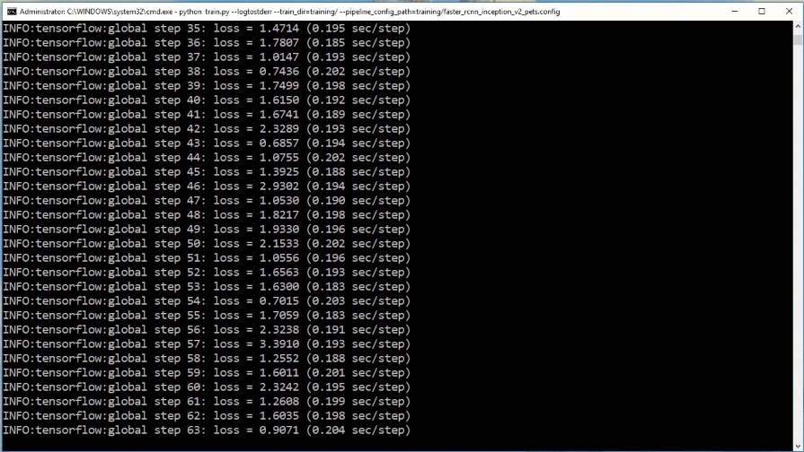

Figure 59 Training Interface

After obtaining a very low error rate, quit the process and generate an inference graph.

1. Export the inference graph

python export_inference_graph.py --input_type image_tensor --Pipeline_config_path training/ ssd_mobilenet_v1_pets.config--trained_checkpoint_prefixtraining/model.ckpt-1--output_directory inference_graph

This creates a frozen_inference_graph.pb file in the \object_detection\inference_graph folder. The .pb file contains the object detection classifier

This frozen inference graph is uploaded into the Raspberry Pi and tested.

### Implementation of Subtask 4-Result

After uploading the trained CNN into the Raspberry Pi, the training was tested by going into the object detection folder and running the code below.

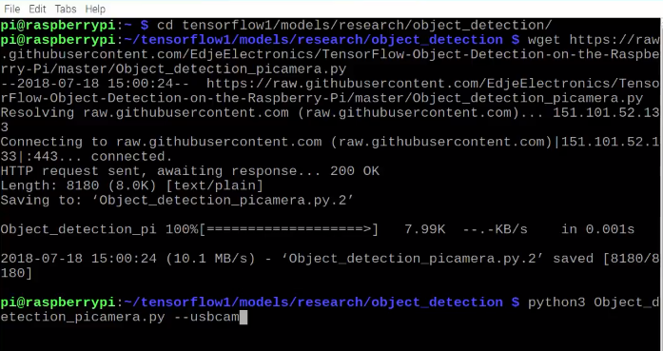

Figure 60 Image Recognition Start-up Interface

After pressing enter, the web cam comes on and within seconds, the video is shown on the screen. The results obtained are below

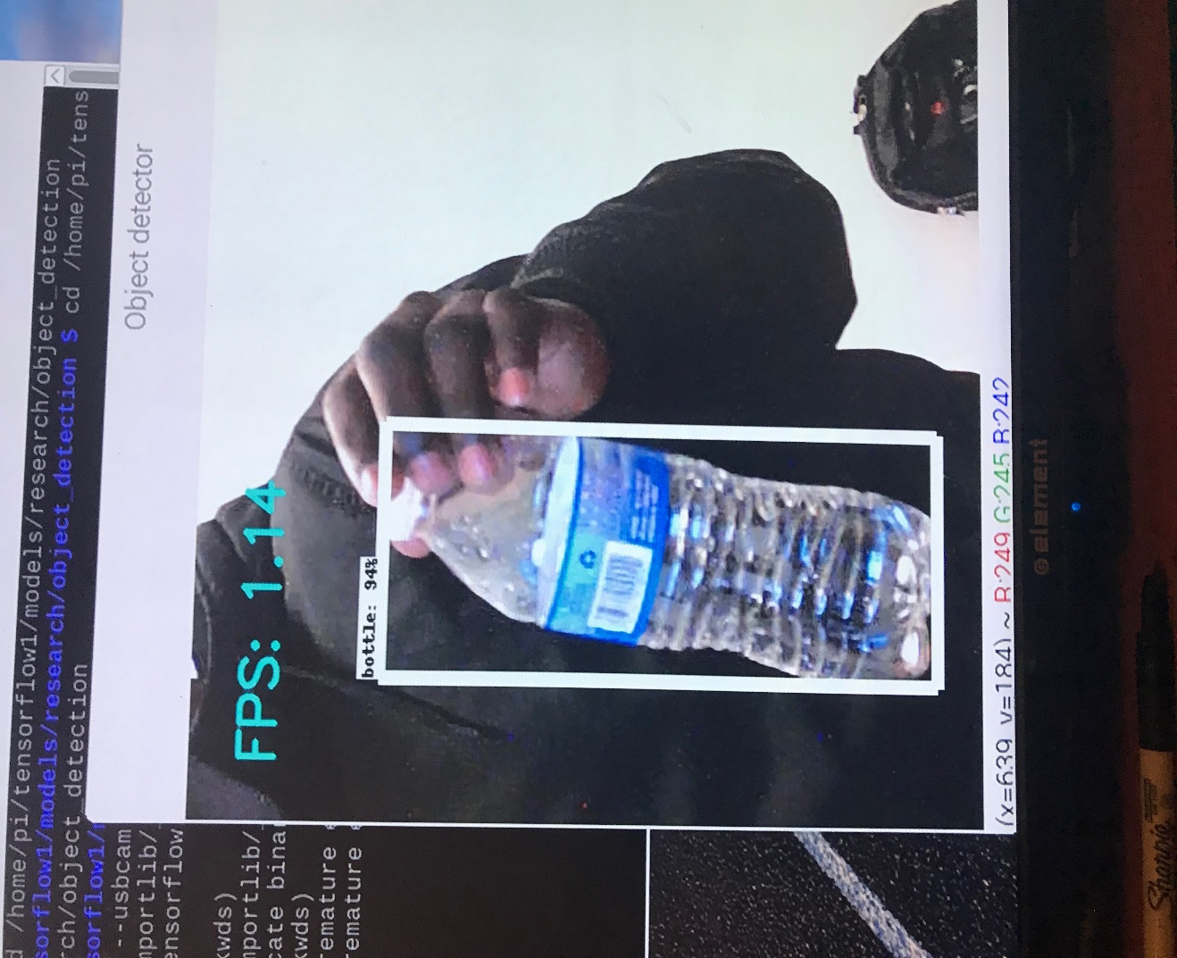

Figure 61 Successful Trial 1

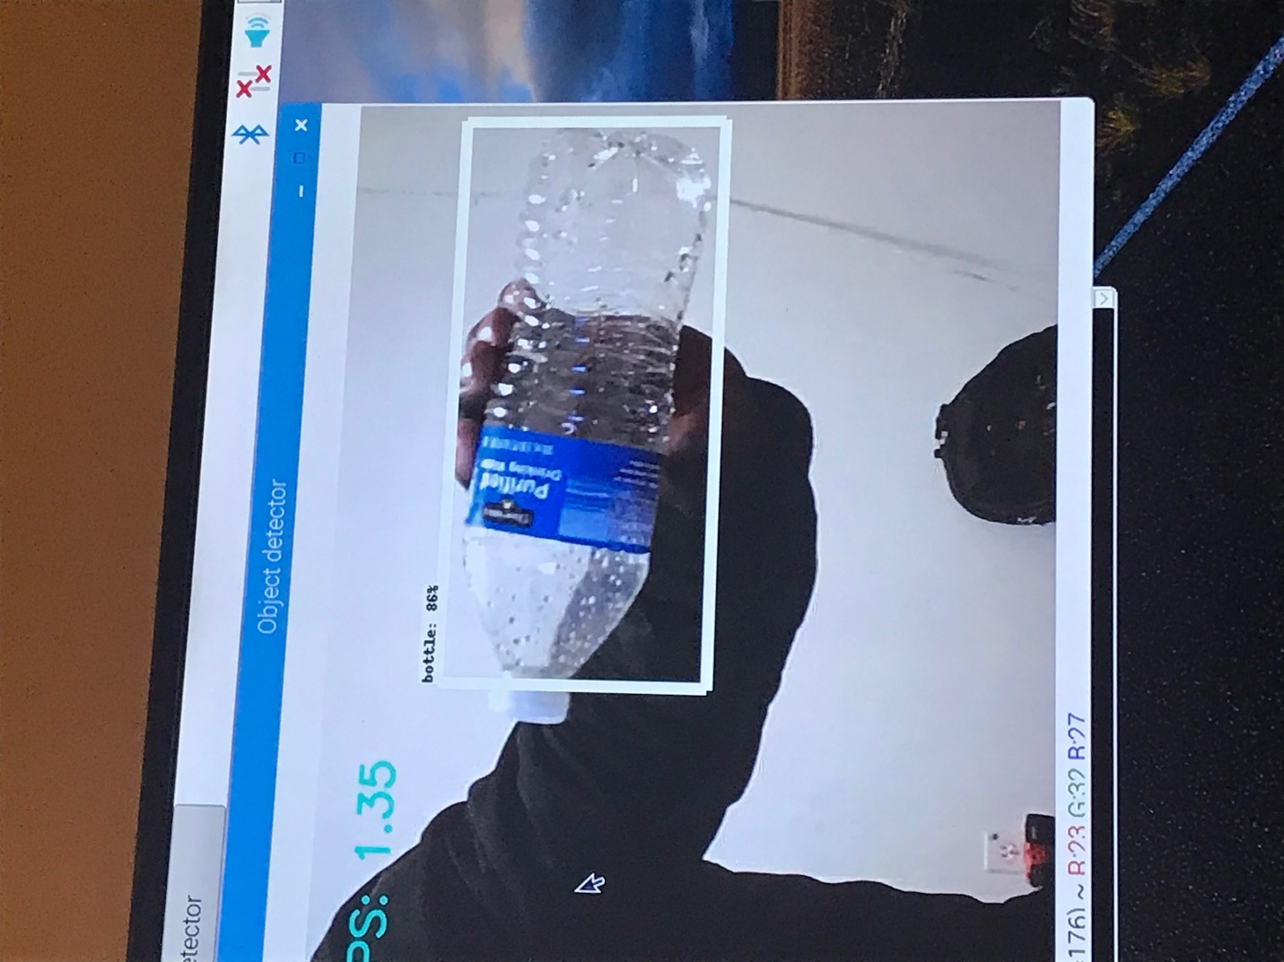

Figure 62 Successful Trial 2

Figures 82 and 83 are examples of two Pictures out of all the testing completed. A frame rate of 1.35 and 1.14 was achieved with 94% and 86% of success.

**Output SIGNAL THROUGH GPIO PINS:**

Achieving this involved communicating and forums and after getting ideas, codes and other resources were improved to meet our standards

* Firstly, tensorflow in initialized then the mobilenetSSD is ran
* Secondly, the pin camera is activated and continuously capturing frames
* The frames from the pi camera is ran through a function that contains the bottle detection code. Inside this function, the frame is passed through the tensor flow neural network
* The network detects the bottle in the fram and draws it’s location in the image

# Draw the results of the detection (aka 'visulaize the results')

vis_util.visualize_boxes_and_labels_on_image_array(

frame,

np.squeeze(boxes),

np.squeeze(classes).astype(np.int32),

np.squeeze(scores),

category_index,

use_normalized_coordinates=True,

line_thickness=8,

min_score_thresh=0.40)

* When detected, the image has 2 properites which are the location, detection percentage.and class name (which is bottle.) and it’s outputted into 3 varibles (boxes, scores and class)
* In order to find the coordinate of the object, the box variables are manipulated. As seen above in fig 61 and 62, the box gives values (ymax, ymin, xmax and xmin) however they have to be multiplied by the image height and image width to get the actual coordinates. Then the program can use that information to calculate the center of the image by computing

x = int(((boxes[0][0][1]+boxes[0][0][3])/2)*IM_WIDTH)

y = int(((b oxes[0][0][0]+boxes[0][0][2])/2)*IM_HEIGHT)

The above lines of codes adds the max and min coordinates, divide by 2 then multiplies to the width of the image. The center value is compared to the center of the frame as a reference.

* In order to output information, the label map is utilized. Since our system is for bottles, our label map class is 1. To use the GPIO pin first run $ sudo pip install RPi.GPIO to allow GPIO work.
* Initialized GPOI pin by

import RPi.GPIO as GPIO

GPIO.setmode(GPIO.OUT)

GPIO.setup(1, GPIO.OUT) // to output 1 into the pixhawk for left turn

GPIO.setup(12, GPIO.OUT)// to output 1 into the pixhawk for right turn

* The code will be edited to

if (int(classes[0][0]) == 1):

x = int(((boxes[0][0][1]+boxes[0][0][3])/2)*IM_WIDTH)

y = int(((boxes[0][0][0]+boxes[0][0][2])/2)*IM_HEIGHT)

if (x<800)

GPIO.output(12, GPIO.HIGH)

Else if (x>800)

GPOI.output(1, GPIO.LOW)

Else break

### Implementation Runtime for Image Recognition Unit

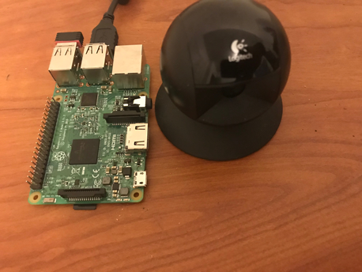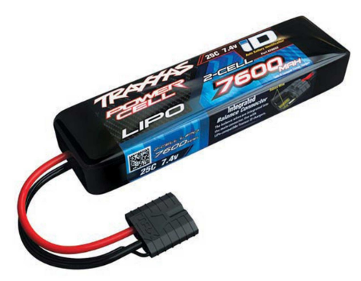

Figure 63 2s Battery & Figure 64 Image Recognition Set-Up

The image recognition unit includes a Raspberry Pi3, a webcam, and 2-cell 7600mAh battery. Because the Raspberry Pi requires a 5v and 2.25A battery to operate, a ubec must be introduced to help regulate the voltage 7.4v coming out of the battery.

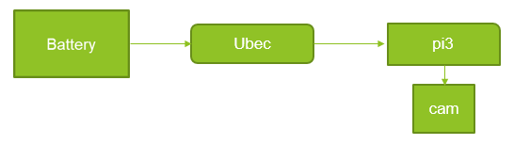

Figure 65 Power Connection Layout for Raspberry Pi

Therefore, the runtime for the image recognition unit will be 7.4Ahr / 2.25A =3hr 17mins.

## Implementation of Task 9- Navigation System

### Implementation of Subtask 1- Research on Pixhawk configuration

Implementing autonomy is one of the primary objective in this project. In other to achieve autonomy, the use of Pixhawk is required. A Pixhawk is a high-performance autoPilot-on-module suitable for fixed wing, multi rotors, helicopters, cars, boats and any other robotic platform that can move. It is targeted towards high-end research, amateur and industry needs and combines the functionality of the PX4FMU + PX4IO. It is a further evolution of the PX4 flight controller system. Pixhawk consists of a PX4-FMU controller and a PX4-IO integrated on a single board with additional IO, Memory and other features.

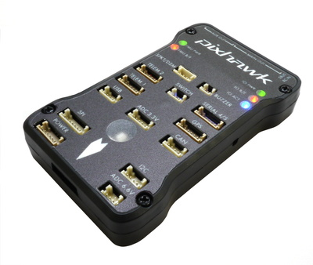

Figure 66 Pixhawk

Step1: Install the Mission Planner

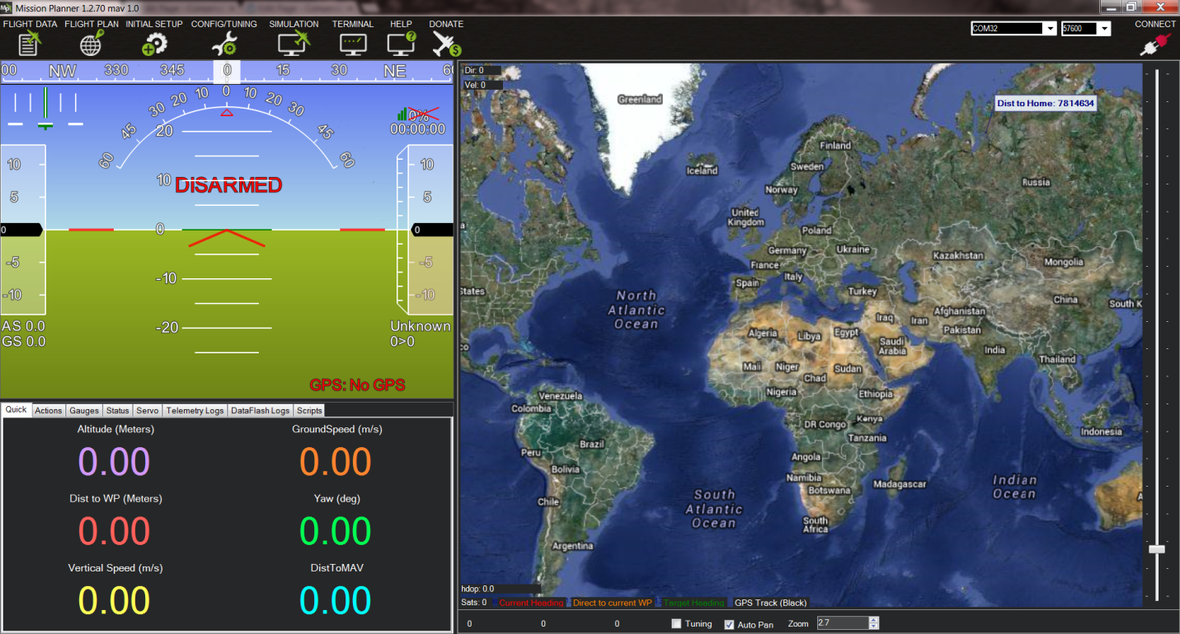

Figure 67 mission planner interface

The figure above shows the interface of the mission planner software on the computer. Mission Planner is a full-featured ground station application for the ArduPilot open source autoPilot project. Mission Planner is a ground control station for Plane, Copter and Rover. It is compatible with Windows only. Mission Planner can be used as a configuration utility or as a dynamic control supplement in our autonomous vessel.

Step2: Connect the Pixhawk to the mission planner.

[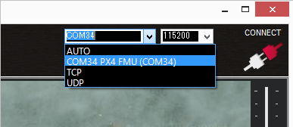](http://ardupilot.org/rover/_images/Pixhawk_ConnectWithMP.png)

Figure 68 Connection to Mission Planner through Port

To connect the two together, open the Mission Planner and select the COM port drop-down on the upper-right corner of the screen (near the Connect button). Select AUTO or right COM in Mission Planner board (PX4 FMU or Arduino Mega 2560). Set the Baud rate to 115200 as shown. Don’t hit “Connect” just yet. Click the correct COM port as shown below.

Step 3: Download and Install Ardurover onto the Pixhawk

Although this project is a water vessel, it remains necessary to work with the rover configuration and try to manipulate it to the specifications necessary for the vessel. On the Mission Planner’s Initial Setup, install the firmware screen and select the appropriate icon that matches the frame. For this case, the rover will be selected. Answer “yes” when asked, “Are you sure?” Figure 90 below shows the different selections the user can choose. In this instance, because it’s the Ardurover, the image of the car is chosen.

[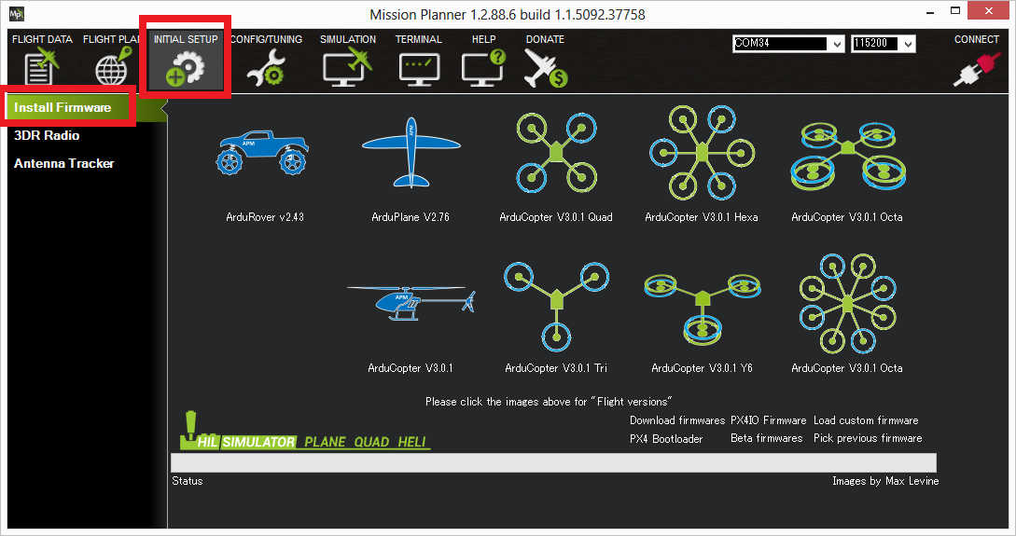](http://ardupilot.org/rover/_images/Pixhawk_InstallFirmware.jpg)

Figure 69 Select the Correct Firmware

For navigation, certain changes must be made to adapt the rover setting for a water vessel. The throttle setting for motion is the same in both cases, but the servomechanism used for changing the rover will be used to control the servomechanism connected to the rudder. Note must be taken of the difference in the direction, and the rudder must be set accordingly due to the fact that it is the reverse when compared to the rover.

For separate steering and throttle vehicles, these parameters values should be set (and should be set by default):

SERVO1_FUNCTION = 26 (GroundSteering)

SERVO3_FUNCTION = 70 (Throttle)

If using the mission planner, the Initial Setup >> Mandatory Hardware >> Servo Output page is a convenient way to complete this step.

[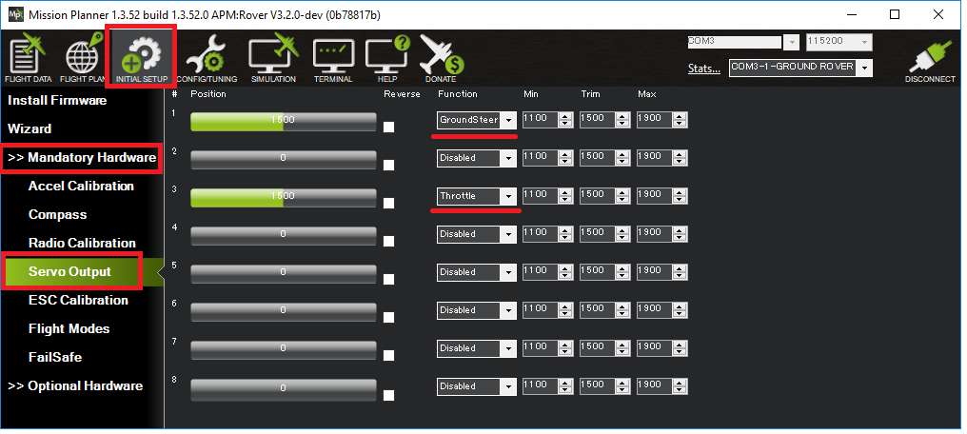](http://ardupilot.org/rover/_images/rover-motor-and-servo-config1.png)

Figure 70 Motor and Servomerchanism Control Set-Up

Due to the differences in terrain, autonomous navigation is more challenging in light of physical factors such as tide and wind. Therefore, the PID tuning is especially important in maintaining balanced movement and staying on course. Recently, new improvement have been made to the autonomous sailing technology, and new features have been introduced.

The special features for boats include:

* Boats appear as boats on the ground station (version 3.3.0 and higher)
* In Auto, Guided, RTL and SmartRTL modes, the vehicle will attempt to maintain its position even after it reaches its destination (version 3.2.0 and higher)
* Vectored Thrust can be enabled to improve steering response on boats which use the steering servo to aim the motors (version 3.3.1 and higher)
* Loiter mode for holding position
* Echosounders for underwater mapPing.

### Implementation of Subtask 2- Layout of the Navigation System

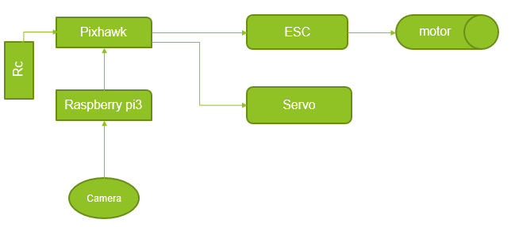

Figure 71 Navigation Layout

In the above layout, the Pixhawk is the primary navigating micro controller. A receiver is connected to the Pixhawk to allow the user to take control manually at any point in time. Raspberry Pi is able to communicate with the Pixhawk using the MAV link protocol over a serial port connection. When an object has been detected, the Raspberry Pi sends signals to the Pixhawk through the RX & TX ports, and then guides it to the object depending on the X and Y coordinates that communicate how far left or right the object is. In turn, the Pixhawk interrupts its mission for collection of the object. After the target has been acquired, the Pixhawk goes back to its mission and the Raspberry Pi continues its search.

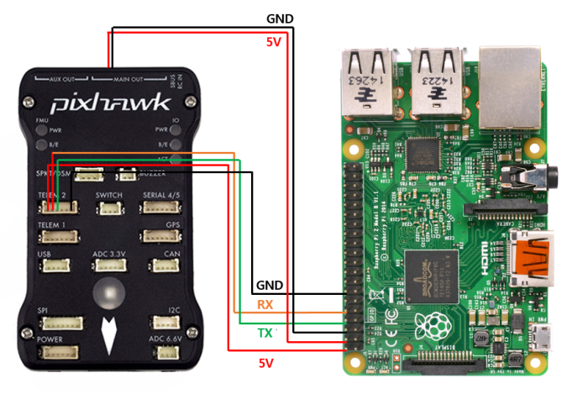

Figure 91 MAV Connection between PI and Pixhawk

When setting up the Pixhawk, some adjustments have to be made on the mission planner. For example, these parameters have to be set.

* SERIAL2_PROTOCOL = 1 (the default) to enable MAVLink on the serial port.
* SERIAL2_BAUD = 921 so the Pixhawk can communicate with the RPi at 921600 baud.
* LOG_BACKEND_TYPE = 3 if you are using APSync to stream the dataflash log files to the RP

The Pixhawk compatibility packages also have to be downloaded on the Raspberry Pi board, and the commands are listed below:

sudo apt**-**get update

sudo apt**-**get install screen python**-**wxgtk2**.**8 python**-**matplotlib python**-**opencv python**-**Pip python**-**numpy python**-**dev libxml2**-**dev libxslt**-**dev python**-**lxml

sudo Pip install future

sudo Pip install pymavlink

sudo Pip install mavproxy.

When the Raspberry Pi captures an image, the coordinates of the picture can be achieved from the screen. These coordinates are vital in tracking the bottle for collection. The x and y midpoint position is shown at the bottom left position of the screen. The size of the coordinates range from 0 to 1000 in both x and y axis with the midpoint of the screen as (800,800). As the object gets closer it becomes visually larger, and the position of the camera is at the middle of the boat, so the vessel should aim for the midpoint of the target. When x<500, steer left and x> 800, steer right but when x=800, the vessel should maintain a forward momentum until collection. The vessel is set to continue moving until y = 0.

### Implementation of Subtask 3- Runtime of the Navigation System

Two 2-cell batteries are used for the setup. Using two batteries allows for managing weight distribution, and makes it easier to troubleshoot if problem arises. Additionally, it is a more affordable option. One battery is used to power the motor and the other battery is used for the micro controllers.

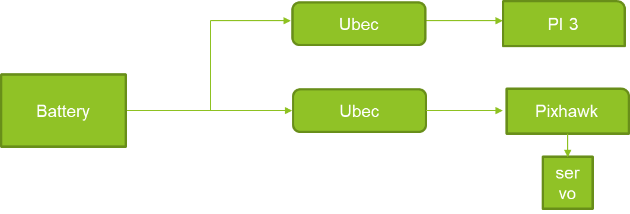

Figure 72 Power Connection for Microcontrollers

* The battery is connected in parallel to two ubec which are connected to the Raspberry Pi and Pixhawk
* The current required by the microcontroller are 2.5 and 2.25
* Total current drawn = 4.75 A
* Battery amp per hour rating = 7600mAh
* Operation time: 7.6Ah / 4.75A = 1.6
* Which is 1hr 36 mins

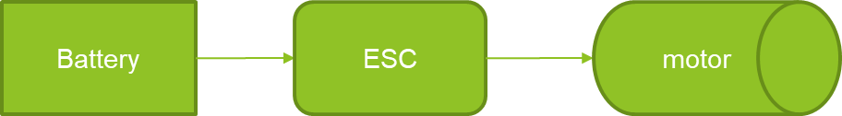

Figure 73 Power Connection for Motors

* Current required for the operation of the motor = 10A
* Battery amp per hour rating = 7600mAH
* Operation time: 7.6/10 = 0.76 hours
* 0.76 * 60 = 45.6 mins

1. Conclusion (Discussion and Future Plans)

At the end of this project, the execution of the concept of image recognition was fulfilling. It included the use of manual tools and machineries in building the boat. It was an eye opening experience. The future plan include increasing the amount of frames per seconds of the recognition system and finding ways to output the coordinates through the GPIO pins.

Acknowledgment

* Yuanwei Jin, Ph.D.
* Virginia C. Heath
* Ibibia K. DabiPi, Ph.D.

APPENDIX

The links for each of these except the aluminum bars are as follows:

[https://www.lowes.com/pd/Krylon-High-](https://www.lowes.com/pd/Krylon-High-Heat-Satin-Black-Spray-Paint-Actual-Net-Contents-12-oz/1000462633)

[Heat-Satin-Black-Spray-Paint-Actual-Net-Contents-12-oz/1000462633](https://www.lowes.com/pd/Krylon-High-Heat-Satin-Black-Spray-Paint-Actual-Net-Contents-12-oz/1000462633)

Spray paint black

Price 3.88

Need it to make the boat submerged parts waterproof

<https://www.lowes.com/pd/Krylon-Gloss-Red-Orange-Fluorescent-Spray-Paint-Actual-Net-Contents-11-oz/1000462639>

Spray paint red

Price 3.88

Need it to make the boat submerged parts waterproof

<https://www.homedepot.com/p/Owens-Corning-FOAMULAR-150-1-in-x-4-ft-x-8-ft-R-5-Scored-Square-Edge-Rigid-Foam-Board-Insulation-Sheathing-20WE/207179253>

Foam board

Price 19.55

Required to make pontoons

Quantity required 1 board

<https://www.amazon.com/Devcon-20445-Flow-Mix-5-Minute-Epoxy/dp/B00C3Z9TTS?th=1>

Epoxy

24.99 for pack of 6

Required to make the system more rigid

[https://m.lowes.com/pd/Blue-Hawk-Actual-10-ft-x-2-ft-Rolled-wire-Galvanized-Welded-Wire-Garden-Hardware-Cloth-Rolled-Fencing/4780937?cm_mmc=SCE_PLA-_-LumberAndBuildingMaterials-_-WireFence-_-4780937:Blue_Hawk&CAWELAID=&kPid=4780937&CAGPSPN=pla&store_code=1538&k_clickID=go_625667893_34613739070_111132546670_pla-258795389990_m_9059726&gclid=EAIaIQobChMI4vHx5s-M4AIVUV8NCh2eyQgMEAQYASABEgK0J_D_BwE](https://m.lowes.com/pd/Blue-Hawk-Actual-10-ft-x-2-ft-Rolled-wire-Galvanized-Welded-Wire-Garden-Hardware-Cloth-Rolled-Fencing/4780937?cm_mmc=SCE_PLA-_-LumberAndBuildingMaterials-_-WireFence-_-4780937:Blue_Hawk&CAWELAID=&kpid=4780937&CAGPSPN=pla&store_code=1538&k_clickID=go_625667893_34613739070_111132546670_pla-258795389990_m_9059726&gclid=EAIaIQobChMI4vHx5s-M4AIVUV8NCh2eyQgMEAQYASABEgK0J_D_BwE)

Aluminum mesh sheet

12.98

Required to make the middle assembly

<https://www.lowes.com/pd/Gatehouse-4-in-Oil-Rubbed-Bronze-5-8-in-Radius-Mortise-Door-Hinge/4772783>

Door hinges

Price for two 6.96

Required to make rudders

<https://www.lowes.com/pd/Hillman-200-Piece-Steel-Zinc-Plated-Combo-Fastener-Kit-Case-Included/3024351>

Various size nuts and bolts

Price 4.10

Required to fasten the system

Pvc couplings most of which are either a dollar or under a dollar and we will require at least 24, this is something that we cannot order and we will need to purchase from a local hardware store but the cost can be up to 20-25$

Based on all the building materials given above the total price comes up to 117.34$

REFERENCES

[1] https://Pixhawk.org/modules/Pixhawk

[2] “Multistar High Capacity 20000mAh 6S 10C Multi-Rotor Lipo Pack.” Hobbyking, hobbyking.com/en_us/multistar-high-capacity-6s-20000mah-multi-rotor-lipo-pack.html.

[3] “Kinexsis 1/10 4-Pole ESC/Motor Combos.” Big Squid RC - RC Car and Truck News, Reviews, Videos, and More!, 3 Nov. 2015, www.bigsquidrc.com/kinexsis-110-4-pole-escmotor-combos/.

[4] “Onyx 2S Hard Case LiPo 25C Battery Pack w/Deans (7.4V/5000mAh) by DuraTrax [DTXC1864] | Cars & Trucks.” HobbyTown, www.hobbytown.com/onyx-2s-hard-case-lipo-25c-battery-pack-w-deans-7.4v-5000mah-by-duratrax-dtxc1864/p211388.

[5] “Pixhawk Overview¶.” Introducing Copter - Copter Documentation, arduPilot.org/copter/docs/common-Pixhawk-overview.html.

[6] http://arduPilot.org/planner/docs/mission-planner-overview.html

[7] <https://medium.com/@tifa2up/image-classification-using-deep-neural-networks-a-beginner-friendly-approach-using-tensorflow-94b0a090ccd4>

[8] Dasgupta, Soumyajit, and Zequek Estrada. “A Guide to Different Types of Boats.” *Marine Insight*, Marine Insight, 24 Jan. 2018, [www.marineinsight.com/types-of-ships/a-guide-to-different-types-of-boats/](http://www.marineinsight.com/types-of-ships/a-guide-to-different-types-of-boats/).

[9] [www.marineinsight.com/boating-yachting/boats-with-a-difference-the-high-speed-crafts/](http://www.marineinsight.com/boating-yachting/boats-with-a-difference-the-high-speed-crafts/).

[10] “{{::Og.title}}.” *ThisIsWhyImBroke*, [www.thisiswhyimbroke.com/electric-hydrofoil-boat/](http://www.thisiswhyimbroke.com/electric-hydrofoil-boat/).

[11] “Catamaran.” *Wikipedia*, Wikimedia Foundation, 17 May 2018, [en.wikipedia.org/wiki/Catamaran](http://en.wikipedia.org/wiki/Catamaran).

[12] “E-Cat 24.” *Bateau.com - Boat Plans Online since 1993*, [bateau.com/proddetail.php?prod=EC24](http://bateau.com/proddetail.php?prod=EC24).

[13] Harmer, Jim. “Beginner Info.” *BetterBoat Boating Blog*, 12 Sept. 2014, [betterboat.com/pontoon/advantages-pontoon-boat/](http://betterboat.com/pontoon/advantages-pontoon-boat/).

[14] “DIY Standamaran Stand Up Paddleboard Plans.” *Fly-CarPin*, [www.flycarPin.com/p/diy-standamaran-stand-up-paddleboard.html](http://www.flycarpin.com/p/diy-standamaran-stand-up-paddleboard.html).

[15] “PVC Pipes - Plastic PVC Pipes Manufacturer from Indore.”[*Http://Www.Pipesmanufacturer.com/Pvc-Pipes.html#Pvc-Plumbing-Pipes*](http://www.pipesmanufacturer.com/Pvc-Pipes.html#Pvc-Plumbing-Pipes), [www.Pipesmanufacturer.com/pvc-Pipes.html](http://www.pipesmanufacturer.com/pvc-pipes.html).

[16] “XPS Foam Board / Extruded Polystyrene Foam Thermal Insulation Board.” *China Glass Wool Board Manufacturer*,

[17] [ec91093670.sell.everychina.com/p-100152739-xps-foam-board-extruded-polystyrene-foam-thermal-insulation-board.html](http://ec91093670.sell.everychina.com/p-100152739-xps-foam-board-extruded-polystyrene-foam-thermal-insulation-board.html).

[18] “Building Insulation Materials.” *Wikipedia*, Wikimedia Foundation, 12 May 2018, [en.wikipedia.org/wiki/Building_insulation_materials](http://en.wikipedia.org/wiki/Building_insulation_materials).

[19] “Volume Formulas Review.” *Khan Academy*, Khan Academy, [www.khanacademy.org/math/basic-geo/basic-geo-volume-sa/volume-cones/a/volume-formulas-review](http://www.khanacademy.org/math/basic-geo/basic-geo-volume-sa/volume-cones/a/volume-formulas-review).

[20] “Ships and Boats | How Do They Float? | History of Ships.” *Explain That Stuff*, 8 Jan. 2018, [www.explainthatstuff.com/how-ships-work.html](http://www.explainthatstuff.com/how-ships-work.html).

[21] “What Is Buoyant Force?” *Khan Academy*, Khan Academy, [www.khanacademy.org/science/physics/fluids/buoyant-force-and-archimedes-principle/a/buoyant-force-and-archimedes-principle-article](http://www.khanacademy.org/science/physics/fluids/buoyant-force-and-archimedes-principle/a/buoyant-force-and-archimedes-principle-article).

[22] “Explore Scientific, Technical, and Medical Research on ScienceDirect.” *Egyptian Journal of Medical Human Genetics*, Elsevier, [www.sciencedirect.com/](http://www.sciencedirect.com/).

[23] “Products.” *Charlotte Pipe*, [www.charlottePipe.com/pl_pvc_sch40_dwv.aspx](http://www.charlottepipe.com/pl_pvc_sch40_dwv.aspx).

[24] <https://theponddigger.com/product/pvc-cement/>

[25] “Z-Poxy Epoxy Resin - 30 Minute 235ml(8 Fl.oz).” *Axminster Tools & Machinery*, [www.axminster.co.uk/z-poxy-epoxy-resin-30-minute-235ml-8-fl-oz-990120](http://www.axminster.co.uk/z-poxy-epoxy-resin-30-minute-235ml-8-fl-oz-990120).

[26] <https://github.com/EdjeElectronics/TensorFlow-Object-Detection-on-the-Raspberry-Pi>

[27] <https://www.raspberrypi.org/documentation/usage/gpio/python/README.md>